Solstice Recreation Group
Marine Adventure Guide Training
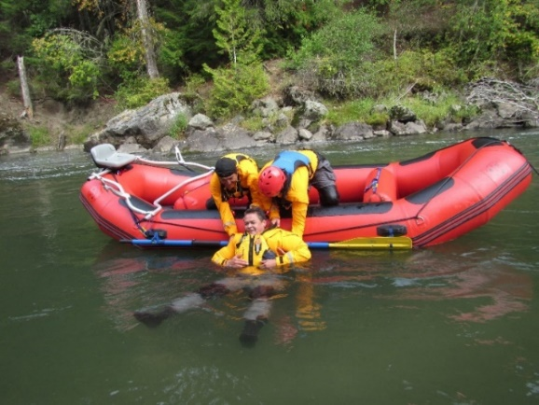
Bella Coola BC
September 8 – October 2, 2020
Certifications include: Stand Alone Courses:

- White Water Rafting Guide Certification (Class 2)
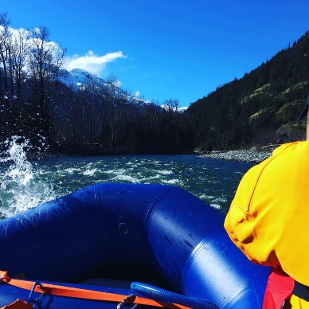
- Swift Water Rescue Technician Course
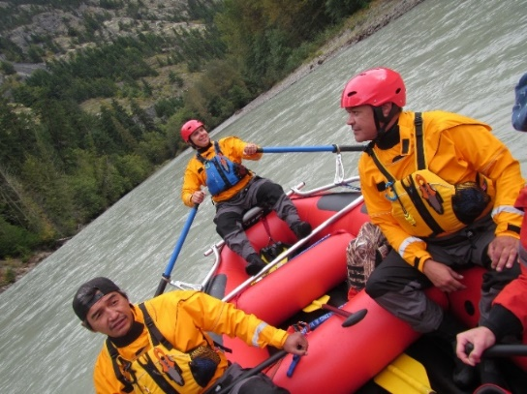
- Marine Baisc First Aid Course
- Commercial Bear View Guide Certification
- Big Canoe Instructor
- Wilderness First Aid Certificate

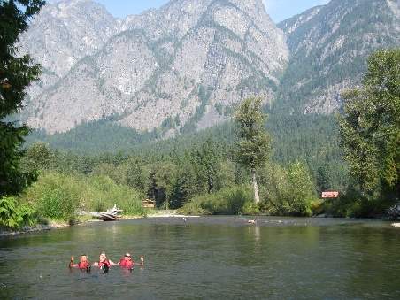
All Training in Accordance with Transport
Canada, NFPA 1006 / 1670 and the BCROA.
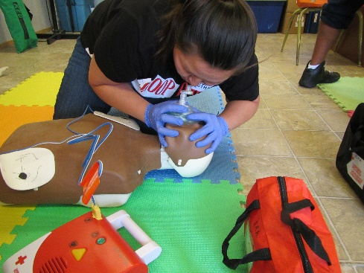
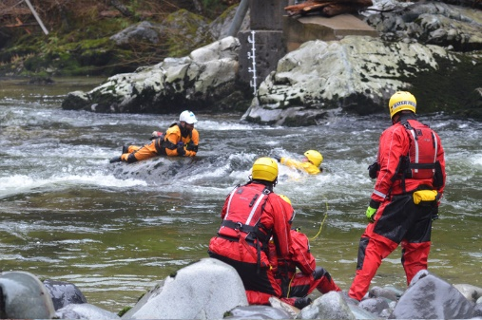
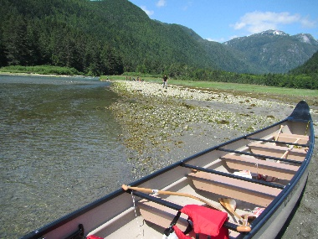
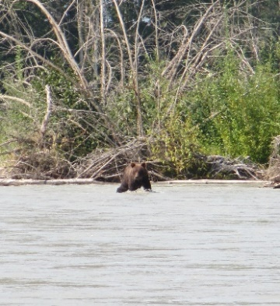
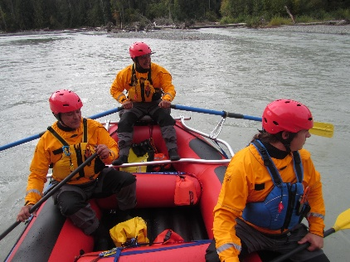
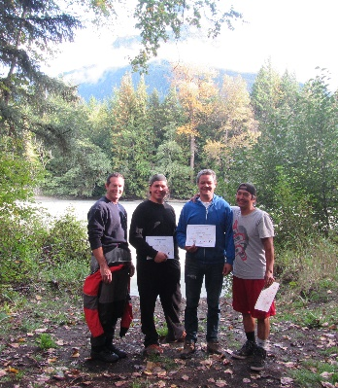

Details: Course runs M-F 9:00 – 5:00 daily. All equipment included, personal items (wetsuits, dry suits, PFD’s, helmets, manuals), training space and transportation is provided. Contact us for more details info@solsticerecreationgroup.com

Our training partners:

