*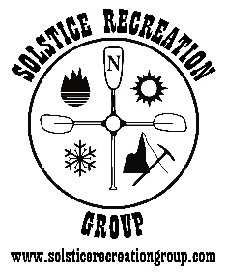Solstice Recreation Group*

Marine Adventure Guides Training

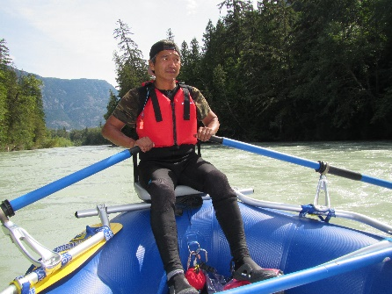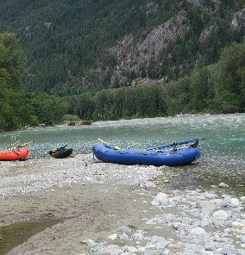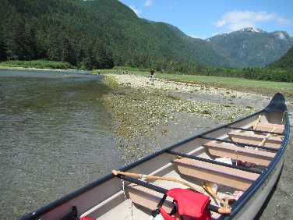

**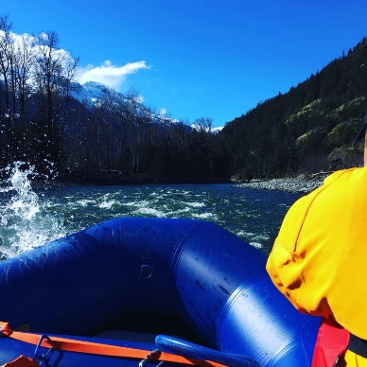*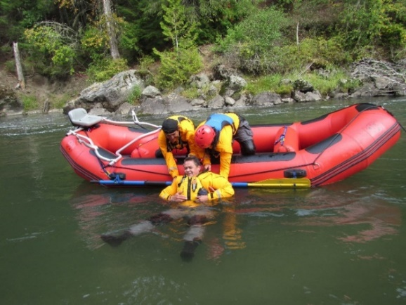***

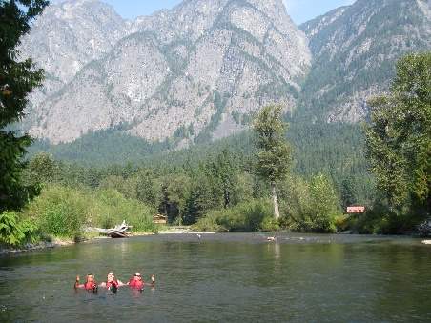

***Employment and Leadership Skills***

***Certifications Include:***

* **White Water Rafting Guide**
* 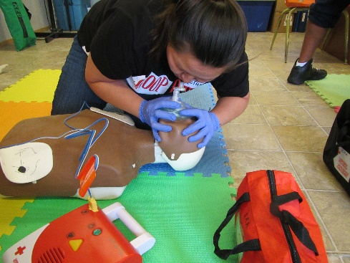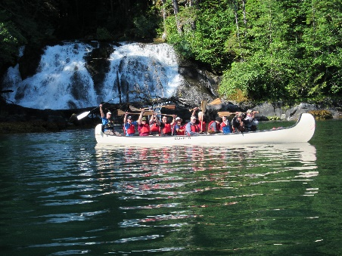**Wilderness First Aid**
* **Marine Basic First Aid (MBFA)**
* **Commercial Bear View Guide Certification**
* 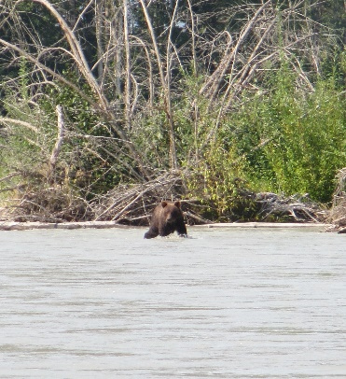**Big Canoe Instructor / Guide Certification**
* 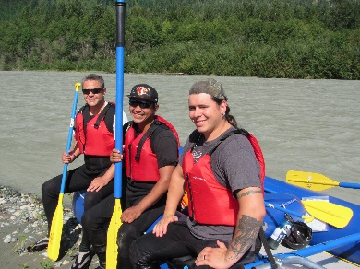**Swift Water Rescue Certification**

**Dates: TBA**

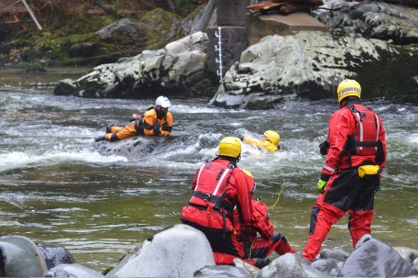**Funding -** Band Education Sponsorship, EI Sponsorship (WorkBC), ISETS (NVIATS / TRICORP) Sponsorship available.

**Details: -** All course transportation, snacks, and equipment is provided. Please visit [www.solsticerecreationgroup.com](http://www.solsticerecreationgroup.com) for course application and further details.

**Contact us:** 250-218-1513 or email [**info@solsticerecreationgroup.com**](mailto:info@solsticerecreationgroup.com)[**www.solsticerecreationgroup.com**](http://www.solsticerecreationgroup.com)

*Our training partners:*

