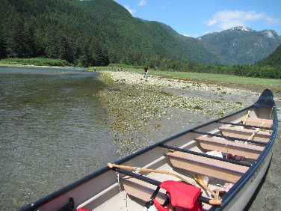
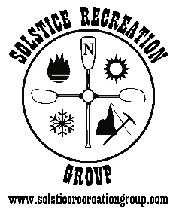
Solstice Recreation Group
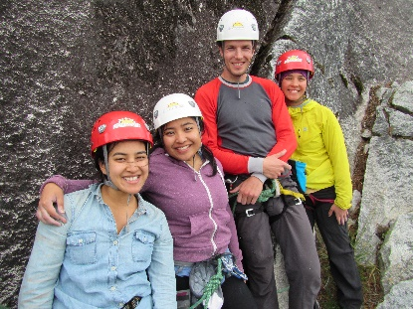
Marine Adventure Guides Training

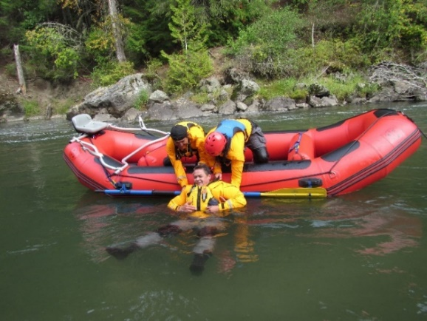
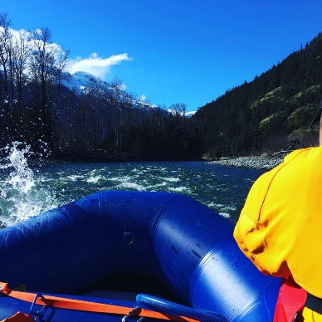
Employment and Leadership Skills
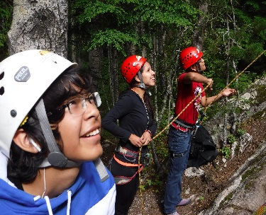
Certifications Include:

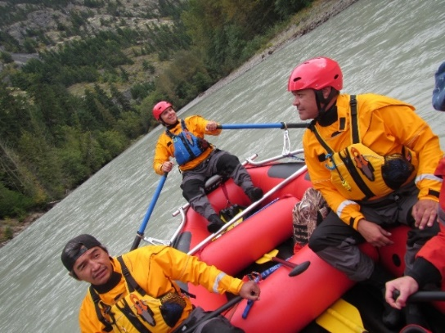
- White Water Rafting Guide
- Belay Certification
- Small Vessel Operator (SVOP)
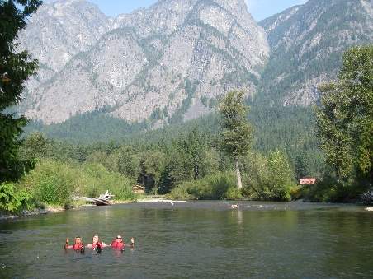
- Swift Water Rescue Training
- Restricted Radio Operator
- Wilderness First Aid
- Marine Basic First Aid (MBFA)
- Commercial Bear View Guide Certification
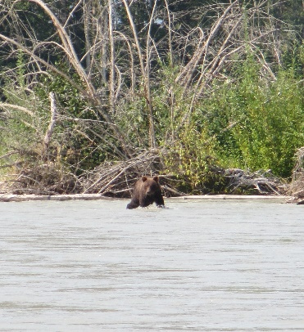
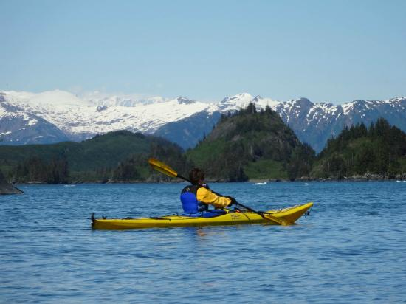
- Sea Kayak Instructor Certificate
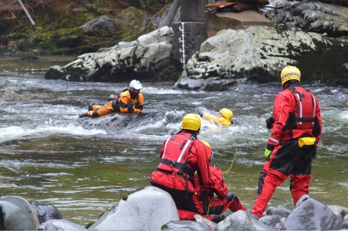
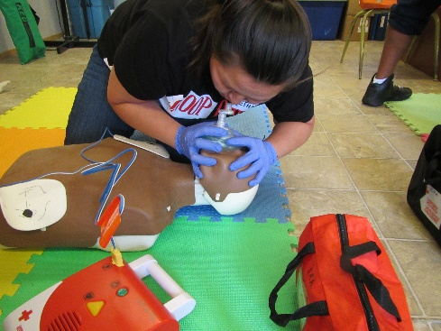
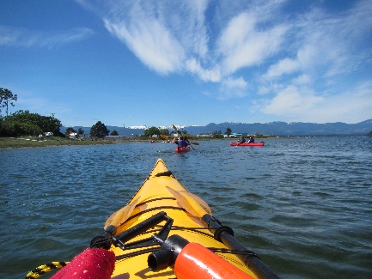
- Big Canoe Operator Course

Dates: Sept. 7 – Oct.9,2020

Funding - Band Education Sponsorship, EI Sponsorship (WorkBC), ISETS (NVIATS / TRICORP) Sponsorship available.

Details: - All course transportation, snacks, and equipment is provided. Please visit www.solsticerecreationgroup.com for course application and further details.

Contact us: 250-218-1513 or email info@solsticerecreationgroup.com www.solsticerecreationgroup.com
Our training partners:
