Matthew Larcinese Gessopalena Research
Who Is Missing from the 1447 Fuochi?
How to use Gessopalena’s medieval tax list without mistaking it for a complete census of families and landowners
CENTRAL FINDING
The 1447 fuochi is excellent positive evidence for the taxable households and names it records. It is not conclusive negative evidence that an unlisted family, cleric, landowner, or lineage was absent from Gessopalena.

Working report

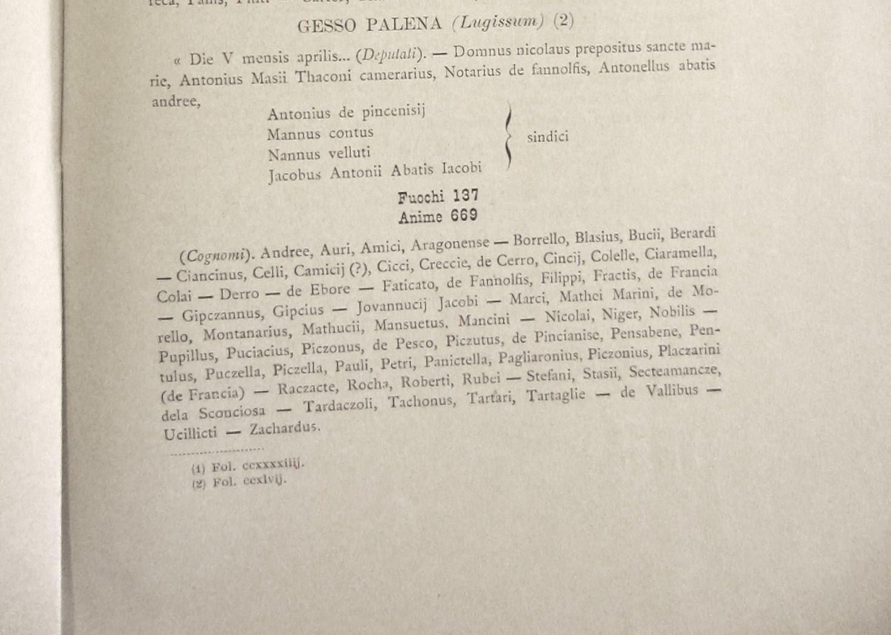
Figure 1. Published transcription of the 1447 Gesso Palena (Lugissum) fiscal entry: 137 fuochi and 669 anime, followed by the extracted cognomina.

The question behind the document
The 1447 fuochi is one of the most attractive surviving snapshots of medieval Gessopalena. It supplies a population total, names civic officers, and presents a substantial list of cognomina at a date long before the regular parish registers. For anyone reconstructing a local family, however, the document also creates an immediate anxiety: if a later surname does not appear in 1447, does that mean the family was not yet in Gesso?
The safest answer is no. Absence from this list is meaningful, but only within the administrative fiscal purpose of the document. The fuochi can tell us which taxable household identities were recognized and transmitted in this particular assessment. It cannot, by itself, define every living person, every proprietor, every cleric, every monastic associate, or every lineage then connected with the castle and territory of Gesso.

What the 1447 entry actually records
The published entry identifies Gesso Palena, also rendered Lugissum, and gives 137 fuochi and 669 anime. It also identifies deputies and syndics and supplies a list headed cognomina. These are powerful data, but each category must be read on its own terms.
Element | What it tells us | What it does not automatically tell us
Fuochi | Taxable household units or hearths. | A separate entry for every adult or every biological family.
Anime | The assessed population associated with those hearths. | A named enumeration of all 669 individuals.
Cognomina | Names or identifying forms extracted from the fiscal record. | A uniform list of fixed, modern hereditary surnames.
Officials | Persons acting for the community in specified offices. | A register of all clergy, proprietors, or influential residents.

A fuoco was a fiscal household, not a surname census
One named or categorized hearth could contain a wife, children, unmarried siblings, servants, laborers, and other dependants. Those people could be genuinely present in Gesso without receiving independent entries. The document therefore counts far more anime than recognizable cognomina. That disparity is not a defect; it reflects the unit being taxed.

The word cognomina requires caution
The 1447 forms do not all behave like stable surnames of the seventeenth century. The list contains patronymics such as Jacobi, Petri, Pauli and Nicolai; geographic descriptions such as de Francia, de Pesco and de Vallibus; personal or ancestral names such as Berardi, Blasius and Stefani; and descriptive forms such as Niger, Rubei, Nobilis and Mansuetus. Alongside these stand names that may already function more recognizably as family surnames, including Mancini, Pensabene, Ciaramella and Pagliaronius.
Consequently, a lineage present in 1447 might be hidden under the name of a father, grandfather, place, occupation, nickname, or prominent household head. A later surname may not yet have become the preferred public label.

Why a Gesso person or landowner might not appear
Several mechanisms can produce an apparent omission. They should be treated as possibilities to test, not as automatic explanations for any favored family.
- Household aggregation: relatives and dependants could be counted inside another person’s fuoco.
- Ecclesiastical affiliation: monks, abbots, priests, benefice holders and people living within an institutional household could enter a different documentary system. Particular exemptions must be demonstrated rather than assumed.
- Nonresident ownership: a person or institution could possess land at Gesso while maintaining a taxable residence elsewhere.
- Mobility and temporary absence: a man described in a charter as de Gypso could be working, studying, serving, or residing outside Gesso when the assessment was compiled.
- Women and inherited property: widows, daughters and heiresses could transmit or control property without supplying the surname under which a later researcher expects to find it.
- Institutional landholding: monasteries, churches, chapels and confraternities owned property but were not ordinary domestic hearths.
- Unstable naming: the later hereditary surname may still be represented by a patronymic, alias, nickname, or Latinized locative form.
- Transmission and editorial mediation: a modern printed list of cognomina is an interpretation of the underlying record and may normalize, separate, or obscure ambiguous medieval forms.

What the Celestine records add
The Celestine materials summarized in the Zanotti register do not duplicate the purpose of the fuochi. They preserve transactions involving vineyards, houses, boundaries, abbots, priors, donors, witnesses, previous proprietors and persons identified as being of Gesso. This is precisely why they recover people and names that a household tax list may not display transparently.
Date | Celestine form | 1447 comparison | Value of the comparison
1390–1392 | Antonius Abbatis Jacobi; Petrus Abbatis Jacobi Joannis de Gypso | Jacobi; Jovannucii Jacobi; Jacobus Antonii Abbatis Jacobi | A strong patronymic bridge across the two record systems.
1429 | Nicolaus Joannis de Sancta Agata de Gypso | No exact Sancta Agata form | A Gesso identification need not appear as the same household label.
1460 | Antonius Bartholomei de Gypso alias Scocchitto | No transparent Scocchitto | Aliases and later-emerging labels complicate negative searching.
1464 | Sinatrinus Jacobi Paglini de Gypso | Pagliaronius | Possibly related name territory; not sufficient to collapse Paglini and Pagliarone.
1464 | Elias Antonelli | Antonellus Abbatis Andree among the officials | A patronymic Antonelli identity may be forming around an earlier Antonello.
1483 | Paulus de Amadiis de Gypso | No transparent Amadii | Clear later Gesso form without an obvious 1447 equivalent.
1483 | Antonellus Jacobi de Accettellis de Gypso | No certain Accettella form | Ucillicti is worth paleographic testing, but equivalence is unproved.

The strongest bridge: Abbatis Jacobi
The Jacobi material illustrates why exact reconstruction requires more than surname matching. Zanotti records Antonius Abbatis Jacobi de Gypso in 1390 and a Petrus Abbatis Jacobi Joannis de Gypso in 1392. The 1447 syndics include Jacobus Antonii Abbatis Jacobi. The sequence is compatible with a continuing family identity expressed through a chain of fathers and an abbatial ancestor. The value lies in the repeated relational formula, not in pretending that Jacobi already operated exactly like a modern surname.

Pagliaronius, Pagliaroni and Pagliarone
The 1447 Pagliaronius has acquired unusual evidentiary weight. A 1602 Paglione protocol includes Liberatore Pagliaroni in a Piedi Castello context. In 1654 Nobile Pagliarone and Francesca de Vallariano baptized their son Liberatore. The 1696 stato delle anime of Sant’Egidio again records Nobile Pagliarone, approximately sixty-five, with Francesca Vallariano, approximately sixty. Later, Maddalena Pagliarone entered the ancestry of Magnifico Giuseppe Larcinese.
This sequence strongly supports Pagliaronius → Pagliaroni/Pagliarone. It does not require Paglione and Pagliarone to be identical surnames. Paglione was itself conspicuous among Gesso’s doctors, notaries and proprietors, while Pagliarone also existed as an established family. They may be connected, but the documents should be allowed to preserve the distinction until genealogy proves otherwise.

De Vallibus and Vallariano
The 1447 de Vallibus and the seventeenth-century Vallariano share a conspicuous vall- root and occur in the same small population. The comparison deserves pursuit, especially because a Vallariano appears in the 1602 notarial environment and Francesca de Vallariano married Nobile Pagliarone by 1654. Yet the forms are not linguistically identical: de Vallibus is a Latin locative meaning “of/from the valleys,” whereas Vallariano could be a stabilized surname or a more particular geographic designation. This is a promising continuity, not a proven equation.

What Antinori adds
Antinori’s historical notices illuminate another population largely invisible to a simple surname comparison: lords, widows of lords, political actors, bishops, churches and institutional events. The notices concerning Teobaldo di Letto, the church of San Lorenzo, and the wider feudal history of Gesso belong to the same place but answer different questions. Antinori helps establish jurisdiction, lordship, chronology and institutional context; Zanotti helps reconstruct the monastery’s transactional network; the fuochi shows the taxable community at one moment. None should be asked to replace the others.

The monastery and parish problem
Gesso’s people moved through overlapping documentary worlds: the castle and civic administration, San Giovanni and its Celestine property, San Valentino, Sant’Egidio, Santa Maria Maggiore, the Annunziata, chapels and confraternities. A man could be visible as a donor in one archive, a neighbor in another, a parishioner in a third, and absent as an independently named fuoco.
D. Federico de Paolo Antonio de Palena illustrates this overlap. He appears in the Celestine material in 1570, began or maintained the early San Valentino register as prevosto, appears in a 1602 Paglione act, and is identified with San Valentino again in 1604. His recurring presence does not indicate documentary duplication; it reflects a cleric whose office naturally crossed monastic, parish and notarial systems.

Example: The Larcinese and Tiberino question
WHAT THE SILENCE PROVES
The words Larcinese and Tiberino are not transparently present in the published 1447 cognomina. That is the secure conclusion. It is not secure to conclude that their ancestral lineages were absent from Gesso.

By the late sixteenth and seventeenth centuries, the Larcinese, Tiberino, Mancini, di Fabrizio, Tozzi and other families are deeply entangled with lands and institutions around Sant’Egidio, San Giovanni, the Annunziata, Valle Arcioni, Bracciola, Colle Ianni and neighboring contrade. Y-DNA evidence connecting documented Larcinese and Tiberino male lines makes the question of an earlier shared formation especially important, but genetics cannot assign a particular 1447 household name without documentary support.
Forms such as Jacobi, Bucii, Berardi or Blasius may eventually prove relevant to that earlier formation. At present they are research candidates, not substitute surnames. The correct method is to connect generations through kinship statements, inherited boundaries, repeated aliases, offices, marriages and property transmission—not to select the most attractive medieval name and declare it ancestral.

A practical method for using the fuochi
- Treat presence as firm evidence. If a form appears, record it exactly, including Latin endings and accompanying relationships.
- Treat absence as a question. Write “not transparently recorded under this surname,” rather than “the family was not present.”
- Search by relationship, not spelling alone. Track fathers, sons, brothers, abbots, widows, witnesses and neighboring owners.
- Separate name types. Distinguish hereditary surnames from patronymics, aliases, occupations and locatives.
- Compare independent record systems. Set the fuochi beside Zanotti’s Celestine acts, Antinori, surviving originals, parish books, notarial protocols and later fiscal records.
- Map the land. Repeated adjacency can preserve a family network even when the label changes, but proximity alone does not prove blood relationship.
- Grade every proposed continuity. Use categories such as documented, strong, plausible, suggestive and speculative.

Recommended language for family histories
Avoid: “The Larcinese family was not in Gessopalena in 1447 because the surname is absent from the fuochi.”
Prefer: “The surname Larcinese is not transparently recorded in the published 1447 fuochi of Gessopalena. Because the register assessed fiscal households rather than exhaustively naming every resident, landholder and ecclesiastical affiliate—and because fifteenth-century identities frequently appear as patronymics, aliases or locatives—its silence cannot establish that the underlying lineage was absent.”

Conclusion
The 1447 fuochi remains one of the foundational documents for medieval Gessopalena. Its value increases, rather than diminishes, when its limits are respected. It gives a disciplined point of reference for the taxable community and its recorded names. Zanotti’s Celestine acts recover the transactional and monastic population around that community. Antinori supplies feudal, political and ecclesiastical context. Notarial and parish records then reveal how earlier patronymics and locatives stabilized, divided, disappeared or re-emerged as hereditary surnames.
For descendants searching the list, the proper response to an absent surname is neither panic nor invention. It is a better question: under what household, relationship, institution, place-name or earlier name-form might this family have been recorded?

Editorial note and evidentiary status
This report is a working interpretation based on the published 1447 Gesso Palena entry; the Celestine regesta associated with Zanotti; Antinori’s notices concerning Gessopalena; and sixteenth- and seventeenth-century notarial and parish materials supplied and reconstructed by Matthew de Larcinese. Medieval readings and proposed surname continuities should be checked against original manuscripts whenever possible. The report intentionally distinguishes documented identity from probable or merely suggestive continuity.

