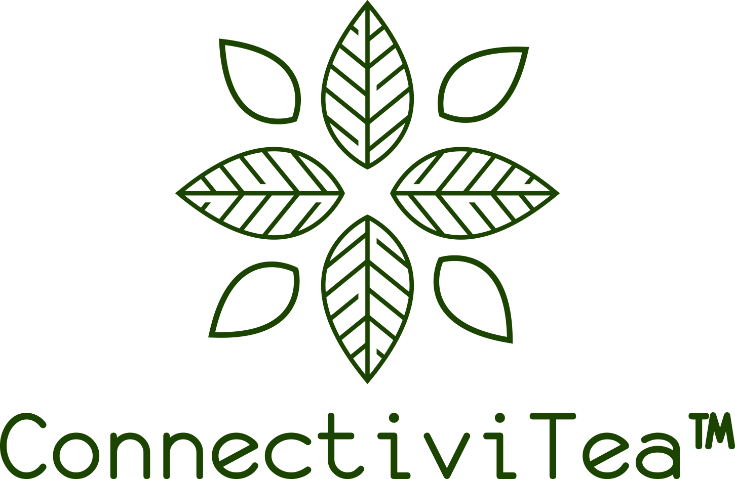

The ConnectiviTea™ Fund is the charitable giving arm of Table Rock Tea Company, Ltd. As part of Table Rock Tea Company’s ongoing commitment to honor God and to give back to our global community, 10% of all income from sales and services goes into The ConnectiviTea™ Fund.

The ConnectiviTea™ Fund is a D.A.F. (Donor Advised Fund) whereby resources are distributed to registered 501(c)3 nonprofit organizations. Although funds may be given to any nonprofit, our primary focus is on assisting small-scale farmers and agricultural entrepreneurs in developing countries. In addition to our 10% of sales and services, individuals may also contribute directly to The ConnectiviTea™ Fund and receive the same tax benefits as giving to any other 501(c)3 organization. If you would like to make a tax-deductible donation to The ConnectiviTea™ Fund, click here.

If you would like to submit an application to receive ConnectiviTea™ funding, click here.

