WATCHOUTS FOR ADDING EVENTS TO THE CALENDAR

This is a major heading and there can be a maximum of 8 major headings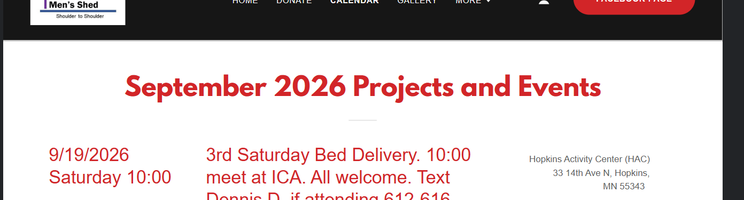
__________________________________________________________________________________

This is a minor heading and there can be a maximum of 5 minor headings under each major heading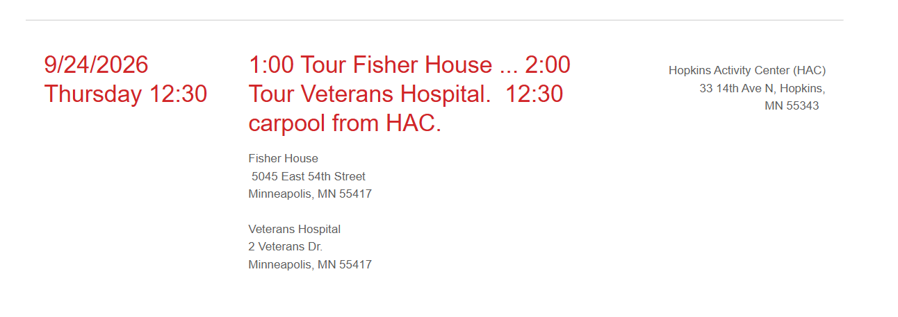___________________________________________________________________________________

If more than the maximum number of headings are added the last ones disappear. I think they go out of sight and if a previous one is eliminated the old last one reappears.

