Hergest & Cavell are fully an inspected and certified member of the National Association of Funeral Directors

Quality Without Compromise

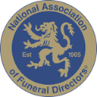




This Photo by Unknown Author is licensed under CC BY-SA

SIKH
COMMUNITY FUNERAL
£2,895
Plus third party fees

128B Milton Road Gravesend Kent DA12 2RQ
Tel: 01474 326400
24 hours

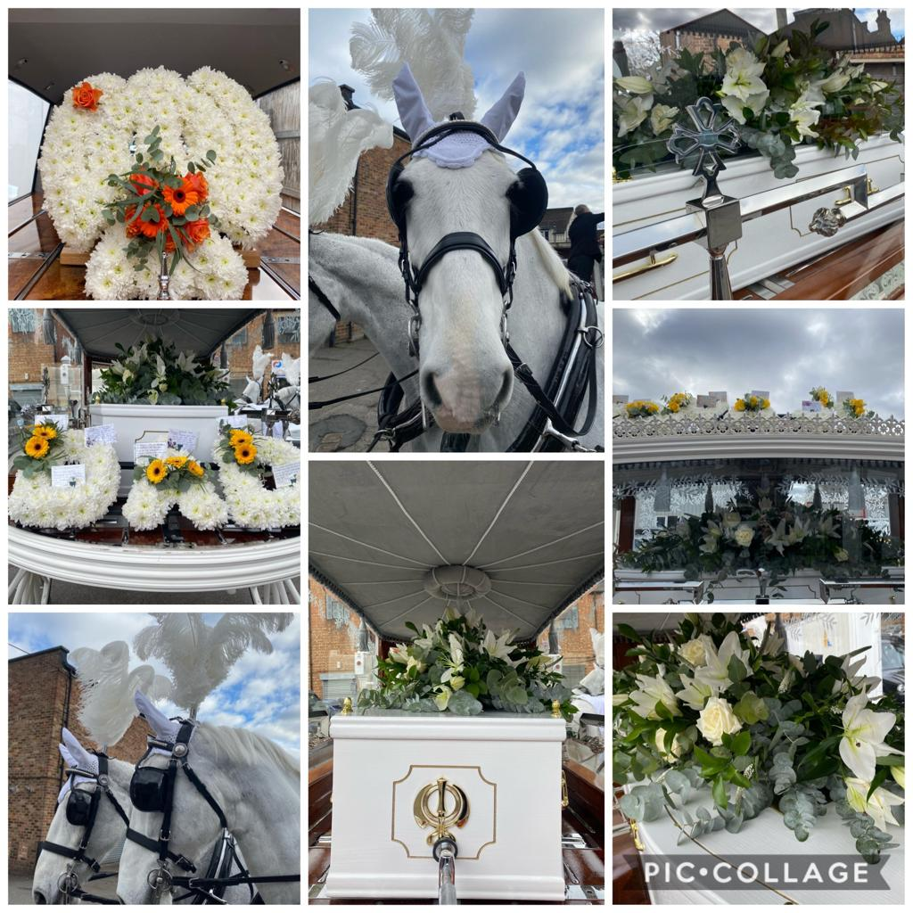

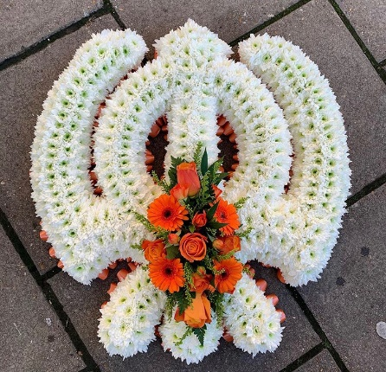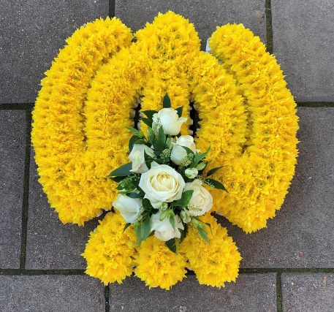
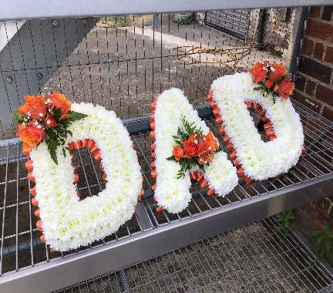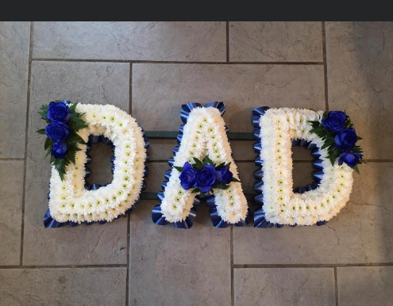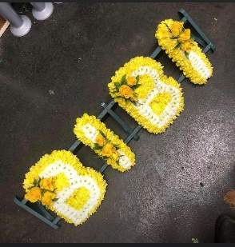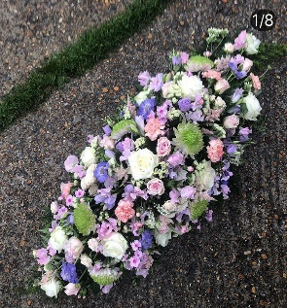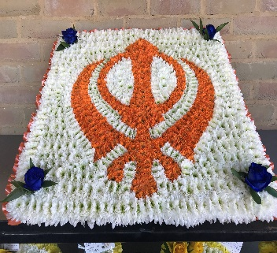
Prices on request.
We do not charge you additional money for handling the order of your floral tributes, we offer this service for your convenience and is part of our service.
Our florist produces tributes to an exceptional standard.

Ashes on water set £175
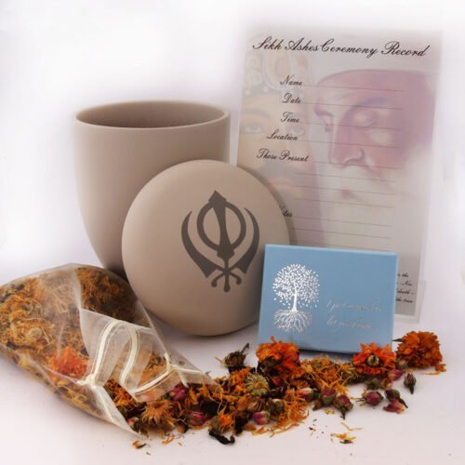

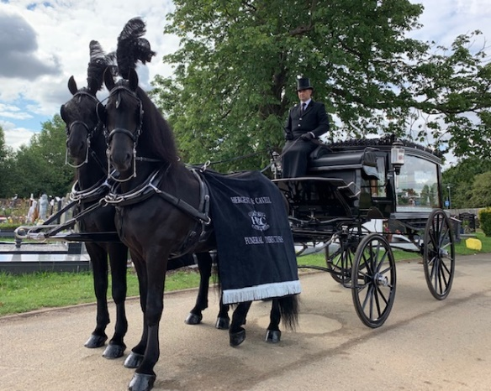Horses from £1250

The Sikh Community funeral
We are a small family owned and run business where family truly matter.
We understand and fully appreciate both the cultural needs and religious customs of our Sikh community, as well as individual family traditions that need to be respected following the death of a loved one.

Our comfortable modern funeral home in Gravesend has excellent facilities. There is a comfortable meeting room where families can sit and make private arrangements; a visiting room where you can see your loved one at any time once in our care, and a modern and well-equipped washroom for use prior to the funeral day.

Sukhmani Sahib prayers are played with incense burned in the company of the Golden Temple image and Khanda ornament. Items needed for the ritual wash are provided and are freely available for use should you choose.

We do not restrict you at all. We are available whenever you need us day or night on the phone and the use of our facilities extends over the weekend to include one 2-hour visit on a Saturday. Additional visits can be booked at £35 per visit to cover staff call out costs. Sundays and Bank Holidays will be charged at £65 each visit.

Our family team of funeral professionals have the experience and care needed to support you. Ladies are on hand to assist with female washing and dressing with our gentlemen providing aid for your male relatives.

The funeral of your loved one is important to us, and we will endeavour to ensure that all paperwork and protocols are adhered to within the timescales you prefer. On many occasions we can arrange proceedings within 7 days, occasionally less. However, we are governed by the authorities issuing the correct paperwork and crematoria availability.

We will also hold the ashes of the deceased without charge until their repatriation to India or final resting place chosen. We can also assist with boat hire.

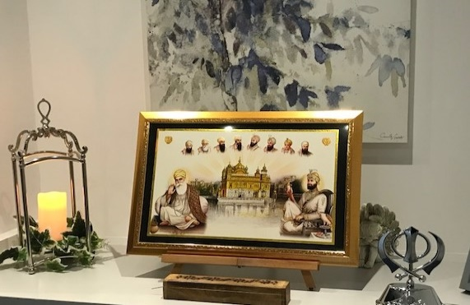

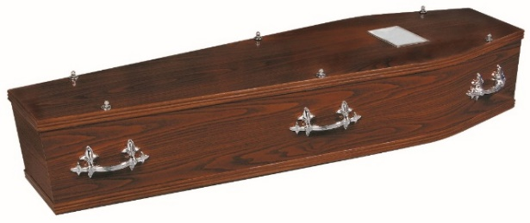

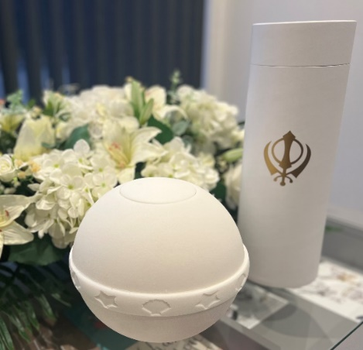

The Sikh Community Funeral - £2895 plus third-party fees

What is Included:
Collection of your loved one (within 15 miles) from the place where they are resting to our Chapel of Rest, provision of a motor hearse and one following complimentary limousine. Care & Preparation of your loved one for visiting prior to the wash. Professional Embalming, if needed, is included.

Support and administration for arranging the funeral, the necessary staff and an experienced Funeral Director to conduct the service on the day.
The provision of a simple wood effect coffin lined and fitted with 6 handles, nameplate and Khanda ornament. The coffin may be upgraded at an additional cost.

We will come to a home address and if required bring your loved one inside (where possible) before following the funeral cortege to the local religious facility before proceeding to a local crematorium, where you may witness the ‘charging’ of the coffin if desired. We will then return you to your local Gurdwara.

We will wear traditional funeral attire and ask if appropriate that our gentlemen wear the ramal as a mark of respect.

A scatter tube is provided within the package costs or alternatively you may wish to purchase a more elaborate urn for use when scattering on water. POA

*Third Party Fees chargeable at current rates.
Thames View £ 990
Medway -includes a witness charge fee of £30 £ 850
Collection from London Hospitals £ 120
Embalming £ 120
Removal of pacemaker £ 50
Additional limousines from £ 285
Visual Tribute £ 135
Webcast – crematorium streaming £ 75
Use of service Room for prayer service £ 120
*Prices accurate at the time of printing, - This is a tailor-made funeral package suitable for the Sikh Community. Prices of crematoria may vary. P.O.A for Specialist embalming where necessary

