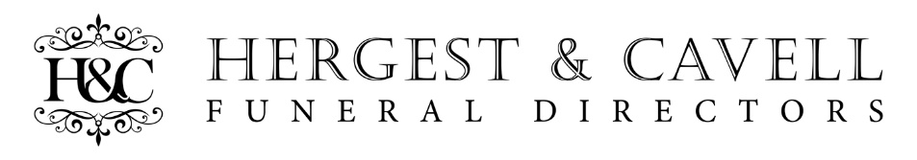
Crematoria Price Information
The information below gives the prices charged by crematoria for an adult (18+ years) funeral within a 30 minute cortege journey of this funeral home.

Crematorium | Standard Fee Attended Service  £ | Reduced Fee Attended Service  £ | Unattended Service  £
Thames View - Gravesend | 940 | 700 | 275
Falconwood - Eltham | 942 | 889 | 435
Medway – Bluebell Hill Chatham | 795 | 610 | 275
Please Note:
- Standard crematorium times are from 10am and allow approximately 40-50 minutes of service time
- Reduced Fee times are early morning services between 9am -10am and allow approx. 20 minutes max service time.
- Unattended services are all conducted before 9am and before the crematoriums are open to the public.
- All services are Mon- Friday. Weekend Funerals are available for an additional cost.

Terms of Business:
Our Terms of Business include the following:
- A minimum deposit is required to cover all third-party fees and 50% of H&C charges.
- The deposit is due within 48 hours of the arrangements, or by agreement no later than the day before the funeral
- The balance payment is due 21 days from the funeral date.
- If you are sending the account to a representative or claiming from the DWP please advise us immediately.
- We offer financial assistance via an approved specialist for those needing support in meeting funeral expenses.
- No late payment fee or interest will be charged for balances where a 12-month instalment plan is agreed.
- We reserve the right to charge a late payment fee 1% per calendar month on outstanding balances where no instalment plan has been agreed or on default of agreement occurs.

Disclosure of interests:
Hergest & Cavell Funeral Directors Ltd is an independent family owned and run business and is not part of a larger funeral group or other business entity.

Register of Charitable Donations and Gratuities:
Hergest & Cavell Funeral Directors Ltd do not donate or give gratuities to any person or organisation to influence referral, recommendation or transfer of business.

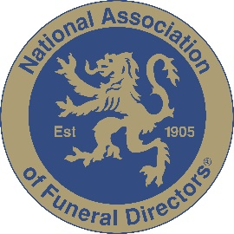

Hergest & Cavell Funeral Directors are a fully inspected member of the National Association of Funeral Directors and adhere to a strict code of conduct.

Company Number:10797581

