Revealed: the 'hidden' heroes who have devoted themselves to help others

Five women in the region have been recognised for their incredible achievements in volunteering.
The Hidden Treasures Honour Roll was established in 2010 by the NSW government to acknowledge women and girls who volunteer in regional, rural, and remote communities.

Orange MP Philip Donato said it was an "absolute honour" to present the certificates sent from Ministers Jodie Harrison and Tara Moriarty.

"One of the most rewarding parts of my job is to recognise and celebrate our local volunteers, who selflessly devote their time to benefit all of us," Mr Donato said.

Paula Townsend said she started the Bowen Community Technology Centre (CTC) in 2007 with "a lot of help". She was the Local Woman of the Year in 2024.
It came after Bowen communities' concerns about social issues such as unemployment, poverty, health issues, and social dislocation. The CTC helps both children and adults, and is a safe space for locals to access computers, homework assistance, employment opportunities, and social connections. Ms Townsend said the centre, which has been running for 17 years, is important because "not everybody can use technology, or read and write, or speak English".

She said hearing back from young adults years on from using the centre who talk about how they are progressing with their education or job is a major achievement.
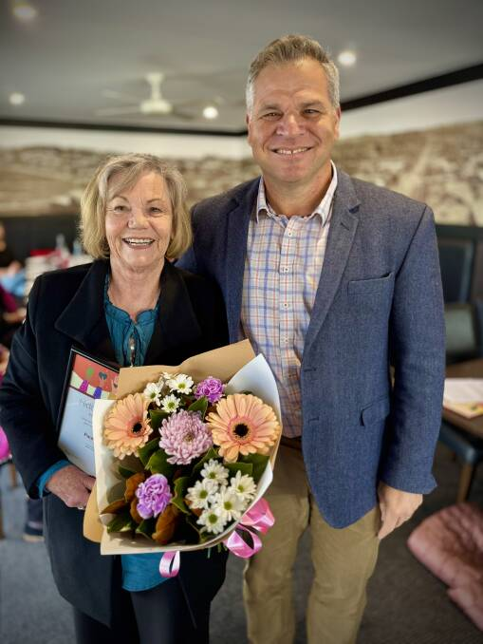
"Seeing people get a job and keep the job, or getting a university degree are everyday things that people don't put a lot of emphasis on but it can make a real difference to someone's life", Ms Townsend said.

