CAT MOUNTAIN

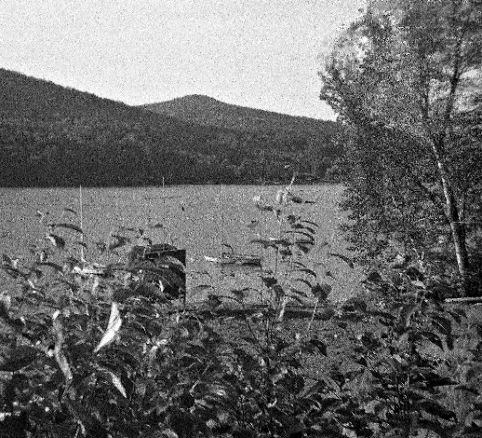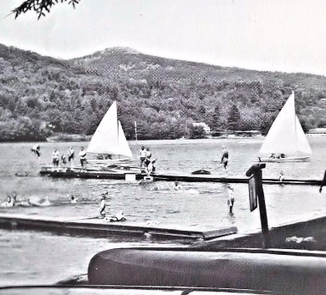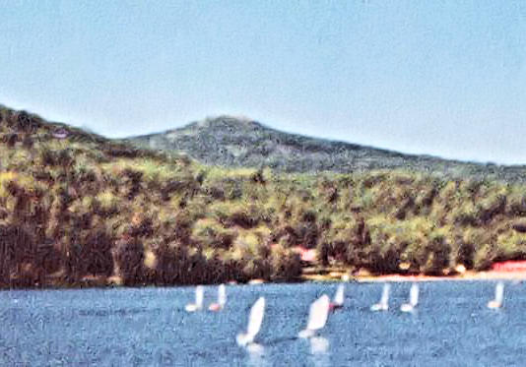

There is probably a State in the Union that does not have a rise in the landscape named “Cat Mountain”. Some state like Kansas. New York has two. The dominant landform is located near Tupper Lake. The lesser version all but bordered on Timlo’s Trout Lake. Morning, noon and twilight, its bald top loomed over Twin Pines Resort, begging for exploration.

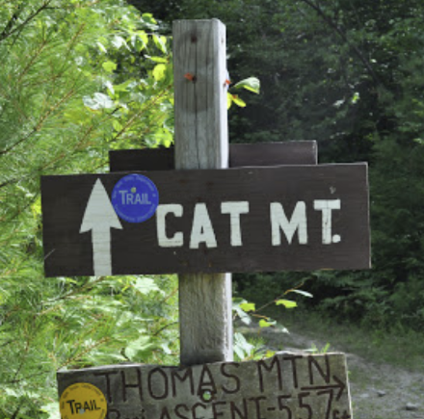And explored it was. One Sunday morning in 1968 the campers in the three oldest cabins were informed that we would spend the day in pursuit of Bald Top’s view. Yes, Bald Top. In ‘68 and ’69, no one seemed to know the local name for the peak. We were not even sure if it qualified as a mountain. “Bald Top” was the common identifier. Packing was light: canteens plus sandwiches carried in something or another (backpacks were an oddity in that era. There were a few in the camp, with racks, owned by the trip counselors. We campers had canvas knapsacks, engineered by BSA vendors as torture devices). The cabins left at staggered times in different directions. Some climbed from the Edgecomb Pond area. Cabin 9 scooted around the lake to Twin Pines and proceeded up one of the disjointed, leafy tracks of what was to be later known as part of Cat Mountain Road.

At that time Cat was privately owned. However, Barr and its owners knew each other. Permission was always generously available. Indeed, the owner later passed the land on to Bolton Landing, which in turn deeded it to the Adirondak Park system. These days, volunteers maintain and mark the trails. Good show!

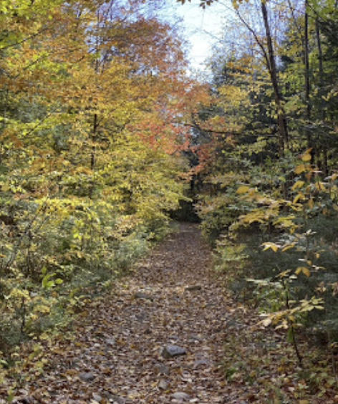The “road” quickly turned into a trail, and then dissolved away at an increase in incline somewhere under the wooded canopy. What now? A couple campers had compasses, entrusted to them by nostalgic parents. The devices all turned out to be examples of overpriced workmanship. What now? Well, the mountain is, by definition, “up”. “Start climbing boys”. And climb we did.

It soon became apparent that packing light and splitting into separate cabins was the way to go. Even within a cabin group, quite the range in abilities was present. Divide and conquer: our counselors were able to keep us together.

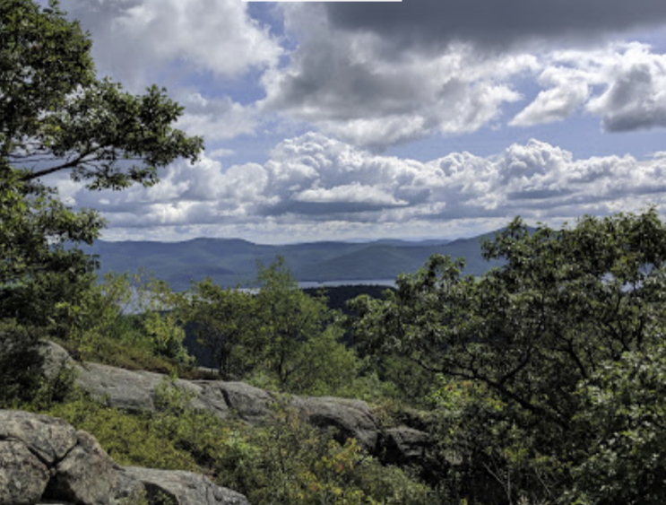Eventually we came to a rock face, climbed for a while, found a bare spot with a view, and figured we had reached the top. Time for lunch! Ha! Cabin 10 drifted by, jeering that they had been to the summit and were on their way down. Rather shamefaced, but with lunch in a more portable location, the climb resumed. With a lot more rock-climbing. Don’t we need an axe and ropes or something? Should we tell our parents about this?

We reached the top. Anyone who had some left, broke out vittles in celebration. The rest of us checked out the terrain.

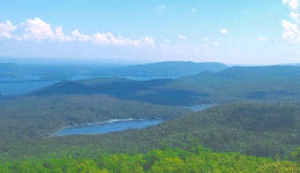To me, Trout Lake looked a bit like a trout. Timlo’s end formed the body of a leaping fish. The southern end of the lake formed the visible tip of one of the flukes. The Trout Lake Club’s quarter, which was obscured by Cooper’s Mountain and Lamb Hill, hid the portion of the lake which would have spoiled the illusion of a tail.

I mentioned my impression. The response was an emphatic, “You’re nuts!” Well, everything was emphatic back then. Having said that, some non-aligned party who much later created a Trout Lake/Cat Mountain Web site, also agreed with me. So there. Whomever you were.

Mission accomplished, after about twenty minutes we were all on our way back down. Easy on the legs, but not so simple when it comes to direction finding. “Down” in this case, spreads out. We arrived out of the woods on the shoulder of Edgecomb road. Well, OK. Head for camp.

But not quite.

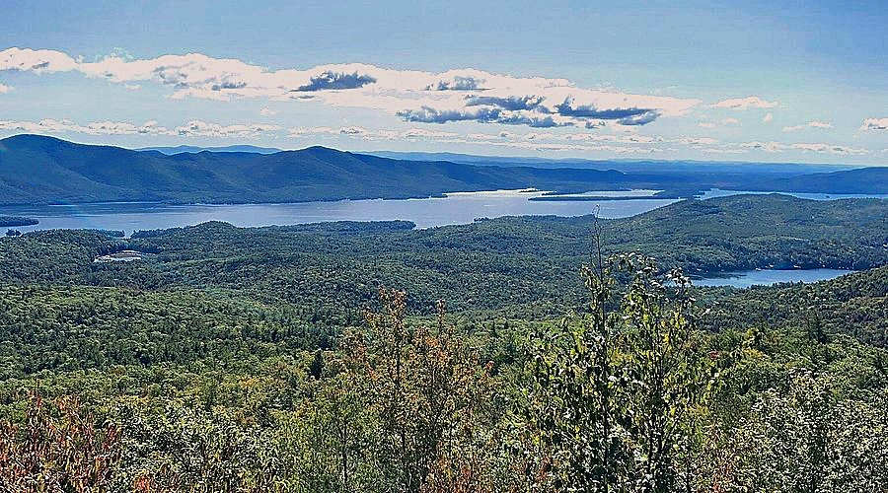On the northeast corner of Timlo there was a kind of “H” intersection. Coolidge Hill Road led to Timlo, then diagonally down to Lake George. Potter Hill Road was one of a pair of roads that led down to Bolton Landing. Trout Lake Road led directly east to Lake George. On Trout Lake Road, out of sight and just east of a broad “S” of curve was Switzerland Campground, which included a general store, surrounded by an assortment of “A-Frame” Chalets (a design fad in the 1960’s) and RV pads. The selling point of the campground was a panoramic view of Lake George. The selling point to a mob of hot, thirsty campers and counselors was the general store. The admonishment of “We’re not supposed to stop on the way back,” guaranteed exactly that action.

I don’t recall if two-liter bottles of pop were a common measurement at the time. If not, there was an Imperial half gallon equivalent. The store was quickly divested of all such and a certain amount of misc. sweets, including ice-cream novelties. “Don’t make yourselves sick”, the counselors yelled. My “catch” was one of the half gallon bottles of orange soda pop, Fanta, perhaps. There are a few encounters with nourishment I remember as particularly delightful: An A&W root beer float in Tonopah, Nevada. A steak and fries meal served up in the Dodge City, Kansas train station. Howard Johnson’s Peppermint ice-cream. 30th Street Philadelphia Station pretzels and cheesesteaks (not Pat’s or Geno’s). And that orange soda-pop.

No one became ill. Guess we needed that stop. However, all were glad to feel the last hill crest under our feet as we trudged past the “Old” Timlo ball field.

In 1972 there was a camp-wide trip to Cat Mountain. The youngest campers were transported to the Edgecomb Pond area in two vans. The rest of us left, by cabin, in various directions with staggered departures. By then I was a 2nd year Junior Counselor. Cabin 10. As it happened, we retraced the route of the 1968 Cabin 9 past Twin Pines, this time not mistaking the rock face for the top of the mountain on the way up. Our decent through the woods landed us on Cooper Mountain Road, on the west side of Cat. We found a fellow guarding his mailbox, who, glad to see us go, gave us directions (turn left on Lamb Hill Road). We were not sure he wasn’t having fun at the expense of our feet, (a fierce generational war was going on in the real world) but after a long walk, Trout Lake and Walden Camp came into view.

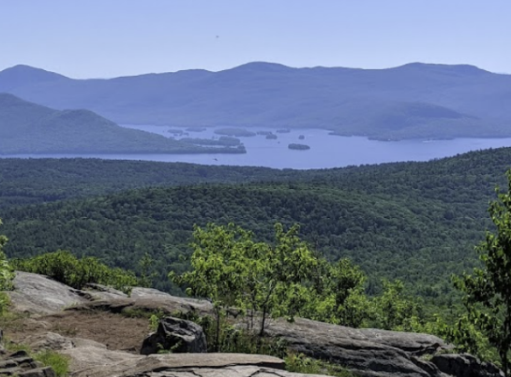And of course, there was the now traditional detour to the commercial campground. We were the last to arrive on foot.

“Has anyone seen Cabins 1,2 & 3?”

“Don’t think they made it to the top.”

“Never mind!”

Just then, the two Plymouth vans pulled up, disgorging weary staff and a mob of energetic tikes. In the store, they found some unsold ice-cream. (Not much left to drink except tap water. Back then, selling tap water would be considered in-hospitable). The whole of Timlo, save the kitchen staff and head table qualified leadership, was on hand at the campground, partying under the trees. (I’m sure HC Bob Northrup knew exactly where we were. He was also wise enough to feign ignorance and wait our arrival out).



There was one other full-camp foot trip during those years. Not to Cat Mountain.

During my first year as Junior Counselor (1971) I had drawn the 4th of July off as a half day. Spending off time in view of the campers was discouraged, so the clock was usually burned with a trip to Bolton Landing by way of hitched ride, shanks-mare or bicycle (ten speeds were all the new rage. Took me about three weeks to combine strength and mountain techniques. Bo Garrison was quite good at it and taught me some tricks). To young to drink, my attention was usually focused on hanging out in the parks or dock area, and laundry. On this particular day, cottoned to a town fireworks display at the Schoolhouse Road ballfield. It was very nice, and ended with a decent finale. Made my donation to the fire department, feeling a bit guilty that I was likely the only person from Timlo to enjoy it. (Perhaps “The Algonquin”, Timlo’s favortie watering hole, and incidentally still in business, put on their own show. The open-air patio was on the Lake George, just south of Bolton). At best, Timlo could only field a couple of illegal sparklers, a campfire with a lot of socialist inspired singing, plus some sort of patriotic speechifying, which in 1971 was as welcome a napalm soup.

Any thoughts of exclusivity were rectified a few years later, probably 1972 or ‘73. The whole camp, little ones too, lined up and marched out. Off we went down Potter’s Hill Road. Rather than dive down Mohican Road to the south side of Bolton, we continued on the much longer loop around the back of Bolton to Horicon Road, thus landing at the park without becoming entangled in the town, tourist and thoroughfare area. Plenty of room. Timlo ‘s presence was not a bother.

After the show, the two Plymouth vans were on hand to shuttle all of us back to camp. (Walking back would not have been at all practical. I did it many times, sometimes had to feel for the edge of the pavement with my feet [plastered staff used their hands], or spy out starlight through breaks in the trees. All good training for my subsequent career as a night owl).

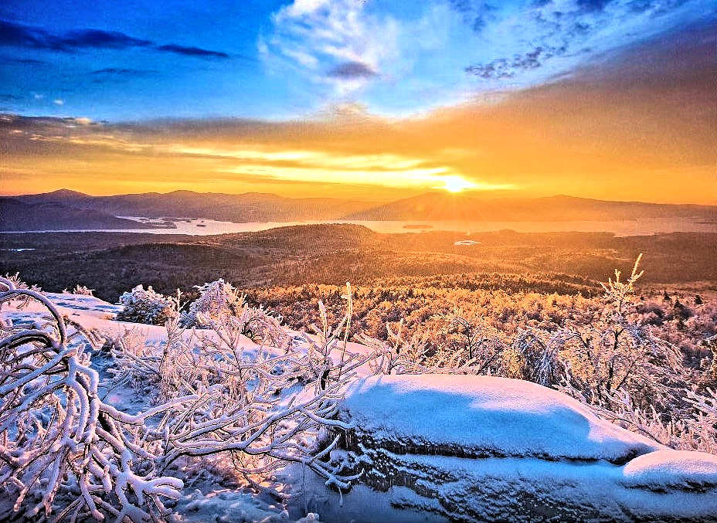The hike across the mountains with views of Lake George followed by the spectacle of the pyrotechnics was a great way to celebrate the day. Alas, as far as I know, a once-only Timlo event.