Cabin 9, 1968

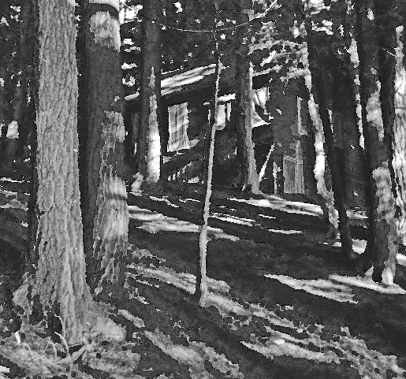

Cabin 9, as a structure, was the best cabin at Timlo. Located in the woods, it was shady and cool all summer. The picture makes sense when the viewer realizes the shelter rested on a slope, one end on the ground, the other on stilts covered over to make a sort of shed. We were rarely bothered by shutter raids: as the supports were mostly out of reach: our adversaries had to remember to bring a stick. The location also made sense as our lights out was officially extended. We chipped in to purchase a SHELL NO-PEST strip. No bugs.\* Life was good.

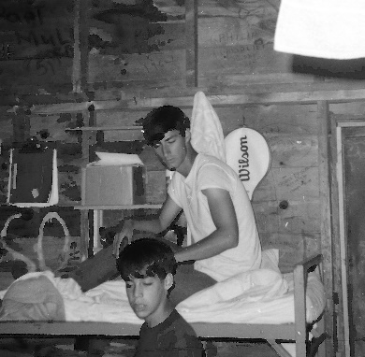

Senior counselor Steve K. Was a tennis instructor. His assistant was Lee Hessburg. (Not one of the red-heads, but related). That is Mitch Goldberg in the foreground. Always front and center, was he.

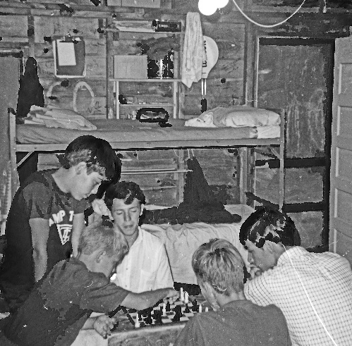Chess was a thing that year. Someone had a magnetic set which could stand up to the rigors of cabin life. Phil Oppenheim and a couple others played a lot, plus there was a stream of visitors.

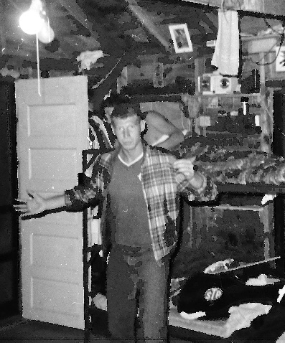

Steve, one of the Red-headed Hessburgs stopped by to see his brother Lee, our cabin counselor.

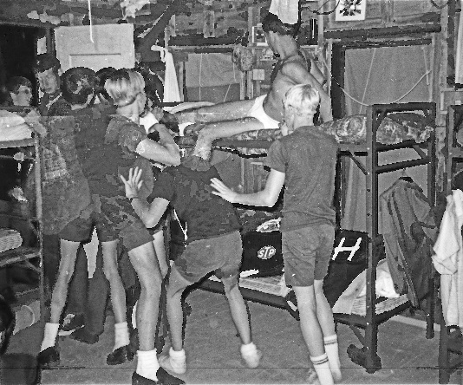

Clean up time. First order of work was the eject the Red-headed Hessburg. Kennedy appears to be pulling, Amos Hutchins pushing, and Phil Oppenheimer providing a subtle nudge to the affair.

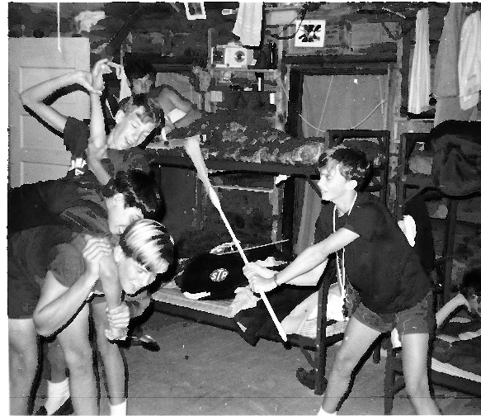Here we have Mitch Goldberg, Amos Hutchins, Kennedy and my lower bunkie (whoever he was) in full cleaning mode. You can see a little bit of Bob Sorenson to the lower right, keeping clear.

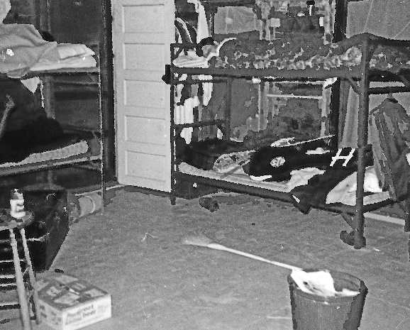

And here we have the results. Can you blame us? Check out the supervision, top bunks, left and right.

Our counselors were actually upstanding and responsible. And if the campers were not a good crew, I never would have returned.

\*Windows also had screens, plus a clever rig consisting of lines and pullies to raise and lower a canvas blind. Pretty classy.