A TALE OF TIMLO

1969: Barr’s winter travels to the homes of prospective campers had yielded results: so much so that a new cabin was constructed behind the recreation hall and the boat house on the waterfront was restored to residential service.

To accommodate the additional campers at feeding time, two additional tables were activated on the screened porch of the lodge. Cabin 9 had an extra- long table to the north side of the main entrance and Cabin 10 had an extra-long table towards the kitchen end of the building.

As we sat down for our first meal, Cabin 10 felt kind of excluded from the lodge events. Plus, from the kitchen, there was a long, time consuming, U-shaped journey for our waiter. It only took a few sittings to take countermeasures: if our waiter handed our food our through the porch window right next to the counter where trays were picked up, he could get right back in line for round two. (This was not entirely greed on our part. Serving dishes and pitchers did not become larger simply because there were more people at a table. Portions either became tiny, or dinner cooled until all were served. Cabin 9 developed a relay system utilizing an unofficial assistant waiter).

Anyway, the point here is geography: time and distance inevitably took its toll. While the rest of the camp was exiting the lodge post-meal, Cabins 9 and 10 would be assisting their waiters, passing down plates and wiping up.

OUR PLAYERS:

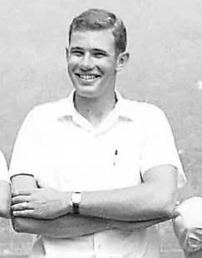Rich Martin: Assistant Sailing Master, Cabin 10 Senior Counselor, Great White Father of the Tribes. Rich was a classic camp counselor—calm, always immaculately turned out in a white shirt, not a hair out of place. Very tall and properly filled out for a young man. Popular with an enthusiastic following. Pretty sure he was Pre-Med or Pre-Law. Had a low-key, active and wry sense of humor expressed by means of an even “Long-Island Ice Tea” sort of twang.

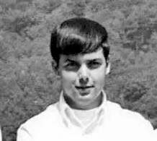Chris Barton: Counselor and Assistant Great White Father of the Tribes. Another classic counselor, but seasoned very differently. Very popular. Had the sense of humor one would expect of an energetic confederate rebel. Being from Georgia, he had the accent and yell to match. Think “Cable Guy”, and you have the audio.

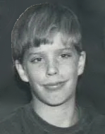John Crystal: Was an older camper or CIT in 1969. Athletic but not overly endowed, brash, energetic and perhaps mischievous. Had some sort of history with Rich. Several times a week he would stop on his way out of the lodge to hurl his best verbal abuse Rich’s way while we table brats were cleaning up. Our leader would roll his eyes, then in his even way, politely give as good as he got. Not that Jim ever indicated that he understood any of the retorts.

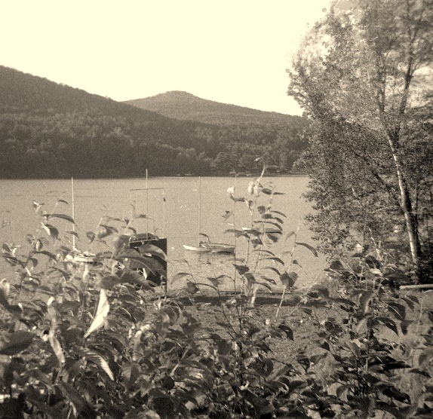Cat Mountain: If you search the Internet for “Cat Mountain”, you will find one not far from Tupper Lake, in the Adirondak Park. You will also find another, just touching Timlo’s Trout Lake. In 1968 we all referred to it as “Bald Top” or “Bald Mountain”. A few years later, learning from the street signs which marked the segmented “Cat Mountain Road” prevailed over ignorance. It is unclear as to which mountain figures in this story—might depend on the gravity of the issue, which could have inspired a confrontation with either.

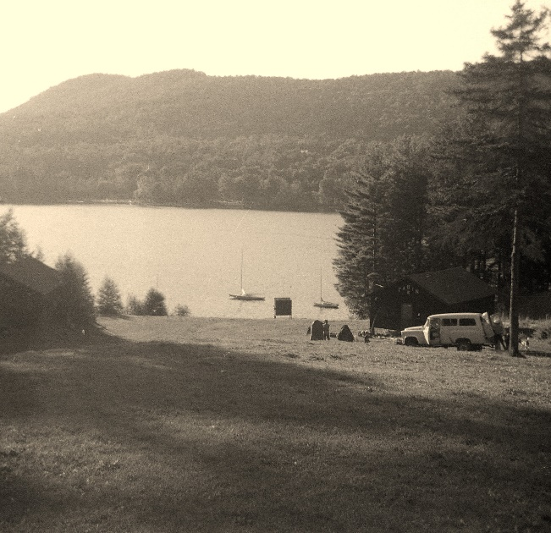Trout Lake: Like the lakes and ponds at any boy’s summer camp, the one bordering Timlo served multiple functions. It was something to sail on, swim in and ski over. It also had a light disciplinary function, to the chant of “XXXX in the lake tonight”. Campers who stepped out of line often found themselves in for a dunking at the hands of their peers. Kind of a good-natured reminder to, “Cool it”. Offense was rarely taken. Of course, camp management had to be strictly against the practice. But, as the policy drifted down to water level, it was modified. Such situations were usually just monitored for safety. Where it looked like a camper could interpret the event as being ganged up on, the event was interrupted. (Most of the campers had a sense of fair-play, just needing the excuse of instruction from “authority” to exit the scene. Also, to the credit of the participants, campers who did not join in were seldom dunked themselves. I deserved a chucking in many times over, but never was. If memory serves, Rick Piverotto held the record for the most involuntary forays into Trout Lake in a single season. Someone in Cabin 7 claimed to be keeping track).

Counselors tried to avoid becoming victims of the practice. Obviously, it was an affront to our authority and dignity. There were also potential injury issues regarding strength and weight relative to that of campers, even in the absence of meaningful resistance.

Which brings us to the beginnings of this story: There was a long Timlo tradition of, after the final Tribal campfire at which deference to the winning tribe at been expressed, that the GWF go for a swim. And perhaps his assistant as well. Much like the traditional Gatorade dousing of a football coach at the end of a season.

Well, that would never do. What to do? What to do?

Act I:

Mid season. Timlo is hosting an inter-camp sport competition (Algonquin? Dark purple or dark blue tee shirts). Lunch is over, the interior of the lodge is cleaned up, we on the porch are finishing our chores. The visiting horde is cut loose: they storm up the stairs, over the deck, across the porch, and into the Lodge for a chance at vittles. While doing so, two figures in matching Timlo Greens break off from the crowd, stop at the foot of our table, and in unison sound their sirens:

“Rich Martin. Rich Martin!”.

Rich looks up, “Oh my God, there are two of them!”

“We are your worst nightmare!” they sing.

Rich’s countenance descends to the table, “I’m doomed”.

That’s right. The Crystal brothers. Twins. Kudos to their parents for mercifully sending them to separate camps. Dress and dialog suggested semi-sophisticated preplanning. With much amazement and laughter from we onlooking campers, that round went to the Crystal clan. Rich was totally blitzed. Of course, additional jousting was on the menu for the rest of the summer.

Act II:

The season is winding down. Tribal competition is settled. The final tribal campfire is in conflagration. With all of the accolades given, the Great White Father steps from the ceremonial tepee into the firelight and announces that he has a story to tell in closing. It went thus:

Not too many moons ago, there was a Great White Father who had a problem. It tormented him daily. Sometimes twice a day. He puzzled as to what to do about it.

He went to the medicine-man. He told him about the problem. The medicine-man said, “You are not sick, I cannot help you. Best to talk to some animals who never seem to have such a problem”.

The GWF found a rabbit. He asked the rabbit for advice. The rabbit said, “I am only a rabbit. I run from problems. Why don’t you try an animal that does not run?”

The GWF encountered a wolf. He told the wolf about the problem. The wolf said, “I am not smart enough to solve such a problem alone. I would have to ask my pack. Perhaps you should talk to the wise old bear.”

The GWF searched out the wise old bear. He told the bear about the problem. Bear said, “I cannot solve the problem. I survive in isolation. Why not consult the Cat Mountain eagle, who from his great height, has a broader view of things?”

The GWF climbed Cat Mountain, and found the eagle. He told Eagle of the problem. Eagle said, “Your problem cannot be solved by those born of mother earth. Take two of my feathers and your problem to the top of Mount Marcy, and ask the moon for guidance”.

As the GWF ascended Marcy to present the feathers, the earth shook, the moon dimmed and the clouds thundered. At last, setting foot on the crest, all became still. Moon said, “I know of your problem! Sun has been consulted. Here is your answer!”

At this point, out of site in the dark from behind the GWF, Chris Barton, in his best Rebel Yell mode, shouted: “CRYSTAL IN THE LAKE TONIGHT!”

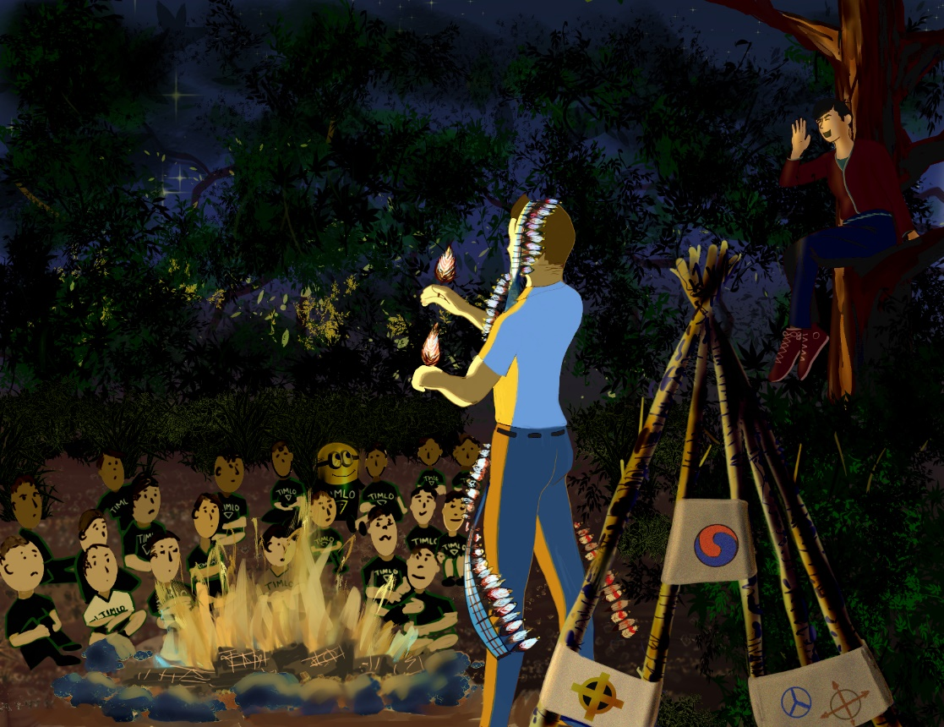

The circle emptied. John was already half way down the hill (he was caught). Rich and Chris exited stage left, remaining dry. As the darkness closed in, we lingering honor braves put out the campfire, in accordance with time-honored tradition.