TIMLO TIME-KEEPTING

1968 Raquette River Trip. Does anyone recall the old camper truck? ‘68 was its last year. Great fun to ride in, but safety concerns were closing in when it came to hauling unsecured children around on benches in the back of an open vehicle. Between all the gear plus two canoes suspended above our knees, we campers were pretty much locked in place. (Timlo’s canoe trailer was in tow).

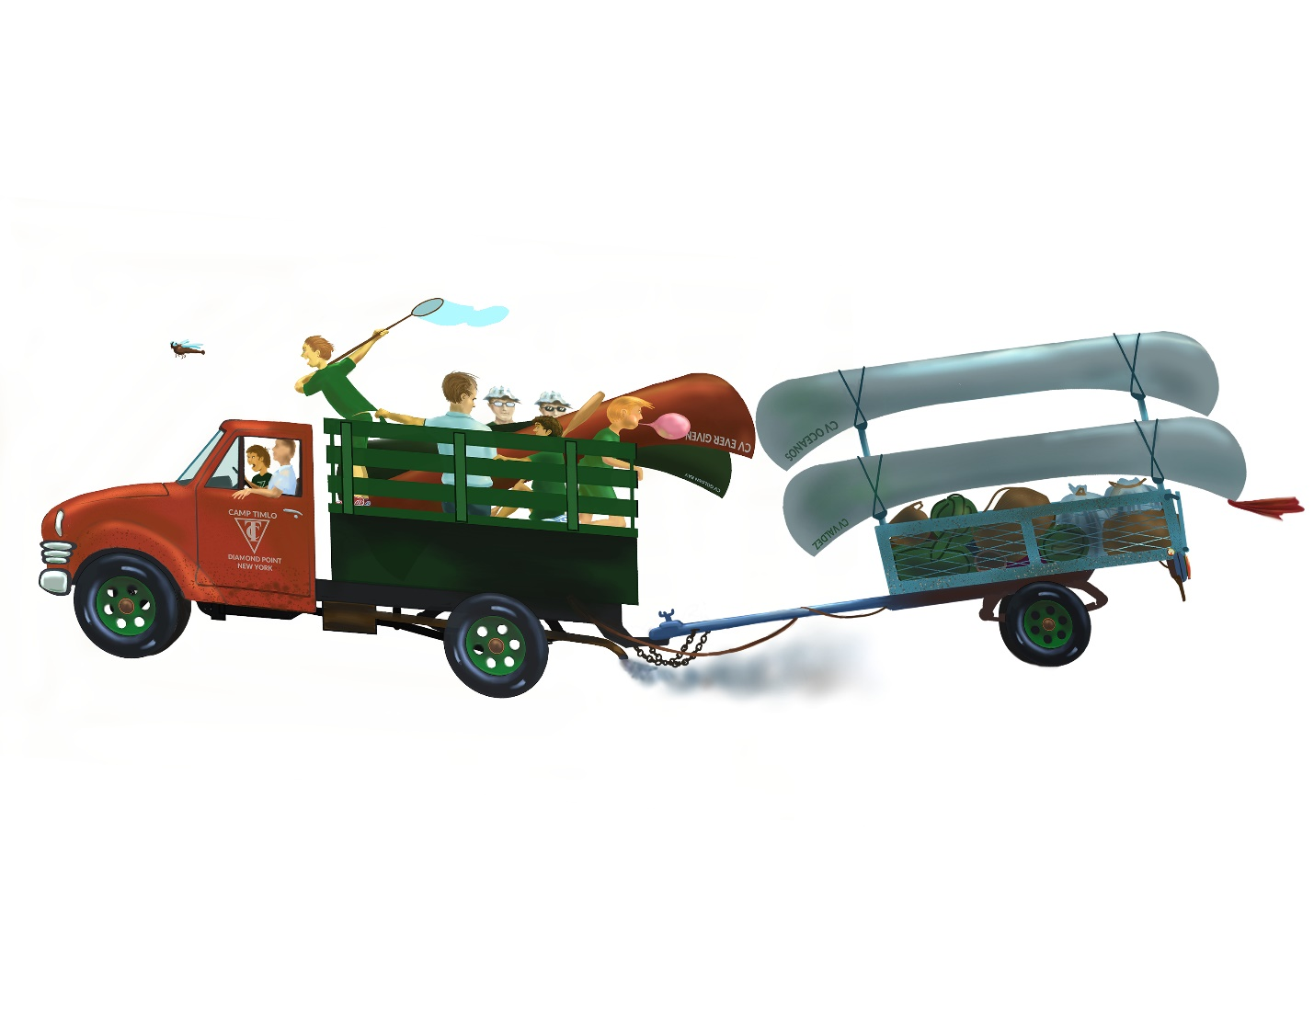The entourage of ‘68 found a wide-spot between some rocks along SR-28, dumped canoes in adjoining Raquette Lake, gear into the canoes, and set off. We had something like eight vessels: five brand new aluminum ones, two wooden green ones, and a rental or two. The aluminum designs were the most watertight and the easiest to carry. The wooden State of Maine products were considered to paddle best in the headwinds which characterized the lake portions of the excursion.

Little did we participants know that a Boy Scout expedition was downloading just around the next bend. We sure found out when we chose from available adjacent primitive campgrounds that night. Every couple of minutes a sports whistle would sound in the scout camp, followed by shouts: “Tweet-tweet: wood detail”, or, “Tweet- tweet: tent detail,” or “Tweet-tweet: clean-up detail”. They had a million of ‘em, which lasted into the night. Near that gang, the wilds of New York were about as serene as the median strip of the Northway. Bah! We thought. Our leaders made quiet suggestions as to the Order of Operations, all the while subtly ensuring that if we wished to eat, the other chores were completed first. All done and fed, on-time, right before sunset.

Next morning, the racket from next door re-commenced. Tranquility could only be accomplished by paddling away as fast as we could.

To no avail. That evening, we were neighbors again. The hullabaloo resumed. It was time to make a point. Somebody found a sports whistle in the luggage, or procured it from a counselor, and a couple campers crept off in the direction of the raucous offenders. Our boys started out with things we had heard. For example, “Tweet-tweet: food detail”. “Tweet-tweet: latrine detail”. The subterfuge faded when the pair started to make things up, like, “Tweet-tweet: bilge detail” and “Tweet-tweet: panty detail”. Our instigators scuttled back to camp ahead of the resulting indignation. There were lots more whistle blowing and tumbling in the scout camp. Could have been dangerous-- those cats across the bushes all carried overpriced BSA approved knives.

The Timlo trip leader, Bruce Campbell, was none too happy with the protest, but he could only get off a few growls. His staff was quietly smirking while we campers were delighted.

Further contest with the Scouts was avoided: the two groups lost each other at one of the longer portages. Our flotilla continued to prove its capabilities, sans noisemakers and lock-step. We were kind of proud of ourselves for that.

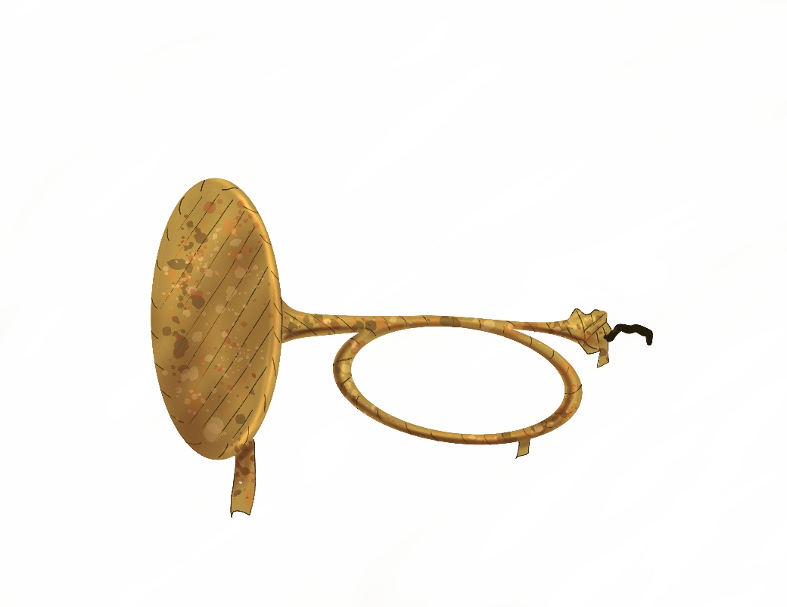Almost the first order of business prior to the first dinner of any Timlo season was for everybody to reset their watches back to “Timlo Time”. Which was simply Eastern Standard Time. The official explanations were that the extra hour of sunlight prior to the wakeup bell allowed the grass to dry, and the earlier darkness made it easier to install the younger campers in their bunks.

Schlegel’s Bugle Bugle

An unofficial reason was that the time change reduced the window of opportunity for those counselors who had the night off to become sloshed in Bolton Landing. (Back then, the drinking age was eighteen. It was not considered possible, fair or expedient to maintain conscripted armed forces populated by participants prohibited from alcohol use. Even during Prohibition, allowances were made for active-duty and veterans. When military forces went professional, that is, the draft ended, the drinking age was quickly raised).

Walden Camp, across the lake, went through no such relativistic contortions. On a still morning, with mist rising off Trout Lake, at 600 am Timlo-Time one could hear their PA system switch on, a phonograph needle drop, then scratch its way across the vinyl to the sounds of a bugle reveille. Most of us rolled over and blessed the, “Extra Hour.” Except Cabin 3. Its guests would already be well into a game of softball out on the green.

One year, Timlo used a real bugle and real player for reveille and flag raising. The player was Tom Farnsworth. By his own admission, he was terrible at the craft. In 1972 Cabin Ten was gearing up to steal the sometimes musical device and bury it. With my professional career having narrowly survived a similar incident with the camp bell (more later) the previous year, these plans had to be diverted. Instead, an effigy of the brass noisemaker was buried as part of a funeral procession during a morning line-up. A pathetic looking papier-mâché and coat hanger bugle stand-in was crafted by Bob Schlegel and a helper. Richard Dunn and company attempted to dig a grave into the two inches of top-soil in the line-up area. Marty Leighton led a funeral procession with the sacrifice presented on a pillow. Half the camp missed comprehension of the gag: too early in the morning, and, where the heck is breakfast? HC Bob Northrop was mostly confused. However, one more camp-crisis was averted. Tom told us later that he would have happily given us the bugle and helped dig its grave. He hated that job.

I think Dave Perry blew taps for us a couple of times. He did it well, but down-played his skill. Too much hassle. Too much flack from colleagues. Such was attitude of the era.

Usually, to keep time, Timlo utilized a large brass bell located on the south side of the Lodge to mark the progression of each day. It rang to start the hated morning exercises, signal pre-meal lineups and pre-activity line-ups, denote activity period changes, plus anything else that could benefit from pre-arranged audio punctuation.

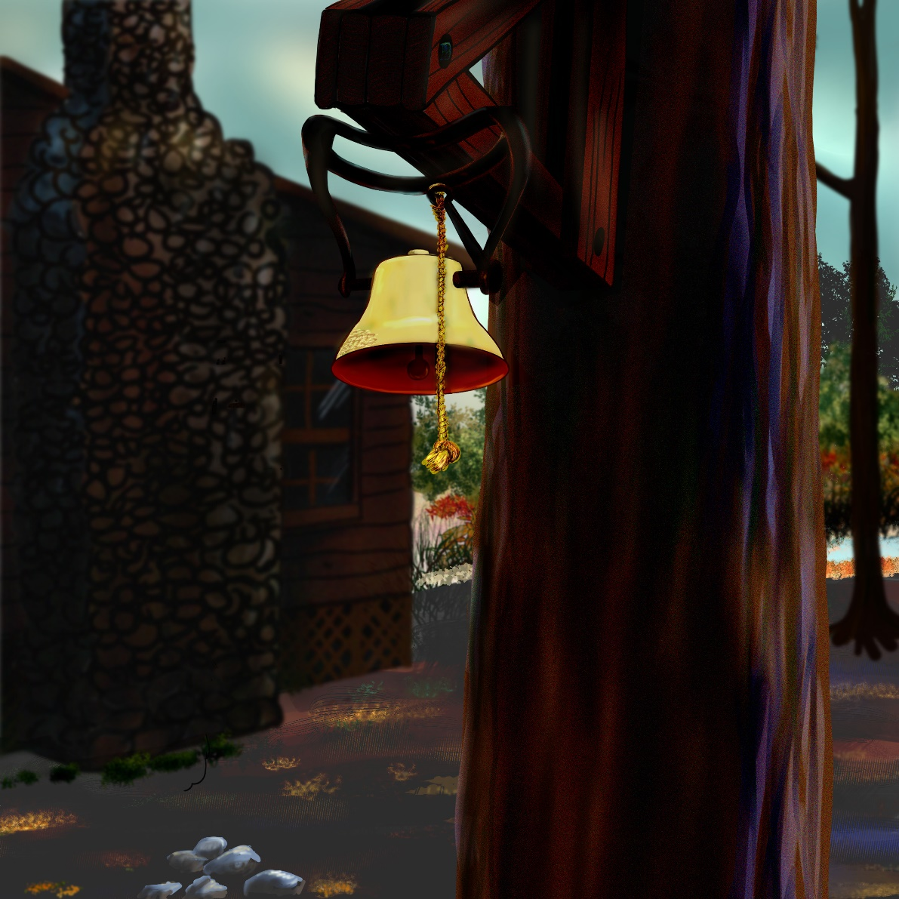

Officially, it was rung by the OD (Officer of the Day: a CIT or Junior Counselor assigned to answer the phone and run endless errands for one of three eight hour shifts). However, other than Reveille, there was usually a crowd of younger campers lurking about, delighted to be set loose and perform the honors.

Campers in the middle age group had a different take on the bell. They could be counted on from time to time to swipe the clapper. Plan B then, was to smack the bell with a rock until the clapper was located or replaced. The little campers could not reach. Dents grew on one side of the bell.

Relocation of the clapper to points unknown inevitably resulted in a sob-story from management. One year, the bell was described as an artifact that made the last voyage on the final paddle-wheel steamboat out of Lake George Village (Not counting the Mini-ha-ha, which steams yet). The next year, the bell was supposed to be on the last train to depart the Lake George train station. We campers caught on to the discrepancy. Thereafter, stories from management were substantially discounted. (Not that they weren’t already. It was the 1970’s. “Don’t Trust Anyone Over Thirty” had morphed into, “Don’t Trust Anyone in a Uniform, wearing a hat, or carrying a clipboard.”)

[Being a life-long fan of industrial archeology, I checked the bell out in detail. It hung upside down from a bell-shaped bracket. Bolts inches thick attached a circular, convex iron base to a triangular wooden truss, which in turn was bolted together to a substantial tree. Given the shape of the iron base, it was likely attached to a boiler of some kind. Possibly a locomotive boiler. It would not have been appropriate for any kind square mounting, such as that of belfry found on a ship, church or school. However, the last-train story has some holes: the Delaware and Hudson scrapped its last steam engine in 1953. The last train left Lake George in 1957. Further, while there were exceptions, the D & H preferred to mount its bells on flat surfaces behind the front headlight. The bell was probably off a locomotive. But, not a local one).

The clappers were expensive--$28 to cast a new one. A bunch of bills back then! Sometimes the sobbing worked and the clapper re-appeared. Almost as often the hardware resumed is place surreptitiously: more than one five-week camper went home with a smug look on his face only to be disappointed during his unpacking process. Occasionally, clapper and camper escaped together. (“What’s that thing, Gram-paw?”). One summer, Timlo experienced something like eight clapper incidents.

In 1975, somebody wised up and welded a little piece of metal to the hook on the clapper, permanently securing it in the bell. How many years did it take to solve the walk-about problem? Why, it is almost as if clapper relocation was a certified camp activity.

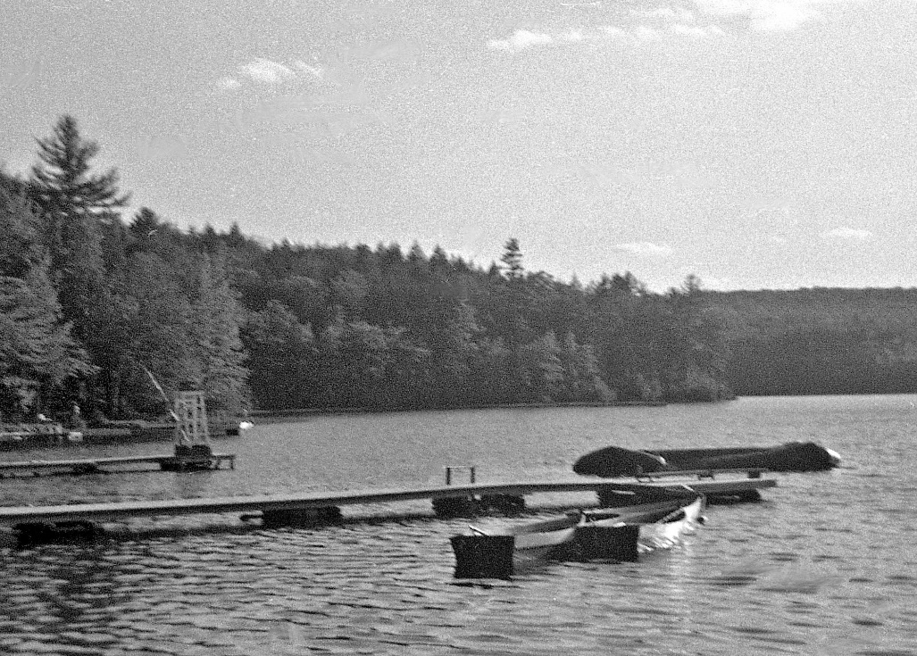

BURIAL GROUND

Have you gotten the idea that respect for authority for authority’s sake was on a serious decline in the 1970’s? In the real world, the protective New Deal programs had devolved into self-serving institutions. The Great Society and War on Drugs was already being seen to combine into something toxic. Republicans advanced to the rear in Vietnam, opened China, signed off on the EPA and instituted rationing and price controls. Watergate. Democrats turned their backs on American workers, favoring open borders and free trade. Jimmy Carter set the stage for de-regulation (Reagan later took credit). The planks of the Party Platforms had been swapped so much that the space between them looked like an Oklahoma trailer park after a twister. Well, participant sentiments at Timlo reflected all that.

To be fair, camp ownership had to cater to where the money was. Running a seasonal business in an era of double-digit inflation was tough. Funding was in the hands of the conservative “Greatest Generation.” Timlo was marketed as a refuge for one’s progeny from rampant liberalism. Outcome: a level of youth rebellion over trivia. A high proportion of the campers liked to pretend they were tough urban kids that spent their winters rioting. We counselors were mostly embracing either a “New Age” or “Everyman for Himself” frame of mind. My theory is that the activism can be traced to the fabled NEW MATH of the 1960’s where a student was taught to draw lines all over a sheet of paper to execute a simple division problem. Well, we post-hippies could not handle arithmetic worth a dam, but with the help of the new $5.98 pocket calculators, there was time and energy left over for discernment. In the Timo universe on the shores of Trout Lake, the rising sentiments were usually confined to endless friction over hair length, Timlo Greens, collared shirts, conflicts with Boy Scouts, and a disdain for bugles.

However, in 1971, Bruce Senn entered the picture, the senior counselor assigned to Cabin 10 (down the slope from the Lighthouse, that year). Barr was skilled at hiring suitable staff. But the process can leak: inevitably someone otherwise slips in. Bruce had to know what he was getting into: he shaved off his beard and shortened his hair prior to setting off on his Timlo summer adventure. Soon however, he was mourning his lost symbology, making endless comments about the John Birch Society and generally resenting authority. A product of his times, version lite. After Parent’s Day, Bruce and Timlo parted ways, but not before he dared Cabin 10 to strike against the Establishment. As a legacy, he outlined a method to steal the bell.

The plot was the worst kept secret in camp. Bruce blathered it everywhere. Everyone, including Dan the HC, knew Cabin 10 was going to make an attempt. What to do about it? Can’t speak for Dan, but for us counselors the answer was, “Nothing.” We had to maintain some sort of street creds if our charges and ourselves were going to achieve any sort of programmed conclusion to the season.

I was the only counselor in Cabin 10 when Bruce left. Knew about the plot. Knew they planned to use the rickety old ladder, kept on hand to open out of reach cabin shutters, to transport he bell. Because of the way the New York State educational system handles birthdays, I was one year older than these kids. On the one hand, some of them could have stuffed me through a knothole. On the other I had access to most of the things they needed to pass their last two weeks pleasantly. Had to be crafty and work with what was presented.

Figured that there was a 50-50 chance the ladder would disintegrate into splinters if it ever felt the weight of the bell. What could not be discerned is how they would unbolt the thing from the truss on the tree. The bolts were inches wide, black with corrosion. I had completed many odd construction and repair projects at Timlo. The craft shop could only offer dull saws, pliers and a couple of drills. The tool shed: shovel, rakes and a bent post-hole digger. In terms of a twisting motions, the sailing department had vice-grips. That was it, save perhaps the out of reach, specially guarded collections of the handymen. Nobody would mess with the handymen. Off limits. And dangerous.

We’ll just see what happens. The bell is safe.

Except 530 one morning Dan was shaking me awake. “It seems your campers stole the bell. Go find it”. I left the campers, no doubt snickering in their bunks, and went outside. Regarding the dubiously accomplished brats, the word was “Later”.

Where to look? Even Dr. Watson could have figured that out. The lazy bed-bugs would not have taken it up hill from the lodge. Nor sideways through staff and camper infested territory. Where would they put it? How would they hide it? (I would have put it in plain sight, under the Lodge. But kids do not think like that. One hopes). Downhill to the waterfront it was.

Locating it took about ninety seconds. Checked the south dock. Nothing. Then the north dock with the diving board. Well, bless their hearts, they had the sense to leave a marker. Tied to one of the log beams, looking completely out of place, was a cheap blue and white braided polypropylene line stretching into the murky depths of Trout Lake, under a considerable amount of pressure. Now what. Well, we’ll see, thinking about my role for the rest of the season.

Dan asked, “Did you see it?” “No”. Not exactly a lie. “I’m thinking it is on the waterfront somewhere.”

Later that morning, the entire waterfront staff searched for the bell.

No one found it. Which was applesauce. All of us were intimately familiar with the diving board area of the north swimming dock. Especially the waterfront staff.

But we counselors were not stupid. Here are the conundrums: How do you finish the season without being the camp snitch? During the last week of camp, Law and Order rests on the fumes of habit. If one becomes totally ineffective (picture your worst ever junior high school teacher), would Timlo even honor your self-sacrifice? Further, and even more immediate, was that if one actually “found” the bell, it was probable that the same one would also have to organize and participate in the recovery party. A lot of grief. A lot of toil. So not fair. Who needs it? Therefore: “What bell?”

Yeah, Timlo ran on Timex watches for a couple of days.

Eventually I held a little meeting with my campers, mentioning that there were some trips they might want to go on—the Katahdin trip had been abolished so they were up for Roquette River, there was still the possibility of a town trip, and there was the sailing trip. Did not expect any of that to have much effect. The buggers already had weighed those consequences out. The new notion I presented was that they would have to explain to their parents why camp ownership might not want them back next season.

The bell was back, next to the tree, the following day.

I was kind of proud of myself, and thankful that my back was not bowed into a pretzel. In retrospect, bet there also was some effective persuasion from either Dan or one of the last few camper-approved counselors. Or perhaps the campers had already made plans to recover it—they did tie it to a rope.

The bell did not make it back on to the tree until two weeks into the 1972 season. That chore took all of the handymen from Timlo and Pinelog, including the giant, Mark Caruso. (One year, saw him sling the 40hp outboard over his shoulder, walk it from the Lodge to the sailing area, and drop it in position on the transom of the ski-boat. By contrast, it took both Rich Browning and myself to struggle downhill with the 10hp version, much to the audible derision of our colleagues. Mark, ever gracious, made no comment).

To this day, I am baffled as to how the Cabin 10 gang unscrewed those big, rusty bolts. That solution; an intellectual exercise for Sherlock Holmes.

shorty