This story has been advanced forward of some others because of a coincidental tie-in with the 2024 summer movie season.

PLAYERS:

Richard (Dick) Russell: 1969 waterfront director. Ancient by camper standards. Forties? One could summer at Timlo as a director if one had the professional standing to attract campers. The duties were light—five hours worth of classes per day plus whatever time it took for planning. Nights were your own, and there were days off to explore the Adirondacks. As for as their relationship with campers, since directors were older and usually from the education fraternity, they held a perceptive slot somewhere between “Coach” and “Assistant Vice-Principle”. (The Hilliers, later arrivals who directed the ski-department, were perceived as gods). Anyway, Coach Russel had the gravitas a camper would not usually opt to mess with.

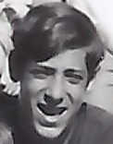Charles Duguay: Ah, the mysterious Charlie. 1969 Cabin 10 member. He was widely known for a penchant for table ketchup. The entire table gasped (except me, I had heard of the practice) when on our first morning together he purposefully dumped the red stuff all over his fried eggs. His preference for the utilitarian sauce extended to many other foods as well, including all known vegetables. Only substances such as Jello and chocolate cake were excluded. Although he may have experimented with the latter. The kitchen was surprising obliging: while they would not put it out if a waiter asked for it in advance of Charlie’s arrival, they would later fill, re-fill and fill again a saucer on request. Charlie was not one of the “Star” athletes, except perhaps at soccer, but above average and consistent. He came in 3rd in the “All-Timlo” rankings, giving those in the outstanding to mediocre categories a life lesson in statistics. Charlie was a Canadien, from Quebec. Pretending that he knew less English language than he let on was a favorite hobby. Sported a classic French-Canadien accent (Not something anyone would term as elegant. Certainly not someone from Paris). He let us think he hailed from Montreal. Perhaps. His Timlo Directory address is of a village halfway between Montreal and Hudson Bay. The medium sized house, perched on substantial ground overlooking a river, is presently a municipal event center. In addition to the cultural significance of its architecture (“Arts and Crafts”), it was built by the natural resources magnet Hector Authier (every hear of “Abitibi Paper”?). From the center’s Web site, I suspect Charlie was the descendant of an in-law. Given all that, the how and why of his arrival at Timlo is a head-scratcher. Kind of a “Get Away from it All” story, flipped.

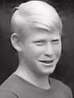

Phil Oppenheim: One of the star campers across many seasons. Excelled in many activities, was better than average in anything he took up. Always gracious and tolerant of his lesser cabin mates. Phil was often a diplomatic influence when tension between two campers or factions was about to get out of hand. He did not insert himself into a situation, but a gentle, often humorous, verbalized perspective almost always diffused it.

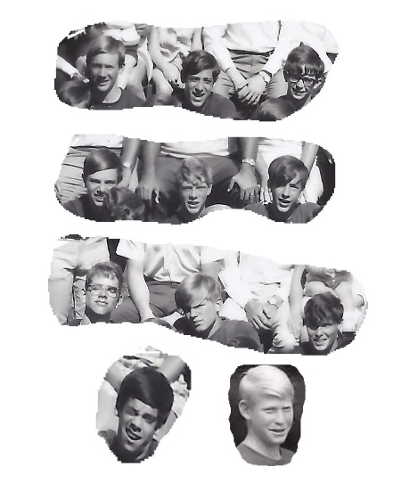1969 Cabin Ten: We were an unusually large group, located in the old boathouse, reactivated that year as a cabin. The plywood windows were pulled down, screens fitted, and we may have had the Timlo patented canvas drapes installed inside. Rain was not much of an issue under the leafy woodland canopy. The joint was never “Shuttered”: we had none. (Thus solving an inter-cabin disciplinary issue). Took two lightbulbs to illuminate the joint and two columns to support the sagging roof. Surrounded by woods and located almost on the lake, the abode was always pleasant. Plus, we were far enough away from the main campus to enjoy an extra measure of senior camper type freedom. Alas, such liberty had a cost—we had to be conscious of time and get a head start up the hill to the endless camp line-ups.

THE STORY:

In the 1960’s the standard for appropriate child minding was nowhere near as intense as it is today. In greater suburbia, unsupervised child commutes to school or town center, with or without sidewalks, were normal. We’d be booted out in the morning, free to roam at will on foot or as far as one could peddle some old tank of a 3-speed Schwin. Meals handled any check-in requirements. Timlo was a bit more careful, with something like seven line-ups of the entire camp and counselor staff in front of the lodge per day. On the other hand, about a half hour after lights out, and if all was quiet within one’s cabin, counselors were encouraged to slip back up to the lodge for the camaraderie of colleagues. Snacks in the form of peanut butter sandwiches and leftovers were even provided. Further, on Sundays, all of the counselor staff was required to attend a 930 pm staff meeting. During the meeting, a director would cruise the campus. From a chair on the stair deck of the lodge. Well, it was more of a job for the ears than the feet.

So, Dick Russell was none too happy when he had to launch downhill to the farthest reaches of Timlo to quiet a noisy Cabin Ten that had gotten itself all wound up. Afterall, at some point, he would have to chug back up that same hill.

Coach Russell arrived, switched on the lights, gave us the standard blah, blah, blah about rest, health and keeping everybody up. Then, for someone supposedly familiar with the characteristics of young men, screwed up. Frustration? Oxygen starvation? Anyway, his closing comment was, “Not a peep! Don’t make me come back down here.”

The lights clicked off. Flashlight and footsteps faded up the hill. Silence ensued. Which we all knew would have a half-life of about five minutes. The seconds ticked on. A minute. Two minutes. Who was going to do it? Three minutes. Who would it be? Mitch? Bill? (You could count on either for that). Then from the south wall, of all people, the Quebecois was heard from: “Shaaddup F—kface!” Only the weakness of steel springs kept us from pitching over out of our beds with laughter.

Possibly realizing the inadvertent setup, Coach Russell had paused partway up the hill. He was back in the cabin in seconds. “Who said it!” he demanded. Silence. Get real, no-one was ever going to give up a cabinmate. Social suicide, just for starters. At least he did not say something dumb like, “I’m not leaving until you tell me.” He would have spent the night. Wisely, Coach stood there and waited. And waited. Eventually Charlie said, “I did”. “Was it really you?” checking to make sure he was not dealing with a noble sacrifice. “Yes”. “What did you say?” Silence. And then in broken English, Charlie told him.

We all saw it coming. Two trains were about to execute the sort of cornfield meet which could devastate a summer. We campers were silent. Coach was silent. It was, as was often the case, Phil Oppenheim, who found a way to avoid the crisis:

“Aw Coach, he didn’t know what he was saying.”

“How so?”

“Charlie is from French Canada. He does not understand half of anything.”

“Is that true?” inquired Coach, seizing the opportunity.

“Oh yes”, we all exclaimed. “He has a big problem that way!” (He didn’t).

“Charlie, do you know what you said?”

“Said what?”

“Just don’t say it again.”

Coach and flashlight turned around, climbing away up the hill. Neither returned. Cabin Ten quietly went to sleep.

EPILOGUE:

Over the ensuing fifty odd years, when reviewing memories, I always thought it might be possible that Charlie really did not know the import of what he said. Afterall, I never again encountered the expression again down here in the lower forty-eight.

However, just this summer (2024), the epitaph turned up, after the movie credits rolled, in the final Easter egg rant of “Deadpool 3”. Almost the last comment by “Johnny Storm.” Plus, the jokes involving the character “Wolverine”, were written with a certain amount of Canadian content.

Did someone from Cabin Ten go on to be a screen writer? Or, is the expression a fairly common one up north? Eh?