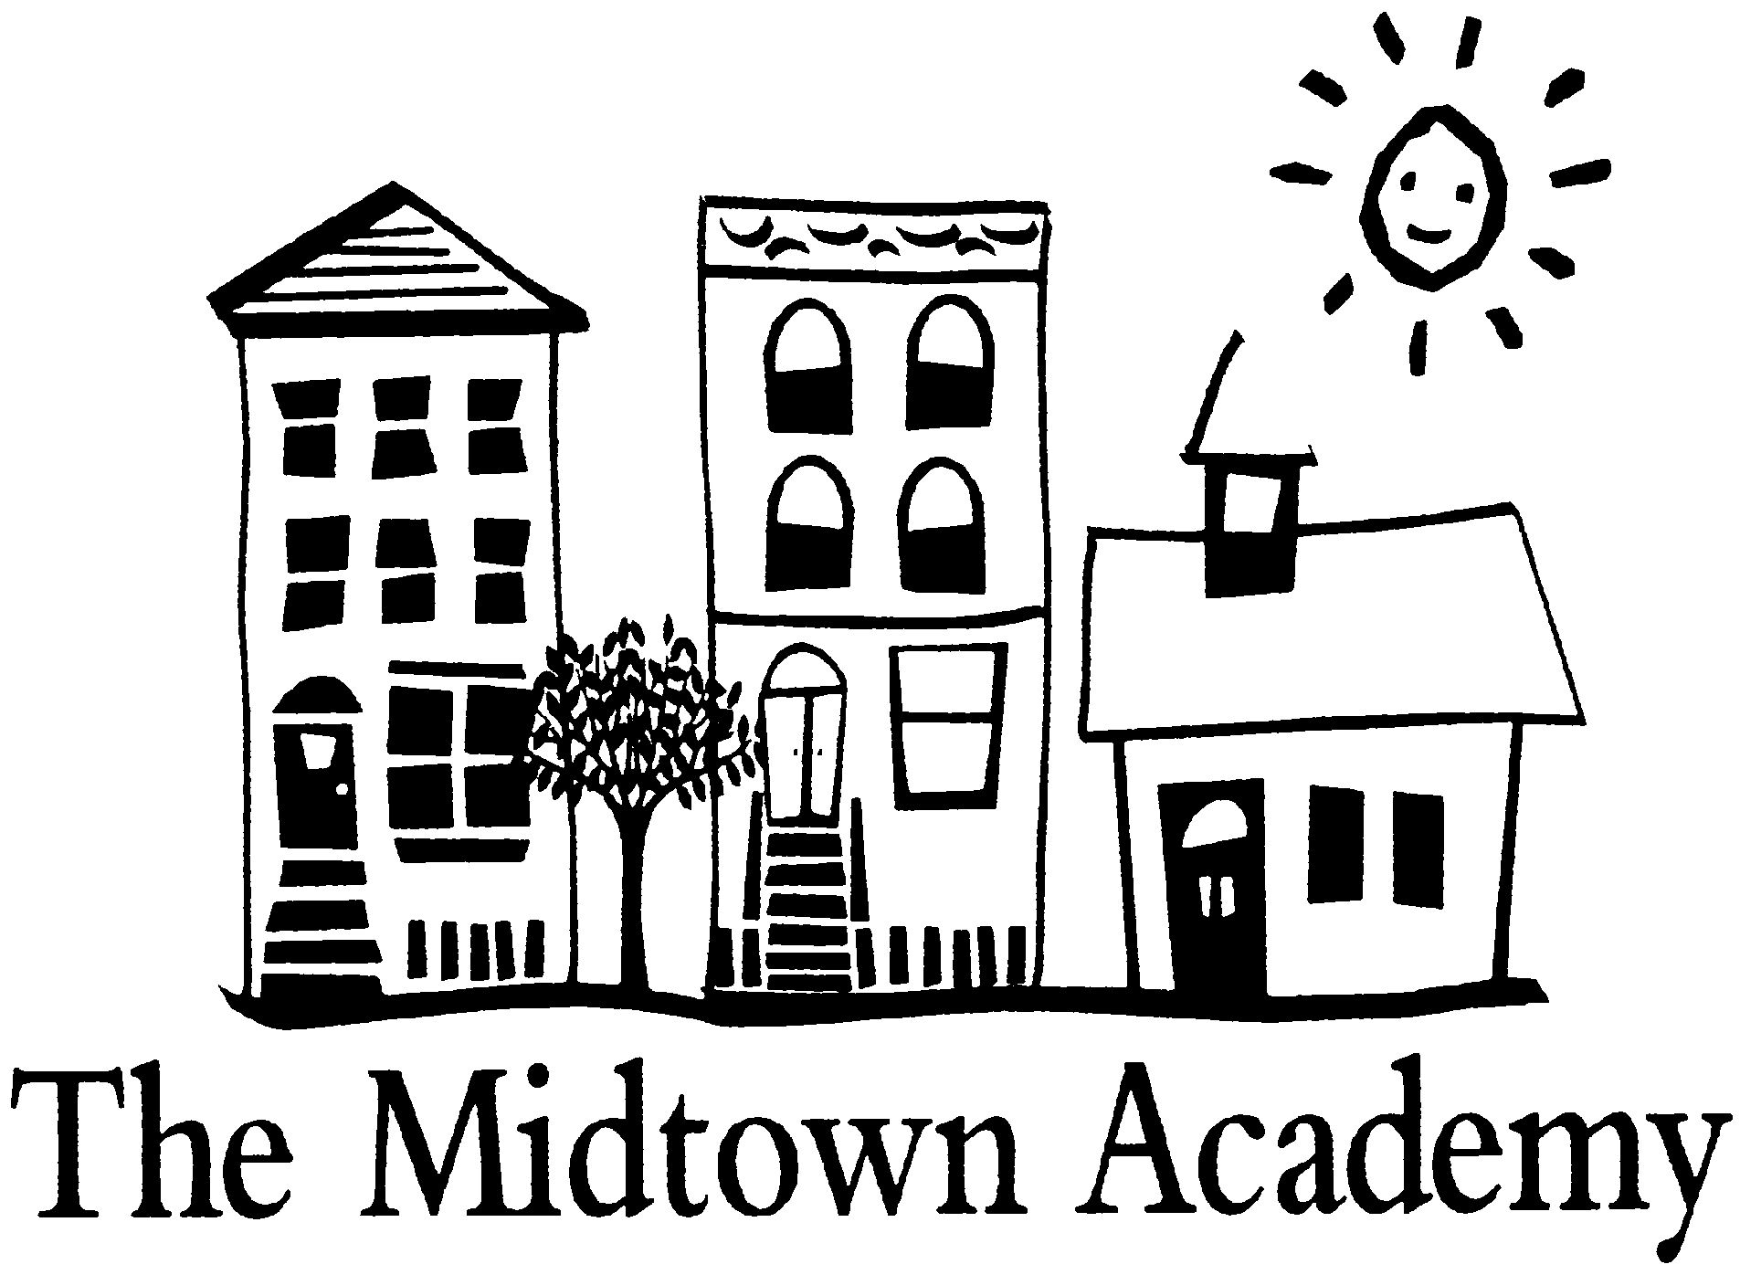

2022-2023:

___BH Received_________

___RH

___MBD **LATE Application**

___CW **Received**_________

For Office Use Only

…uniting diverse communities, igniting an enduring passion for learning, developing outstanding global citizens

*1398 Mt. Royal Avenue Baltimore, MD 21217 Phone: 410-225-3257*

www.themidtownacademy.org

# APPLICATION

**Deadline for submission to be considered for the 2022-2023 admissions lottery is February 2, 2022.**

**PLEASE PRINT ALL INFORMATION CLEARLY- INCOMPLETE APPLICATIONS WILL NOT BE PROCESSED**

___________________________________________________________________________ ___/___/___

Student’s Last Name First Name Middle Birth Date

**August 2022** my child will enter grade: K 1 2 3 4 5 6 7 8

For planning purposes only: _____Male _____Female **BCPS Student ID #** (if known)__________________

My child’s current school is: ____________________________________________ Years attended________

Previously my child attended: ___________________________________________ Years attended________

Do you have other children currently attending The Midtown Academy? No___ Yes ____

Siblings applying to The Midtown Academy for the 2022-2023 school year:

Name: _______________________________ Grade entering August 2022 _______________

Name: _______________________________ Grade entering August 2022_______________

Name: _______________________________ Grade entering August 2022 _______________

***(You must complete a separate application for each sibling.)***

**Legal Guardian One:** __________________________________________ Relationship: _________________________

Address: ________________________________________________________________________________

________________________________________________________________________________

______________________ __________________________ __________________________

Home Phone Cell Phone Work Phone

________________________________________________ __________________________

E-mail Address Fax

**Legal Guardian Two:** __________________________________________ Relationship: ________________

Address: ________________________________________________________________________________

________________________________________________________________________________

______________________ __________________________ __________________________

Home Phone Cell Phone Work Phone

________________________________________________ __________________________

E-mail Address Fax

Does the student live in Bolton Hill, Reservoir Hill, or Midtown Benefits District? If so, please check below:

* Bolton HIll
* Bolton HIll
* Bolton HIll

Bolton Hill Reservoir Hill Midtown Benefits District

Does either guardian work in Bolton Hill, Reservoir Hill, or Midtown Benefits District? If so, please give company name and

address: _____________________________________________________________________________________________

**School Information**

How did you first hear about The Midtown Academy? ______________________________________________________________________________________________________________________________

Parent/Guardian’s Signature: ___________________________________________ Date: ___________________________

**Applications can be mailed or emailed. Faxed applications will NOT be accepted.**

**Send applications ATTN: ADMISSIONS APPLICATION**

**Mail: 1398 Mt. Royal Avenue, Baltimore, MD 21217**

**School Telephone: 410-225-3257, ext.0**

***An email receipt will be sent to you when Midtown receives your application. If you do not receive the email within two weeks of submitting your application, contact the office at 410-225-3257***

**Thank you for considering Midtown Academy as your Baltimore City public charter school of choice.**

**The Midtown Academy virtual lottery date for the 2022-2023 school year:**

**Monday, February 7, 2022 at 10:00 AM.**

**If your child’s application is not selected for the 2022-2023 school year, and you wish to apply for the following school year, *you must fill out another application*.**

**Applications do NOT roll over from year to year.**

***As per Baltimore City Public Schools, all kindergarten applicants must be 5 years of age by September 1, 2021. All openings (Kindergarten – 8th grade) are filled by Baltimore City residents first, and in accordance with The Midtown Academy’s admissions process. If additional openings are available, applicants from outside of the city will be contacted.***

Baltimore City Public Schools does not discriminate on the basis of race, color, ancestry or national origin, religion, sex, sexual orientation, gender identity, gender expression, marital status, disability, veteran status, genetic information, or age in its programs and activities and provides equal access to the Boy Scouts of America and other designated youth groups.