PLyometric quick tip sheet

what is plyometrics?
- Exercise involving repeated rapid stretching and contracting of muscle to increase muscle power.

Phases of plyometrics:

Phase 1: Eccentric Pre-stretch – the pre-loading phase.

Phase 2: Amortization (Time to Rebound) – time from the stretch to shortening of muscle.

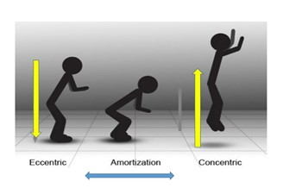
Phase 3: Concentric (Shortening phase) – resultant power production phase.

Theoretical training benefits:

Ability to increase average power and velocity

Increased peak force and velocity of acceleration

Increased time for force development

Heightened levels of muscle activation

clinical guidelines when beginning a plyo prograM:

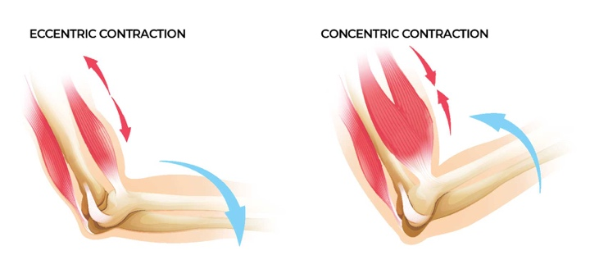
Things to be considered:

Patient age

Injury history

Type of injury

Foundational strength

Resistance training experience

Contraindications for plyo training:

Pain

Inflammation

Acute or subscate sprains

Joint instability

Soft tissue limitations (from a surgery etc)

Lacking foundational strength or training base


examples of testing prior to plyos as well as volume reccomendations:

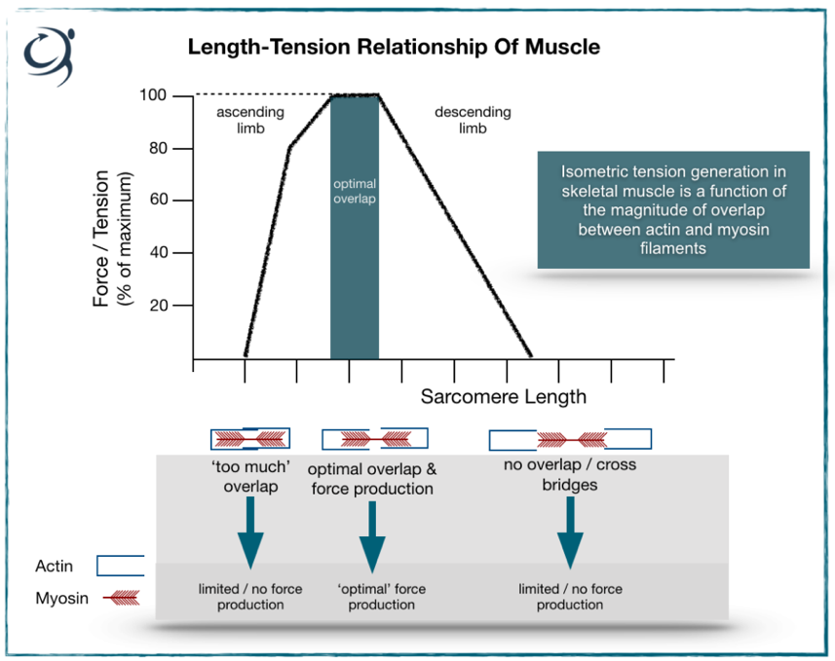
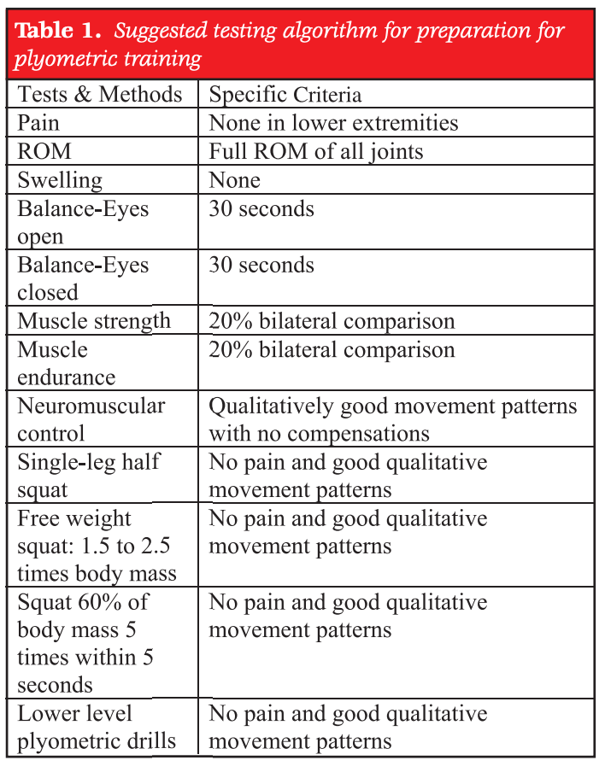

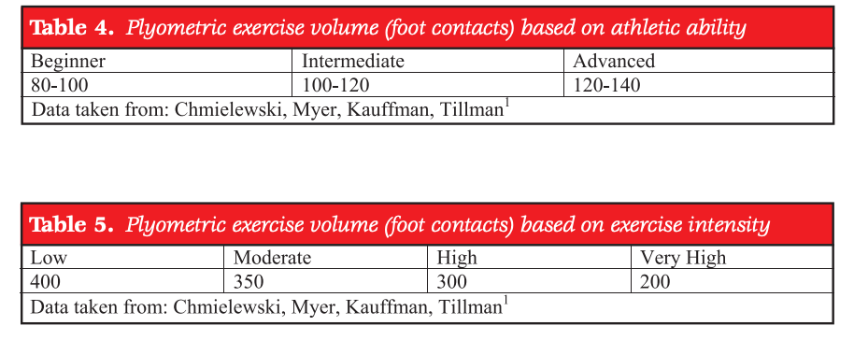

Sources: this is a synthesized document, all concepts are from the citation below

Davies G, Riemann BL, Manske R. CURRENT CONCEPTS OF PLYOMETRIC EXERCISE. Int J Sports Phys Ther. 2015 Nov;10(6):760-86. PMID: 26618058; PMCID: PMC4637913.

