programming for strength and conditioning

what principles drive the desired strength adaptation?

Overload: a stimulus of sufficient strength, duration, and frequency as such that it forces change.

Variation: manipulating training variables that alter the overload stimulus.

Variables: exercise type, order performed, intensity (% of rep max), sets, reps, and rest periods.

Specificity: the competition/sport you are training for impacts what needs to be optimized for training (mechanical, metabolically).

I.e. football players experience 7-10 seconds of max effort followed by 20-60 seconds of recovery. The training should seek to optimize that effort window.

Load:

What will look to drive adaptation.

In the physical therapy/performance world, a method of modification based on relevant feedback is important.

A popular method is Daily Adjusted Progressive Resistive Exercise (DAPRE). This allows for more flexibility than the more traditional approaches.

This approach is a zone-based approach and focuses on strength/power, strength/hypertrophy, and hypertrophy.

This approach uses Rate of Perceived Exertion (RPE) as a measure of session intensity as well as specific exercise intensity.

RPE is particularly useful in rehab, since it allows for monitoring intensity w/o having to establish a 1 Rep Maximum (1 RM).
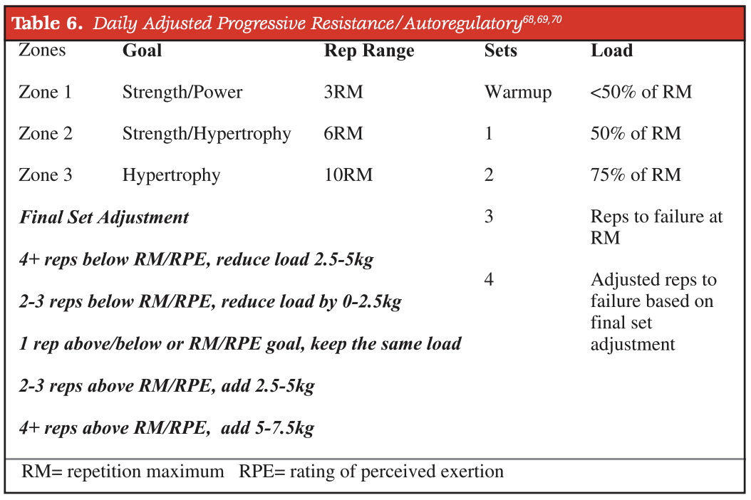



strength:

Should be considered fundamental to all other aspects of training and forms the FOUNDATION of most successful Return to Play (RTP) approaches.

Defined as the ability to produce force. Typically measured by a 1 RM or by taking a % of RM to failure.

Strength and the ability to rapidly produce high levels of force are closely correlated, thus the initial emphasis when training should be on maximal force development.

Force development improves because of an increase in cross-sectional area of muscle tissue (CSA) and changes in neural drive (how fast the muscles can respond from the stimulus).

Loads approximately >80% of RM in trained individuals should build the foundation of most programming for strength.

Also, 3-4 sets of approximately 8 sets/muscle group.

If multiple sets aren’t an option, single set training taken to failure is still a sufficient stimulus to elicit significant changes in strength and hypertrophy.
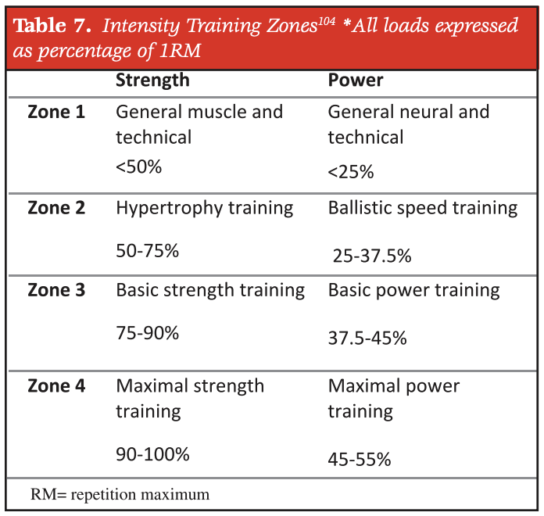

Power:

Many aspects of sports and daily life require the ability to produce high magnitudes of force in short periods of time.

Defined as the rate at which work is performed and is the product of force and velocity.

In rehab, power is important because it can decrease a person’s fall risk, and it is what allows athletes to return to sport post injury/surgery.

In athletes the ability to produce high power outputs w/ a high rate of force development is a critical aspect of success in sport.

Power can be divided into 3 different subcategories:

Muscular strength

Rate of force development

Maximal force at high velocities of movement

A mixed methods approach for load appears to be the most beneficial for power (50-70% of 1 RM and <50% of 1 RM).

Considered optimal because it combines heavy resistance training w/ higher velocity work so that power is developed across the entirety of the force/velocity spectrum.

For the novice strength development alone is sufficient for power improvements.

Maximal strength levels will always constrain the upper limits of maximal power output. The ability to generate force rapidly is less useful if the level of force generated is below a threshold.

Optimal load training indicates that training loads should be chosen to allow for maximal power output.

It is imperative that you do not neglect higher load work, because that is what will lead to higher power outputs.

All exercises should be performed as rapidly as possible regardless of the actual speed of exercise.

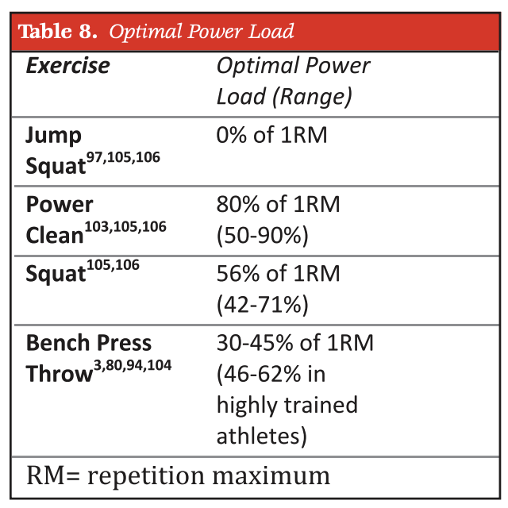
An example of some recommendations for power training intensity zones based on a variety of exercises commonly used to improve power:

Sources: this is a synthesized document, all concepts are from the citation below

Lorenz D, Morrison S. CURRENT CONCEPTS IN PERIODIZATION OF STRENGTH AND CONDITIONING FOR THE SPORTS PHYSICAL THERAPIST. Int J Sports Phys Ther. 2015 Nov;10(6):734-47. PMID: 26618056; PMCID: PMC4637911.

