Periodization of strength and conditioning quick tip sheet

what is periodization?
- The planned manipulation of training variables (load, sets, and repetitions) to maximize training adaptations and to prevent the onset of overtraining syndrome.

Types of Periodization:

Linear Periodization: a model that is based on changing exercise volumes and load across several predictable mesocycles.

Undulating Periodization: a model that is based on that volume and load are altered more frequently (daily, weekly, biweekly) to allow the neuromuscular system longer periods of recovery as lighter loads are performed more often. There are more frequent changes in stimuli.

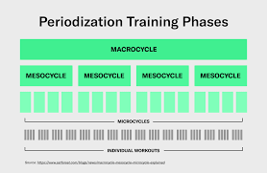
Block Perioidization: this involves highly concentrated, specilialized workloads. Each step in the training cycle has a large volume of exercises focued on specific, targeted training abilities to ensure maximum adaptation.

Linear periodization:

Broken down into distinct blocks:

Macrocycle: planning over a 12-month period.

Mesocycle: planning over a 3–4-month period.

Microcycle: planning over a 1–4-week period.

Advantages:

Rep and loading schemes are predictable for both athlete and PT.

Helps ensure that each training parameter (strength, power, etc) is address in stepwise progression.

Disadvantages:

Originally designed for competitions that have a time to peak at, for athletes that play multiple sports or that have multiple competitions in a season, this may not be optimal as the athlete’s tolerance to loading may undulate based on injuries or frequency/intensity of competition.

Maintenance of specific training parameters is difficult once an athlete transitions into another phase.


I.e. a strength to a power phase

Example of Linear Periodization:
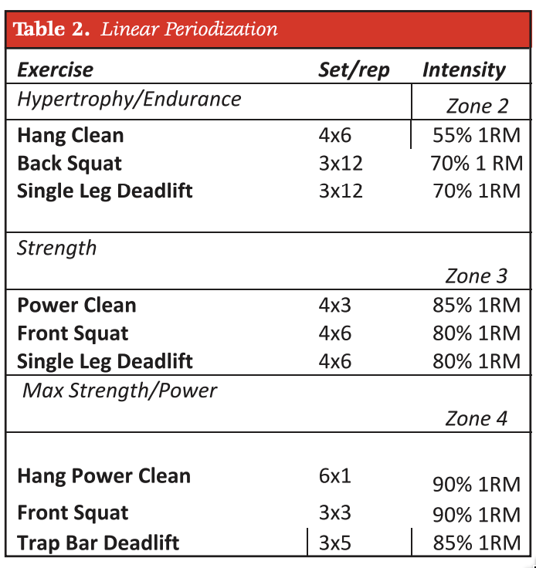

undulating (non-linear) periodization:

In this model there are more frequent changes in stimuli.

These more frequent changes may be highly conducive to strength gains.

Advantages:

Weekly fluctuations in training loads may lead to better neuromuscular adaptations compared to linear (more unpredictable loads)

Accounts for the need for modifications in the training program based on the athlete’s recovery from competition or training session.

Several training parameters may be addressed at the same time.

Can address power and strength within the same week.

The concurrent nature of the training may allow you to avoid some of the detraining effects that you would see in an LP approach.

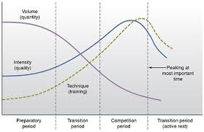



Disadvantages:

In the recovering athlete, it may not be appropriate to engage in lifts that focus on power development, if an appropriate strength base has yet to be achieved/established.

It also may not allow for each performance characteristic to be optimally developed due to focus on multiple parameters at once.

Examples of Undulating Periodization:

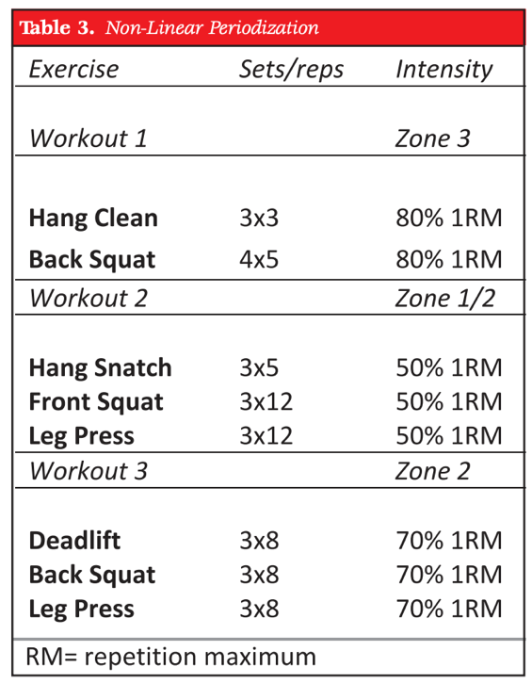

block periodization:

A renewed interest as of late in the strength literature.

Broken into 3 stages:

Accumulation phase: building work capacity; higher vol of exercises performed at 50-70% of 1 RM. Lasts 2-6 weeks, typically.

Transmutation phase: specific exercises w/ greater loads, comprising 75-90% of 1 RM.

Realization phase: more specific movements than transmutation phase w/ loads at 90% of 1 RM or greater.

In some cases, there is a week of reduced loading and vol following phase 2 to allow for recovery.

This system allows for specific qualities (strength, power, etc.) to be maintained throughout the year. This is known as the long-lasting delayed training effect.

In the block approach if an athlete doesn’t require endurance for their sport, it is not a focus of training.

In this approach you can follow up a strength training exercise with a similar plyometric exercise.

Broken down into 2–4-week blocks.

More research is needed in comparison between the other methods of periodization to discern true advantages and disadvantages.

Examples of Blocked Periodization:
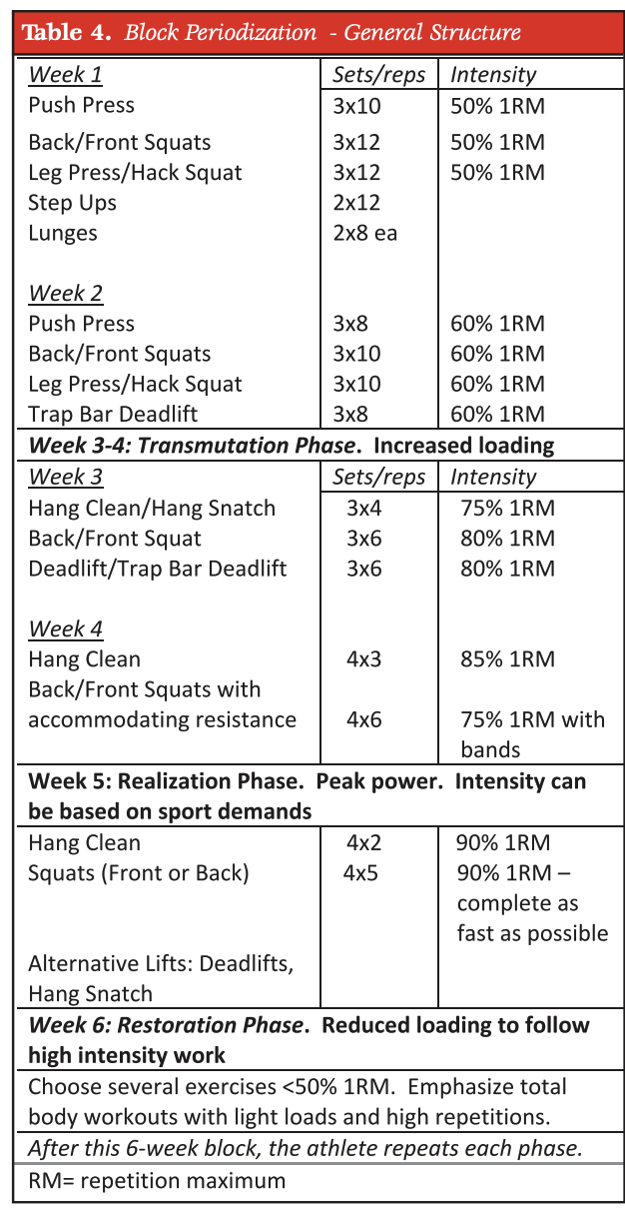

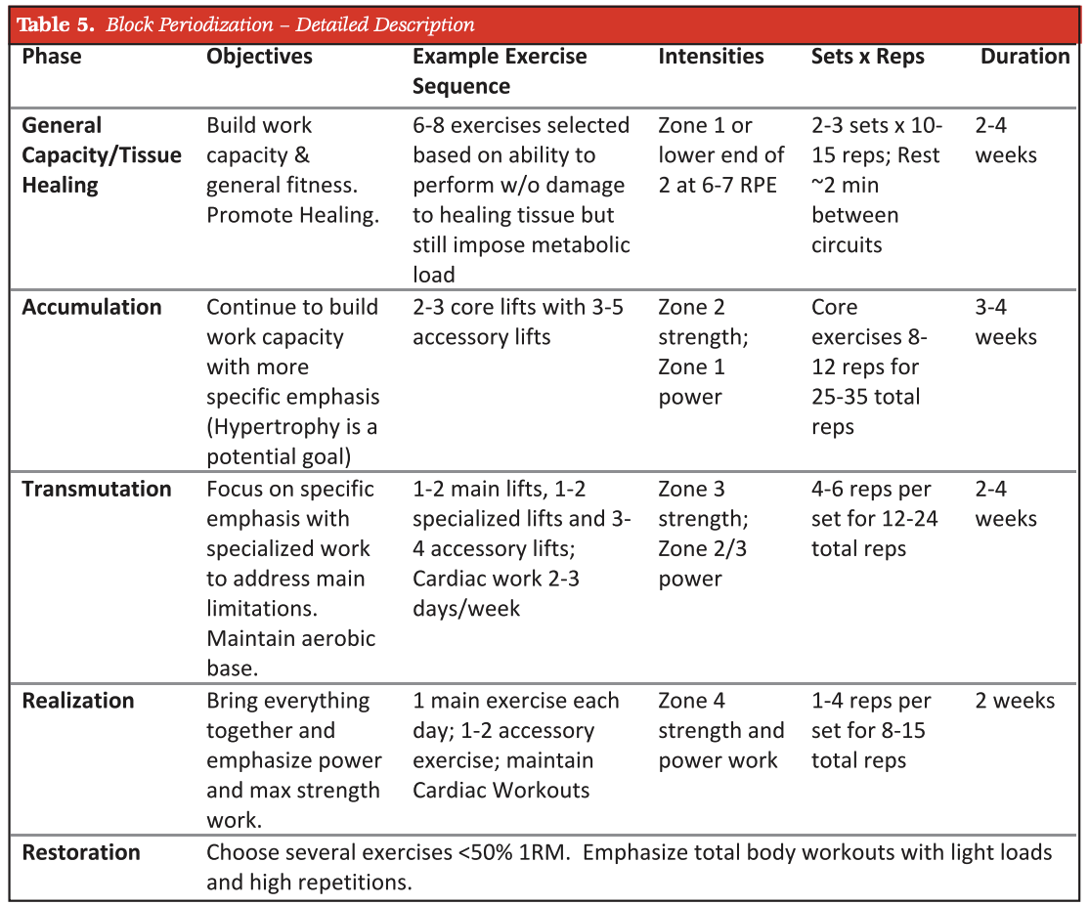

Sources: this is a synthesized document, all concepts are from the citation below

Lorenz D, Morrison S. CURRENT CONCEPTS IN PERIODIZATION OF STRENGTH AND CONDITIONING FOR THE SPORTS PHYSICAL THERAPIST. Int J Sports Phys Ther. 2015 Nov;10(6):734-47. PMID: 26618056; PMCID: PMC4637911.

