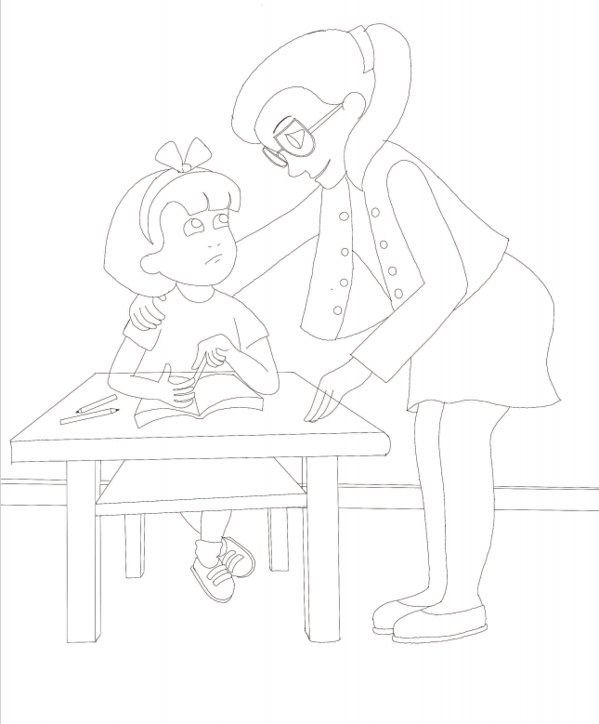

BELLA’S BUTTERFLIES © CHRISH VINDHY
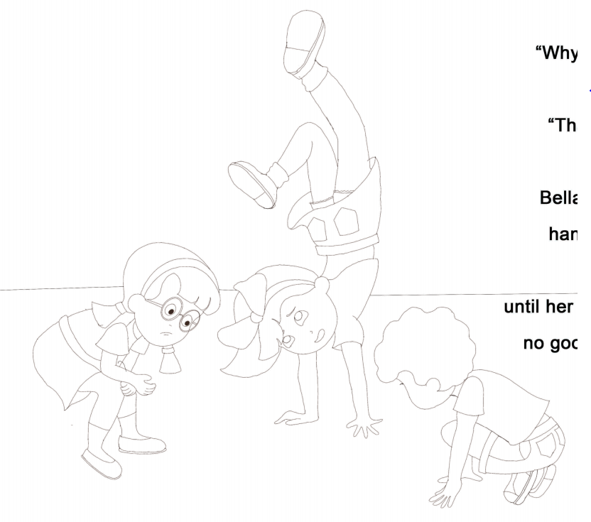

BELLA’S BUTTERFLIES © CHRISH VINDHY

