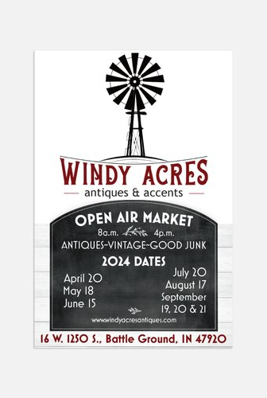
2024

Information for Vendors
Thank you for your interest in our annual Open-Air Market. Please see the bullet points below. We appreciate our vendors and their willingness to follow some guidelines to help keep our market running smoothly, keep our customers happy, keep everyone safe, and keep the facilities clean.
1. Open Air Markets will run on the 3rd Saturday of every month, starting in April with the last market in September on the weekend of Apple Popcorn Festival in Brookston.
2. Market runs from 8a.m. to 4p.m. Vendors are encouraged to stay for the entire market. Vendors who consistently leave early will not be allowed to return.
3. Set up starts at 6am. Do NOT start setting up until you check in with our staff. Must be torn down by 5:00pm.

4. We accept the following vendors:
-antique dealers
-vintage resellers
-artists & makers
-farmers/seasonal produce

-food trucks (must be licensed in WHITE COUNTY)

-boutiques

Please avoid “garage sale” type items. Sorry, no direct sales.
5. Spaces are approximately 10x20. You may pay for more than one space. Trailers and tents are allowed. Spaces are first come first served.
6. Pricing is as follows:
$25/space. Fee collected day of. Pricing for Apple Popcorn Festival weekend TBA.
There are NO refunds provided. We do NOT have rain dates.
7. Vendors are responsible for bringing their own change. We will not provide change in the shop. There is WiFi available if you collect electronic payments. Password is windy22!
8. Vendors are also responsible for keeping their area clean and disposing of their own trash. Vendors found to be “dumping” trash or unsold items at the shop will be asked to not return.
9. Please leave your trailer/vehicle in or near your space. Parking in our gravel lot will be for customers only.
10. Restrooms are available in the shop. Soft drinks and water are available for sale inside the shop.
11. If you bring children, they must be supervised.
12. Your booth is your responsibility. We are not responsible for your items in any way.
Any questions or inquiries can be directed to Windy Acres Antiques & Accents:
(765) 735-7435
windyacresantiques43@gmail.com
www.facebook.com/WindyAcresAntiquesandAccents
on Instagram @windyacresantiques_accents

