WINTER NEWSLETTER 2025
Welcome to our Winter Newsletter for 2025. We have been working hard behind the scenes, new staff, change of classes in the gym and more.
Allied Health News
We have some exciting news – Our provisional Psychologist Storm is now a Registered General Psychologist. We are extremely proud of Storm and all her hard work.
Psychology
Our newly registered General Psychologist Storm Drabsch is part of the family now and her books are filling fast. Storm has experience in NDIS and works with clients of all demographics. Storm has a passion to help assist clients with their challenges, by utilizing current strategies and CBT, to improve the client’s mental health and overall wellness.
Our General Registered Psychologist Michael Gordon is as popular as ever and his books are currently full until the end of July. Michael has experience working across a life span, including adolescent and adult clients. Michael has a range of interest areas that include self-management and goal-oriented behaviours, physical health and eating disorders.
Katie Murrell’s passion and Btransformed’s vision is to help all with improved wellness and quality of life. A Wellness Program that focuses on overeating and undereating is in the final stages of planning and will be offered to clients that want to improve their overall health, with the direct assistance of Psychologists, Dietitians and Exercise Professionals. Details of this course and the client’s eligibility will be sent to clinicians in the near future.
Katie’s books are currently full until August, however there is availability for Eating Disorder clients.
Please note that consultation fees apply. If you have any questions or concerns about fees, feel free to contact our reception team.

Dietitian
Kym Connolly is an Accredited Dietitian and Diabetes Educator with 15 years of experience in private practice. She has a broad knowledge across nutrition for chronic health challenges, and specialises in women’s health through their 40s, 50s and beyond. She is passionate about empowering men and women to take back control of their health and age with strength and vitality.
Kym currently works from B Transformed every Tuesday and every second Monday.
Teonie Buchanan is an Accredited Practicing Dietitian and has clinical specialisaton in the following :
Credentialed with ANZAED in Eating Disorders
Certified in :
- Nutrition and Mental Health
- Dialectical Behaviour Therapy and Eating Disorders
- Paediatric Disordered Eating in Practice
- Monash University IBS Management
- Gastroenterology Nutritional Management
- Medical Nutrition Therapy in Food Allergy and Intolerance
- Food Allergy Prevention
- Women’s and Children’s Health
Clinical practice includes supporting diabetes, hyperlipidaemia, renal function, menopause nutrition, fitness and weight management.
Teonie participates weekly in Multidisciplinary Team Case Conferences to ensure patient access to a holistic approach of integrated care.
Teonie currently works from B Transformed every second Wednesday.
B Transformed is currently taking referrals for Psychology, Dietitian, Diabetes Education, Eating Disorder and Speech Pathology (Literacy only). We also accept Plan or Self-Managed NDIS Clients. Please refer to our website for more information regarding consultation fees.

Speech Pathology
Fact: The English language is often considered as one of the most complex languages to learn to read and spell. With its myriad of irregularities and exceptions in spelling, and baffling grammar and sentence structure, it’s no wonder that so many children (and adults) find it so challenging.
Did you know that speech pathologists can play a crucial role in supporting kids with literacy difficulties?
Our Speech Pathologist, Alison Marsh, has made the move away from the provision of general speech pathology services, to focus on supporting clients with literacy challenges. Through targeted assessments and evidence-based interventions. Alison is supporting school-aged children to build their skills and confidence in reading and spelling.
There is nothing more wonderful than watching a struggling reader, read their very first book!
Other News
Recently we welcomed Mark from Key Solutions to Health on board here at B Transformed.
Mark treats a wide range of conditions including back and neck pain, muscle and joint issues. Treating the body as a holistic unit Mark’s knowledge and skills also allow him to assist with treating nerve dysfunction, circulation, and the respiratory system.
His approach is rooted in a deep understanding of the interconnectedness of the body, ensuring each patient receives personalised treatment tailored to their specific needs. Whether you are seeking relief from chronic pain or recovering from an injury, Mark is dedicated to helping all ages achieve optimal health.
At KSH, we believe in a holistic approach to wellness, not only addressing the symptoms but also the underlying causes of discomfort.
By considering the entire body system, Mark aims to restore balance and function, promoting long term health benefits.
Discover how Mark’s comprehensive care can empower you to unlock your potential to enhance your quality of life through effective hands on techniques, treating all body systems for comprehensive health and wellness.
Since retiring from a 38 year career as an Osteopath, he continues to offer his experience and skills as a Physical Therapist with great success for his patients. Throughout his career, Mark has lectured at Southern Cross University, had over 30 associates, very successful clinics and continues to mentor colleagues today.
He feels he has a duty to help educate and assist people to achieve health and wellbeing.
Mark can be contacted on 0436 015 849 or docbones25@gmail.com
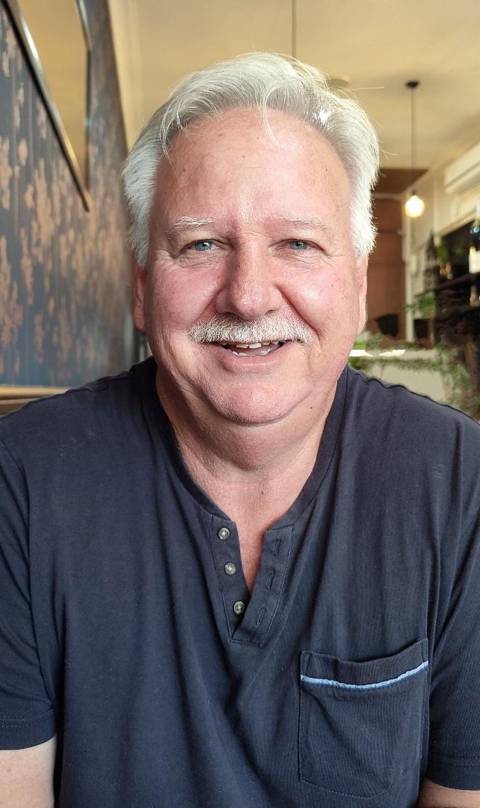

Supporting Women’s Health Through Menopause – Group Fitness at B Transformed Fitness Clinic.
At B Transformed Fitness Clinic, we’re passionate about helping women feel strong, confident, and supported through every stage of life – including the transition through menopause.
We’ve developed a range of classes specifically designed for pre and post-menopausal women to support bone density, manage body composition, enhance mental health, and promote long-term wellbeing:
IGNITE 50 Circuit - A functional, low-impact circuit designed to boost energy, mobility, and strength in women of all ages. Ignite50 combines resistance training and cardio intervals, with movements that are fully scalable – perfect for both seasoned fitness members and those new or returning to exercise.
StrongHer – Targeted strength training focused on improving bone and muscle health, supporting hormonal balance, and building body confidence.
K.O. Cardio – a fun, empowering boxing-inspired workout that lifts your heart rate and your mood. K.O. Cardio incorporates multi-directional movement and impact-based boxing to help maintain bone density and improve coordination.
Ausercise Dance Fitness – A unique cardio dance class emphasizing multi-directional movement, balance, and coordination. With high and low-impact options available, Ausercise supports cardiovascular fitness and joint resilience – crucial for fall prevention and mobility. Each class is set to popular music, making it a fun and uplifting way to exercise and boost your mood.
Aus-Pump – A dynamic , full-body barbell and dumbbell workout that builds lean muscle, muscular endurance, and postural strength. Each exercise is set to music, with a focus on time under tension and varied tempos to challenge each muscle group effectively.
These classes are welcoming, supportive, and led by expert trainers who understand the unique needs of women in this life stage
Referrals welcome. We work closely with GPs and Allied Health Professionals to support patients through safe, evidence-based exercise.
Let’s help women thrive – not just survive – through menopause.

Meet Our Fitness Team : Amanda, Emmylyn, Blake and Tricia
At the heart of our training community are four passionate and highly experienced fitness professionals – Amanda, Emmylyn,Blake and Tricia – each bringing their own unique strengths, energy, and expertise to help you achieve your goals.
Amanda is a Personal Trainer and Group Fitness Instructor with over a decade of experience, having earned her Cert 3 and 4 through B Transformed. Since 2011, she has been dedicated to empowering clients on their fitness journeys. Amanda specialises in strength training , weight loss, functional fitness, and injury rehabilitation. Her passion lies in guiding individuals toward sustainable lifestyle changes with a tailored, supportive approach. With Amanda, you’ll not only transform your body but also build a healthier mindset for life.
Emmylyn is our newest team member and a certified Personal Trainer with two years of experience. She’s bursting with enthusiasm and ready to help you smash your fitness goals. Outside of training, Emmylyn enjoys great music and growing her active wear collection. Her vibrant energy is contagious- be sure to say when you see her around the gym!
Blake brings a powerhouse of experience and a long list of credentials, including Cert 3 & 4 (B Transformed in 2011), Level 1 Strength & Conditioning Coach, Level 1 Powerlifting Coach, Master Functional Trainer, and Punchfit Boxing Instructor. With a background in everything from triathlons and CrossFit to AFL and powerlifting, Blake’s training is as diverse as it is intense. He previously ran his own studio, 3B’z Fitness Bundaberg, for 12years before joining forces with B Transformed. Blake is known for his tough, exhilarating workouts and his ability to push clients beyond their limits.
Tricia has been inspiring movement and building strong communities since 1993, when she first entered the fitness industry teaching Jazzercise. With over 30 years of experience, she brings unmatched energy, knowledge, and care to every class. At BTransformed, Tricia has created a strong following through her functional fitness approach, helping members improve balance, strength, and mobility—so they can move well and keep moving for life.
Outside the gym, Tricia’s passion for health and fitness extends to the hockey field. A lifelong lover of the game, she’s also a dedicated hockey coach, bringing the same enthusiasm, encouragement, and team spirit to her athletes as she does to her classes.

Join Tricia for a range of fun, functional and results-driven sessions, including:
🔥 Ignite50 Circuit🥊 K.O. Cardio🧘‍♀️ Stretch & Re-Set💪 StrongHer🌅 AMB with Trish
🏋️ Tone & Tension⚖️ Classics Core Fitball
Whether you’re just getting started or looking to take your fitness further, Tricia’s inclusive and empowering coaching style will help you feel strong, capable, and supported every step of the way.
Our trainers are here to support and inspire you every step of the way.
To learn more, contact us :
P : 0473 624 417 E: teamleadergym@btransformed.com.au W : www.btransformed.com.au

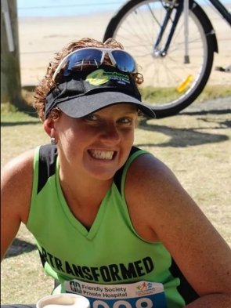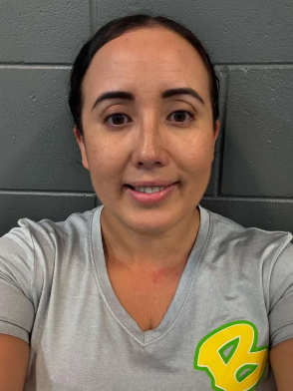

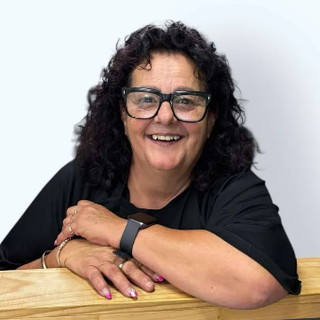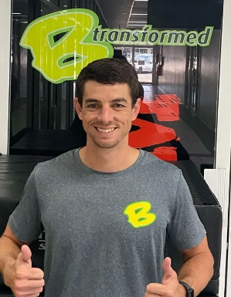
We have recently updated our class timetable for the gym

