SPRING NEWSLETTER 2024
Welcome to our Spring newsletter for 2024. Spring is upon us, which means it’s time to start thinking about our health and well-being for the warmer months ahead. We have been working hard behind the scenes, new staff, change of classes in the gym and more.

Allied Health News
Recently we were nominated for the 2024 Telstra Business Awards in the category of Championing Health. The Telstra Business Awards celebrate the best in business, recognizing companies that demonstrate excellence, leadership, and a commitment to the community. Not only were we nominated but we were also successful in progressing through to Stage 2. To be nominated is an incredible honour and we are proud to be considered among Australia’s top businesses. The nomination is a testament to the hard work, dedication, and innovation that our team brings to the table every day.
Psychology
Our Provisional Psychologist Storm Drabsch is part of the family now and her books are filling fast. Storm has experience in NDIS and working with clients of all demographics. Storm has a passion to help assist clients with their challenges, by utilizing current strategies and CBT, to improve the client’s mental health and overall wellness.
Our General Registered Psychologist Michael Gordon is as popular as ever and his books are currently full until September 2024. Michael has experience working across a life span, including child, adolescent and adult clients. Michael has a range of interest areas that include self-management and goal-oriented behaviours, physical health and eating disorders.
Katie’s passion and Btransformed’s vision is to help all with improved wellness and quality of life. A Wellness Program that focuses on overeating and undereating is in the final stages of planning and will be offered to clients that want to improve their overall health, with the direct assistance of Psychologists, Dietitians and Exercise Professionals. Details of this course and the client’s eligibility will be sent to clinicians in the near future.
Katie’s books are currently full until November, however there is availability for Eating Disorder clients.

Dietitian
Kym Connolly is a dedicated and highly skilled dietitian and diabetes educator with over two decades of experience providing expert nutritional guidance across various health needs. Kym has seen a lot of change on how to eat to live over this time and understands the different models. Her passion is menopause, bone density, healthy aging, and longevity, offering personalized advice to help individuals navigate menopause, maintain strong bones, and apply the evolving science of how to live with greater health as we age.
In sports nutrition, Kym tailors’ nutrition plans to enhance athletic performance and support recovery, helping athletes achieve their best results.
Her expertise in cardiac nutrition emphasizes heart-healthy guidance to support overall cardiac health. Additionally, Kym supports patients before and after bariatric surgery, ensuring optimal outcomes through well-rounded nutritional plans. With a passion for improving her patients' health and well-being, Kym Connolly is a trusted and invaluable expert in the field of nutrition.
Kym Connolly is a qualified Dietitian and Diabetes Educator. Kym has extensive experience and is taking new clients for both Dietetics and Diabetes Education.
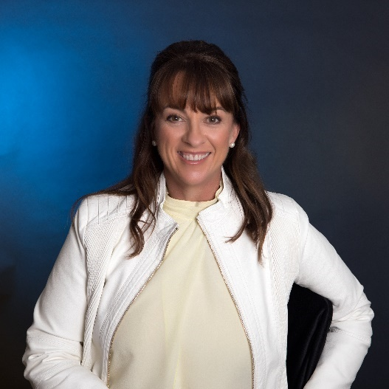

Teonie Buchanan is an Accredited Practicing Dietitian and Nutritionist. Teonie has been working privately in Wide Bay Regional/Rural Health Facilities and at Btransformed, Bundaberg since 2017 and has specialized in IBS management, Medical Nutritional Therapy for intolerances and Allergies and Gastroenterology Nutritional management.
Teonie is a credentialed Eating Disorder Dietitian, using a Multidisciplinary approach to patient care in the outpatient setting. This includes case conferences with GP’s, Paediatricians and Psychologists for best practice patient care.
Along with this Teonie has a lived experience of diabetes, through a sibling with T1D. This interest has covered dietary management for diabetes health in related Renal, MASLD, Cardiovascular, Neuropathy and “diabetes burn-out” support.
Teonie has referrals from Bariatric Specialists for pre-and-post surgical education, with follow-up support for nutritional adequacy and long-term weight management.
Recently, Teonie attended the Annual Women’s Health Update 2024 in Brisbane, looking to expand her knowledge of dietary management for women’s health across the timeline.

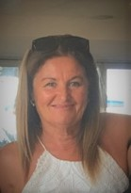

B Transformed is currently taking referrals for Psychology, Dietitian, Diabetes Education, Eating Disorder and Speech Pathology (Literacy only). We also accept Plan or Self-Managed NDIS Clients.

New pricing structure for our Allied Health services are as follows:

Psychology
Katie Murrell
Initial Consult $200 (MHCP Rebate $96.65)
Review Consult $170 (MHCP Rebate $96.65)
Psychology Eating Disorder - Bulk Billed (EDP only)

Michael Gordon
Initial Consult $140 (MHCP rebate $96.65)
Review Consult $125 (MHCP rebate $96.65)
Psychology Eating Disorder – Bulk Billed (EDP only)

Storm Drabsch (Provisional Psychologist)
Initial Consult $ 85 (No rebate)
Review Consult $85 (No rebate)

Marriage / Couples Counselling
Initial Consult $220
Review Consult $180
(No medicare rebate is available for marriage/couples counselling)
Dietitian
Kym Connolly , Teonie Buchanan
Private Consultations (No Medicare rebate)
Initial $125
Review $80

EPC Consultations
Non-Concessional Initial - $95 (Medicare rebate $60.35)
Review - Bulk Billed
Concessional Initial - Bulk Billed
Review – Bulk Billed
Dietitian Eating Disorder – Bulk Billed (EDP only)
(Please note that only Teonie Buchanan can see Eating Disorder clients under Dietetics)

Speech Pathology
Fact: The English language is often considered as one of the most complex languages to learn to read and spell. With its myriad of irregularities and exceptions in spelling, and baffling grammar and sentence structure, it’s no wonder that so many children (and adults) find it so challenging.
Did you know that speech pathologists can play a crucial role in supporting kids with literacy difficulties?
Our Speech Pathologist, Alison Marsh, has made the move away from provision of general speech pathology services, to focus on supporting clients with literacy challenges. Through targeted assessments and evidence-based interventions. Alison is supporting school-aged children to build their skills and confidence in reading and spelling.
There is nothing more wonderful than watching a struggling reader, read their very first book!

Speech Pathology
1 Hour Initial Consultation $ 190
1 Hour Standard Therapy Session $190
45 Minute Therapy Session $145
30 Minute Therapy Session $ 95

Gym News
Recently we welcomed back Amanda Robinson as our Gym Team Leader. Amanda is a Personal Trainer & Group Fitness Instructor. Amanda completed her Cert 3 & 4 with B Transformed and has over a decade of experience. Amanda’s academic achievements also include Pregnancy Studies, Post Partum, The Ageing Population, Children’s studies and Russian Kettlebell Strength Training.
Amanda has been empowering clients of all abilities, including athletes, to reach their fitness goals since 2011. Her passion for health and wellness drives her commitment to guiding individuals towards sustainable lifestyle changes. Specialising in strength training, weight loss, functional fitness and injury rehabilitation, Amanda’s tailored approach ensures clients reach their goals while enjoying their fitness journey.

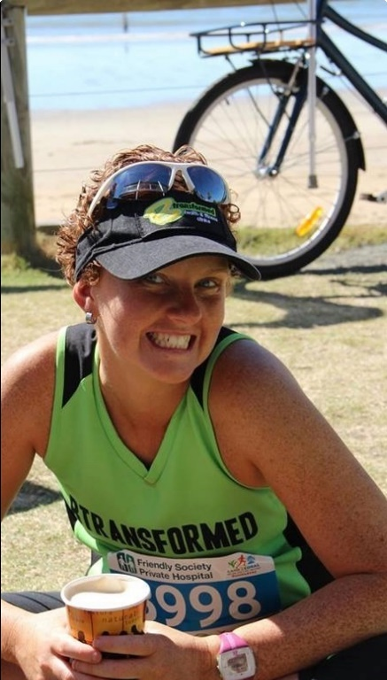

We have also recently updated our class timetable for the gym

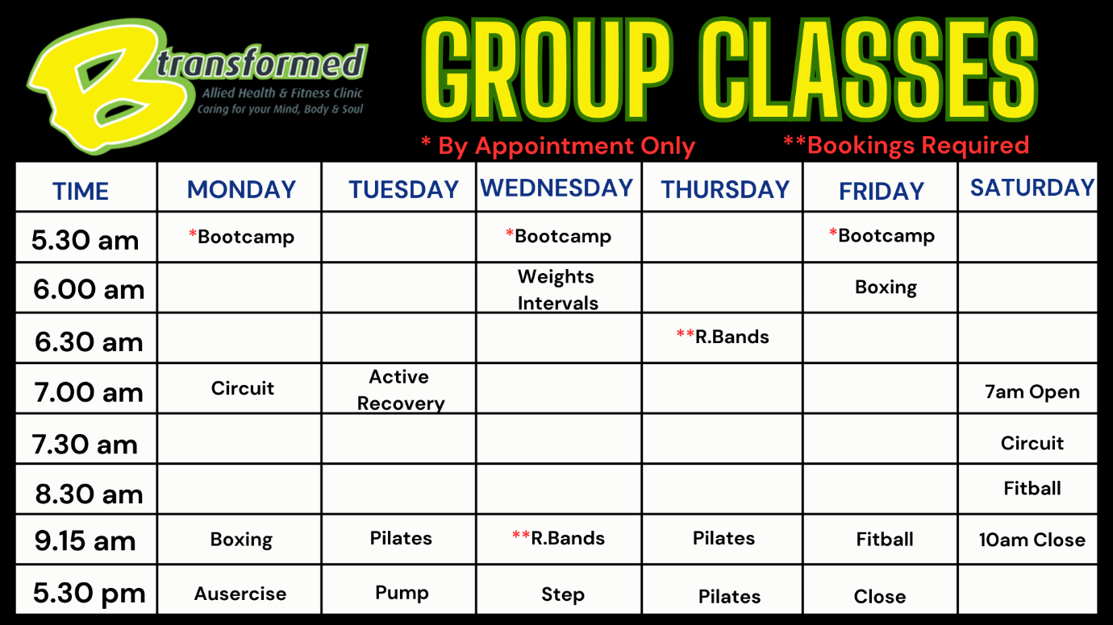

Other News
We would like to welcome on board Mark from Key Solutions to Health.
With 38 years of experience as an Osteopath, Mark treats a wide range of conditions including back and neck pain, muscle and joint issues. His approach is rooted in a deep understanding of the interconnectedness of the body, ensuring each patient receives personalized treatment tailored to their specific needs. Whether you are seeking relief from chronic pain or recovering from an injury, Mark is dedicated to helping all ages achieve optimal health.
At KSH, they believe in a holistic approach to wellness, not only addressing the symptoms but also the underlying causes of discomfort. By considering the entire body system, Mark aims to restore balance and function, promoting long term health benefits.
Discover how Mark’s comprehensive care can empower you to unlock your potential to enhance your quality of life through effective hands-on techniques, treating all body systems for comprehensive health and wellness.
Mark can be contacted on 0436 015 849 or docbones25@gmail.com
Marks Fee Schedule is as follows :
Initial Consultation and Treatment (45min) $150
Standard Consultation and Treatment (45min) $ 110
Short Treatment (15min – at Practitioners discretion) $50
Please note: There is currently no rebate available from Medicare, Private Health Insurance, DVA Services .
Key Solutions to Health is not a NDIS, EPC or DVA service provider.
A Service fee of 1.9% is added to all card transactions.
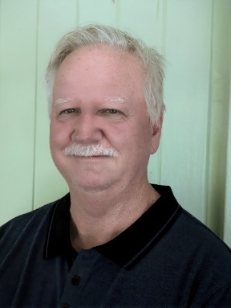
In September and October we will be holding FREE talks with two of our Allied Health Practitioners. The first being with Katie Murrell on 24th September, and then following on with Kym Connolly on 15th October. These talks are open to the public and bookings are essential.
Wellness Over 30
Are you in your 30s or beyond and ready to take control of your health? Join us for an insightful and inspiring talk from our very own Katie Murrell on how to optimize your wellness as you age. Whether you're looking to boost energy, improve your fitness, or simply feel your best every day, this event is for you!
Receive expert advice
Learn practical tips you can apply immediately.
Connect with others on the same wellness journey
Date: Tuesday 24th September 2024
Time: 6.30pm
Location: B Transformed
47 Bourbong St, Bundaberg QLD
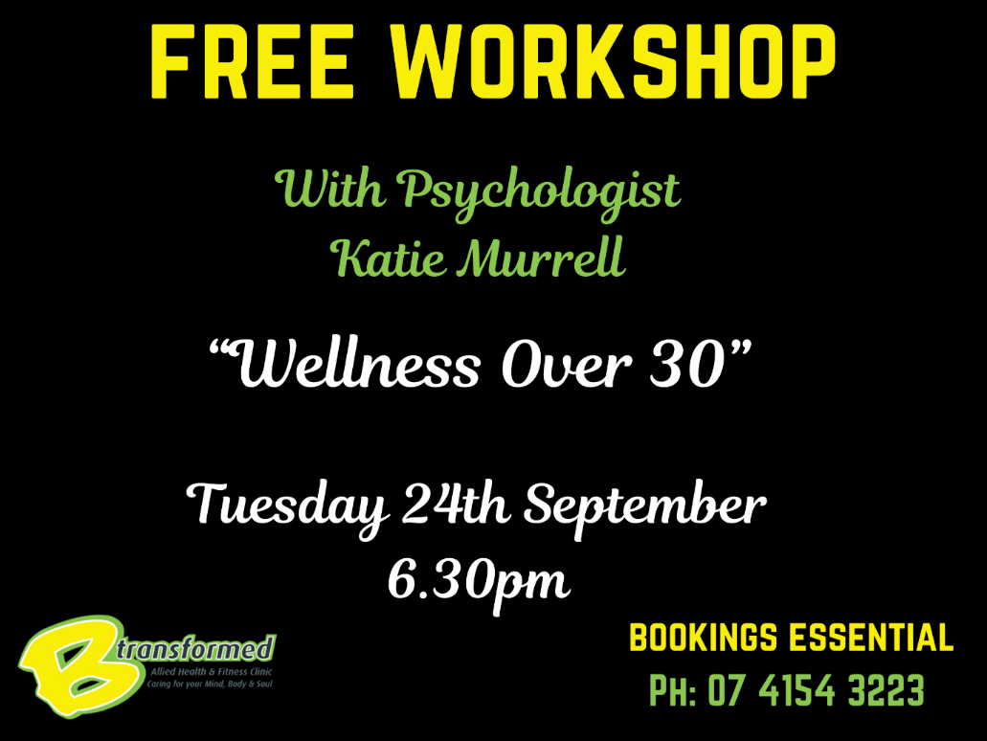
Fit & Fabulous: Women’s Health in Your 40s, 50s, and Beyond
Join Kym Connolly, an experienced dietitian with nearly 20 years in the field, for a free workshop on October 15th. Kym is passionate about helping individuals maintain vitality and health well into their 40s, 50s, and beyond, with a focus on supporting women through the transitions of menopause. She empowers her clients to age gracefully, feeling biologically younger while embracing each stage of life.
In this workshop, discover essential strategies for ageing with optimal health. Learn the key areas to focus on so you can thrive, not just manage, during this transformative phase and beyond. This talk is invaluable for women in their 40s and 50s and those of all ages—because it’s never too early to prepare. It's also perfect for men who want to support the women in their lives, as menopause impacts everyone involved. Ageing is inevitable, but how you age is your choice. Don’t wait—start making the right choices now
Date: Tuesday 15th October 2024
Time: 6.30pm
Location: B Transformed
47 Bourbong St, Bundaberg QLD
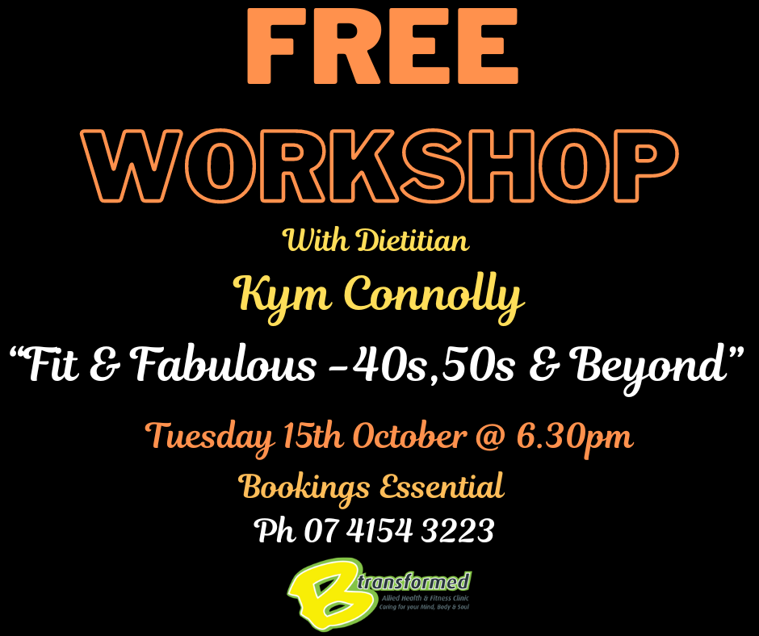

SPECIAL OFFER

Contact our gym on 0473 624 417 for more information and to redeem your special offer

