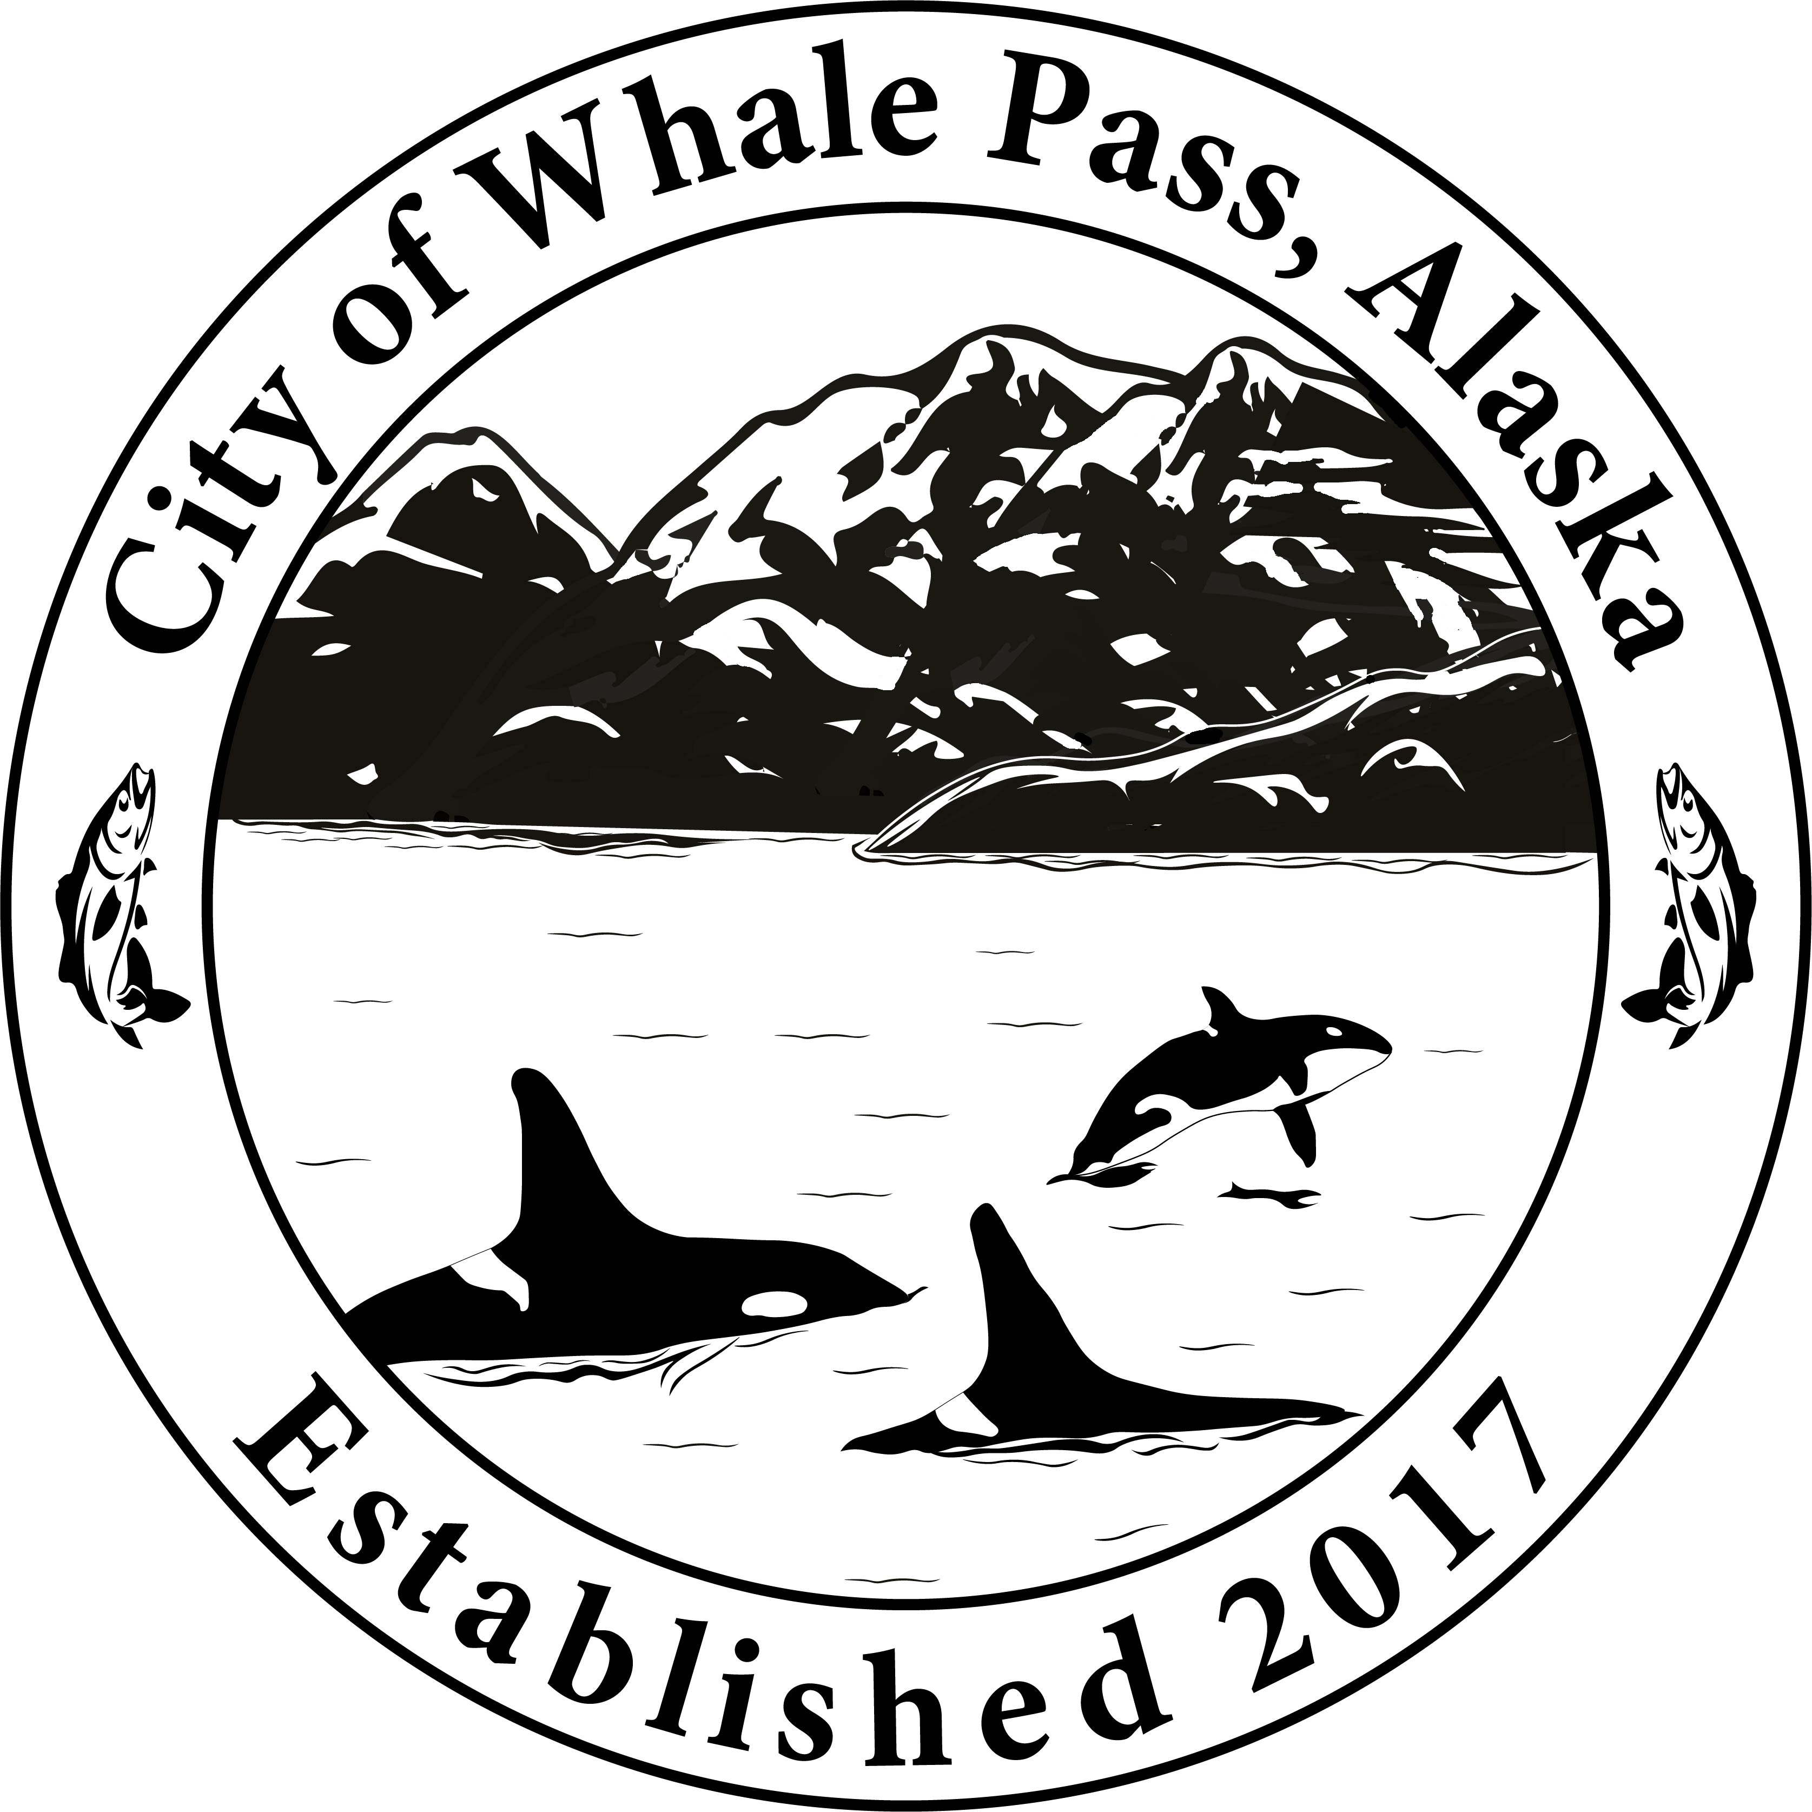City of Whale Pass

“*The City of Whale Pass pursues financial responsibility with a minimum of governance, encouraging residents to flourish”.*

**Regular Council Meeting**

Tuesday September 15th 2025

**6:00 pm @ Library & zoom**

**AGENDA**

**Call to Order:**

**Roll Call:** [ ]Dave Webb, [ ] Vice-Mayor Caleb Toman, [ ] Mayor Tamara Weaver,

[ ] Tom Weaver, [ ] Matthew Beck, [ ] James Greeley, [ ] William Pattison *X=In Person O=Phone*

**Invocation:**

**Pledge of Allegiance:**

**Approval of Agenda:**

**Approval of Minutes:** August 19th, 2025

**Persons to be heard/Public comment.**

**Mayor Report**

**Clerk Report**

**Treasure Report**

**EMS Report**

**Fire Department Report**

**Harbor/Committee Report**

**Library Report**

**Roads Report**

**Correspondence/Issues**:

* Seeking New Fire Chief
* Neck Lake Road Project
* Bull Moose Progress

## **Unfinished Business;**

* Mobile building removal
* Minute keeping
* Harbor fee box/ nonskid
* Public meeting recordings
* Clerk replacement process
* Tide land lease

**New Business:**

* Temporary clerk / 2.04.040. “…In case pf the temporary absence of the city clerk, the council may appoint an acting city clerk, with all the powers and obligations of the city clerk…”
* Public hearing to the City of Whale Pass, Ordinance 25-09-16-01.

Passage of Whale Pass code.

**Adjourn:**

Posted 9/12/25

**Resolutions & Ordinances:**

**Public/Council Comment:**

**Executive Session:**

Join Zoom Meeting  
<https://us06web.zoom.us/j/5373797173?pwd=MTJXZzBLaWpKNWxwb1hscVJRK1ZvZz09>  
  
Meeting ID: 537 379 7173  
Passcode: 123456