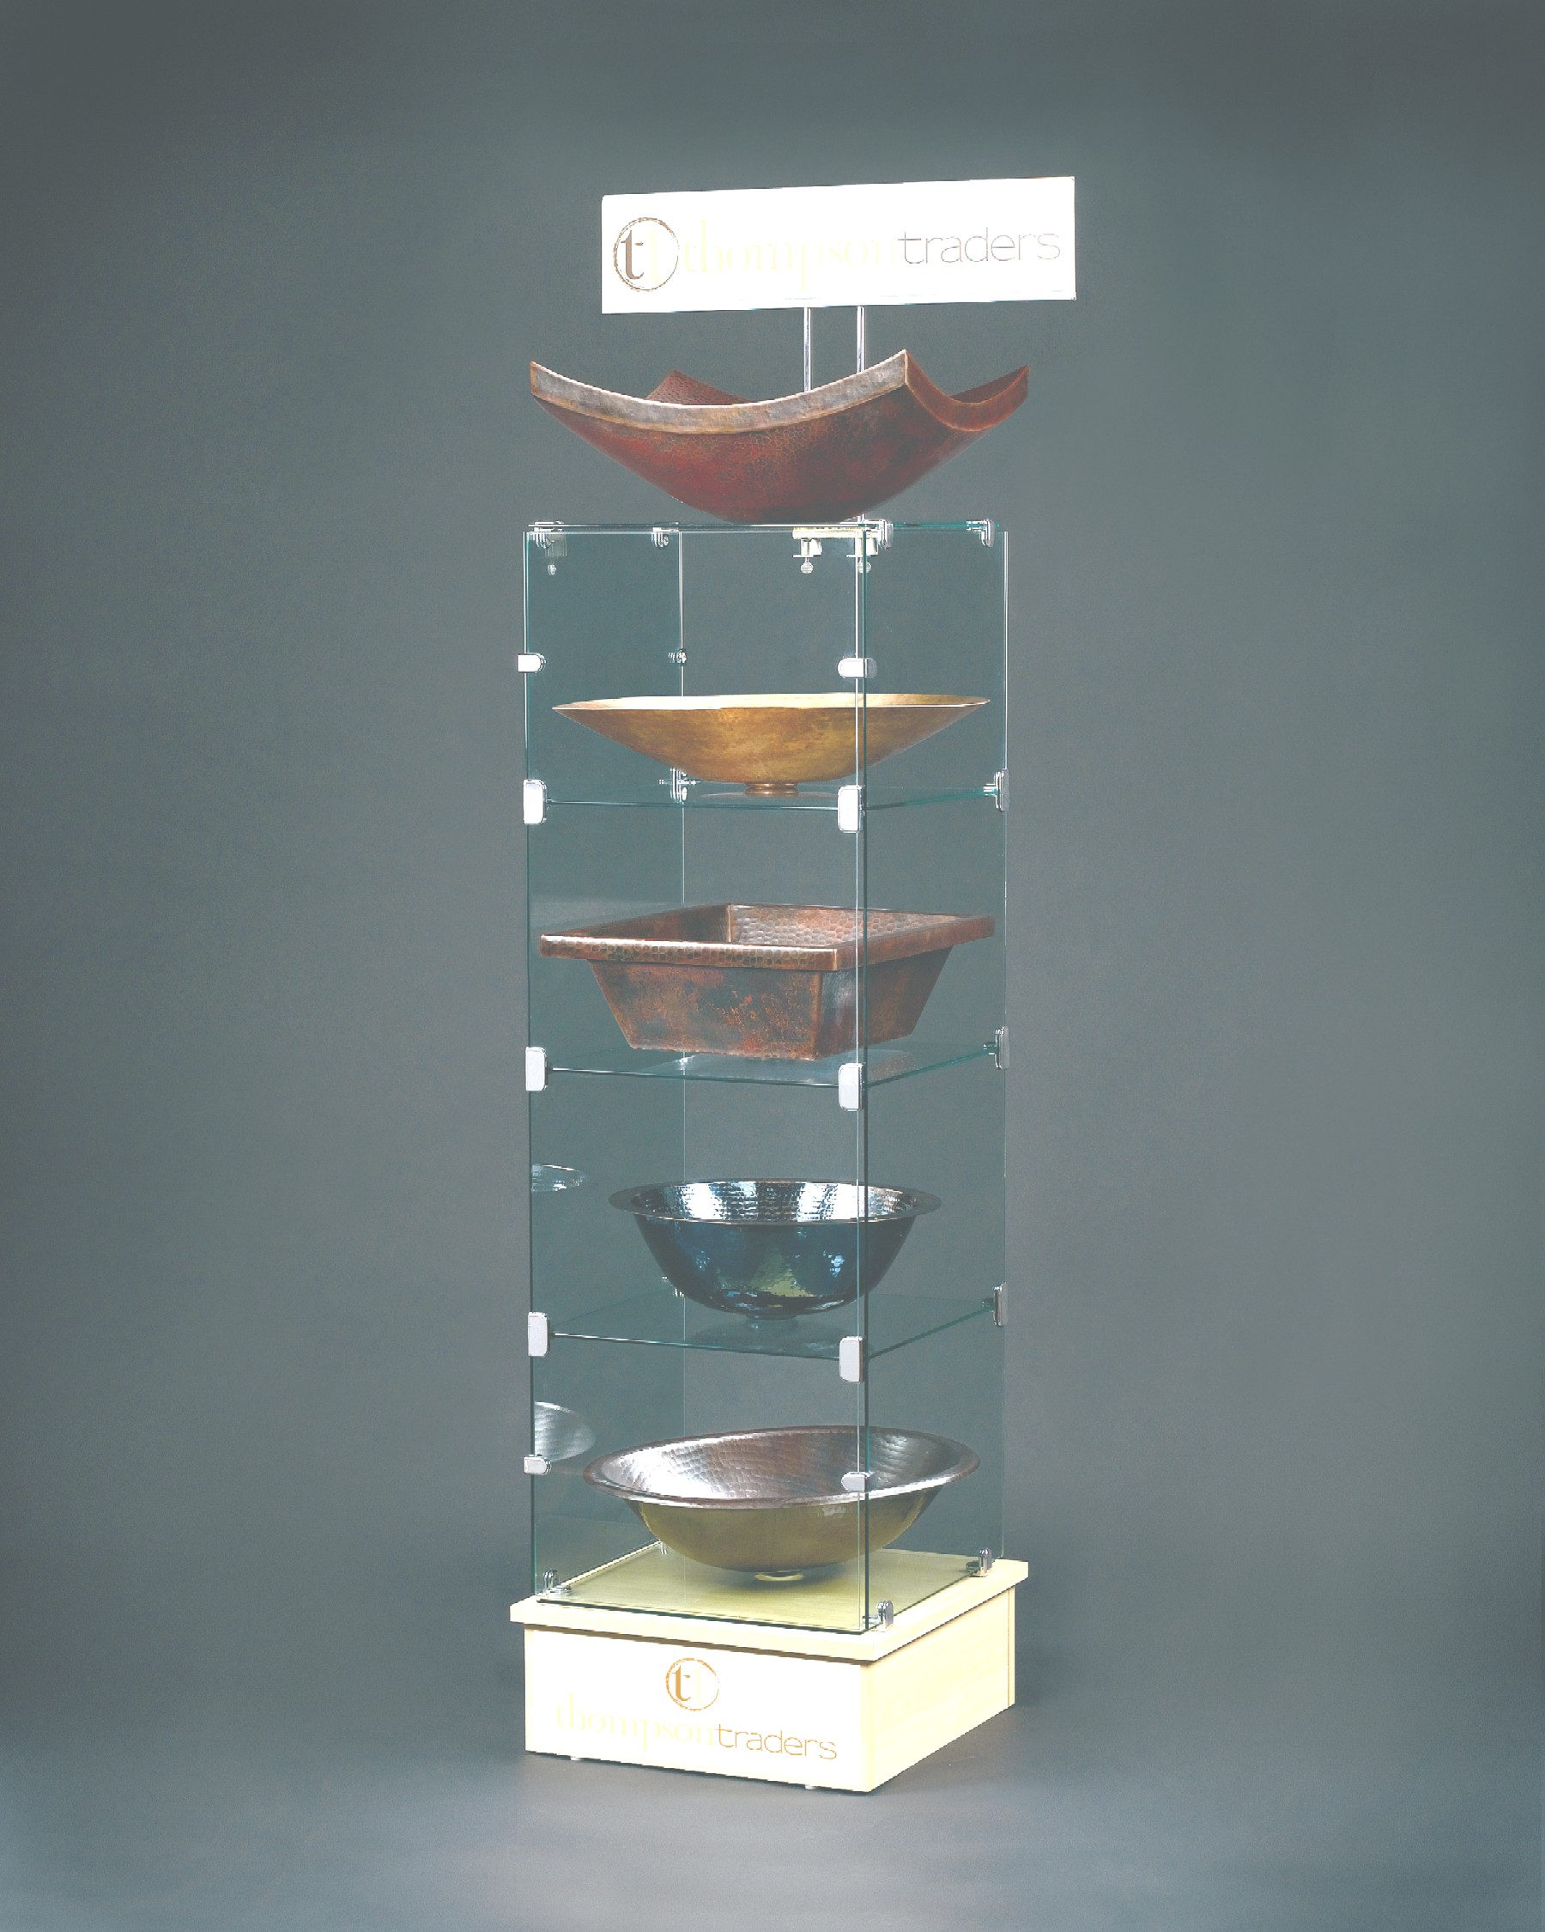

ThompsonTraders
Assembly Instructions
ThompsonTraders
Glass Tower Display Assembly Instructions

Contents

Qty | Description
1 | Wooden base
5 | Shelves 18 X 18 tempered glass
3 | Sides 18 X 48 tempered glass
12 | 2 screw brackets
12 | 3 screw brackets

Tools required
Flat blade screw driver
Measuring tape
Glass cleaner and towels

Assembly (Numbered steps shown on drawing)

- Place 1 side (18 X 48) on the floor
- Along each long side place a 3 screw bracket at 1’, 2’ and 3’ with the long slot inserted on the glass and the short slot pointing up. This will use a total of 6 brackets.
- Along each long side place a 2 screw bracket at 6” and 42” using a total of 4 brackets.
- Insert vertically into the 3 screw brackets 3 shelves (18 X 18).
- Insert the 2nd and 3rd sides (18 X 48) vertically into the 2 screw brackets.
- Place 6-3 screw brackets with the long slot on the top of the 2nd and 3rd sides and the short slot on shelves on the top side.
- Make sure the sides are all aligned top and bottom and the shelves are square to the sides and properly spaced.
- Tighten all the screws.
- Place remaining 2 end shelves (18 X 18) on the floor and install on opposite sides 2 screw brackets at 4” and 12” using the remaining 8-2 screw brackets.
- Tighten the screws holding the brackets to the shelves
- Slide one of the shelves (18 x18) on each end so the brackets on the shelves are on the top of the 2 vertical sides and tighten the screws.
- To stand the tower up, roll 90 degrees to one side and then lift from one end. This allows the tower to roll upright on 2 of the 2 screw brackets limiting the amount of stress on the structure.
- Place the wood base and lift the tower onto it leaving an equal distance from the glass to the edge of the base on all 4 sides.
- Clean the tower with glass cleaner.

ThompsonTraders
Glass Tower Display Assembly Instructions
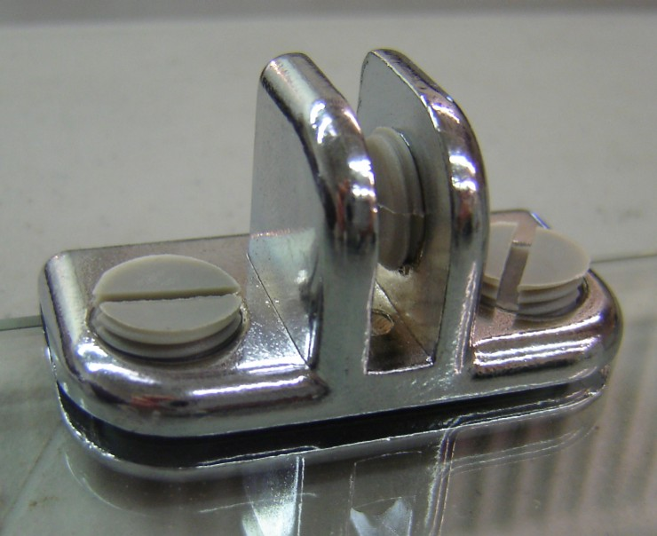Step 2
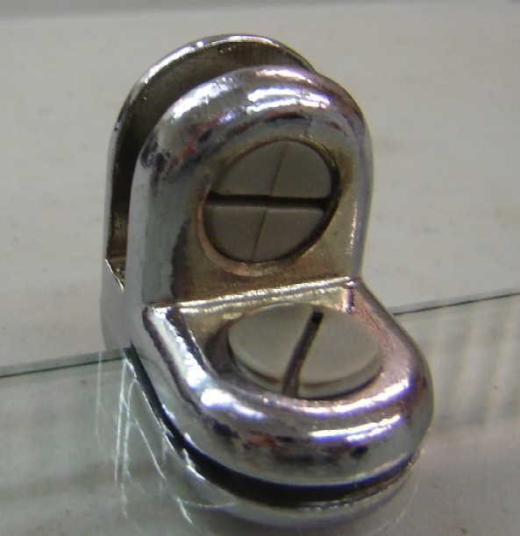 Step 3 and Step 9
Figure 2
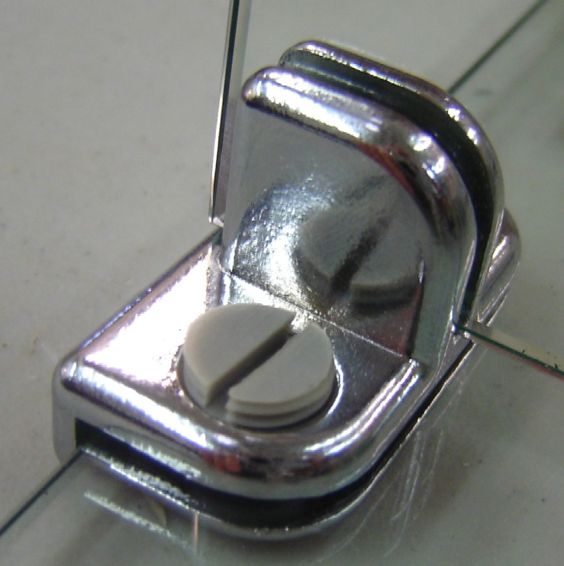Step 4 and Step 6
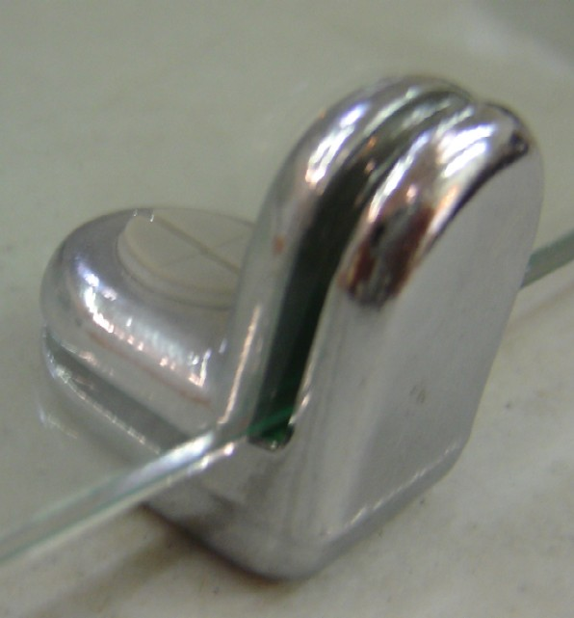Step 5 and Step 11

