TSSAA District 2-A Volleyball Tournament
(Thursday, October 2, 2025)

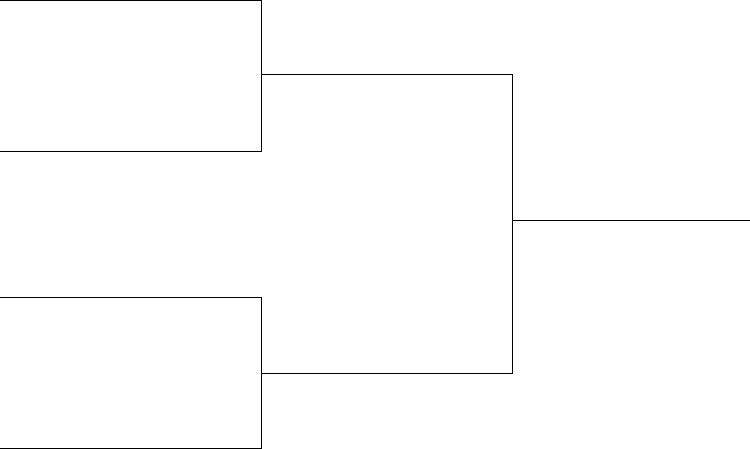
#1 Washburn

Game 1
5:00pm

#4 Cosby

Game 3
8:00pm

Winner

#2 Eagleton

Game 2
6:30pm

#3 Hancock County

