NYSMICJ Region 3
2020 Women’s Day Training
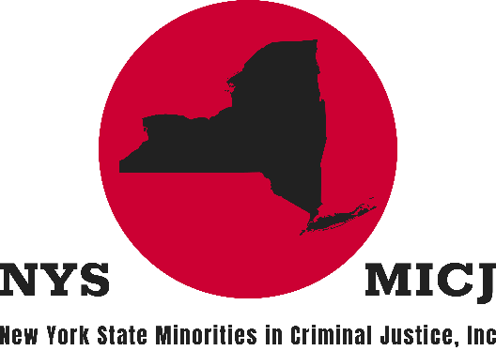
FRIDAY, MARCH 6, 2020
8:00 A.M. TO 4:00 P.M.
Hudson Valley Community College
Bulmer Telecommunications Center
80 Vandenburgh Avenue, Troy NY
“Valiant Women of the Vote”
Online Registration PREFERRED. Registration and additional information at www.nysmicj.org/womens-day-training

MAIL-IN REGISTRATION FORM
☐ Early Bird 1/2/20 – 3/1/20: $50.00 | ☐ Regular 3/2/20 – 3/5/20: $60.00
☐ Late/On-Site 3/6/20: $70.00 ☐ Add NYSMICJ Membership for just $35.00
Lunch is included. Mailed registrations will be based on postmarked date.
Name: |  |  | Title:
Facility: |  |  | Agency:

NYSMICJ Member | ☐ Yes ☐ No | Membership No
Dietary Restrictions
WORKSHOP CHOICE (PLEASE SELECT CHOICE 1, 2, 3 AND 4 for both sessions):
AM Session |  | PM Session
 | Diversity and Inclusion |  | NYS Discovery Reform
 | Check Y.U.R. Chicken: How to Stop a Self-Defeating Mindset |  | Yoga for Stress Reduction and Self-Care
 | NYS Bail Reforms |  | Smart Strategies for Managing Debt
 | Investing Basics: Five Steps to Building a Disciplined Investment Strategy |  | "DOCCS Can Help You Write Your Future" NYSMICJ College Initiative Presentation
NYSMICJ Region , PO Box 5733, Albany NY 12205-5733
Return Registration Form with your Check*** or Money Order
To: NYSMICJ Region 3
P.O. Box 5733
Albany, NY 12205-5733
***Returned checks will be charged a $35.00 fee
CONTACT INFORMATION:
D Hille | Central Office 518-445-6093 | Dannielle.hille@doccs.ny.gov | dhille@nysmicj.org
K Trapalis | Hale Creek C.F. 518-736-2094 | Kristen.trapalis@doccs.ny.gov | ktrapalis@nysmicj.org
D Wilburn | Central Office –Douglas.Wilburn@doccs.ny.gov | president@nysmicj.org
W Bruno | Central Office – Wendy.Bruno@doccs.ny.gov | wbruno@nysmicj.org
J Lewis | Coxsackie CF –Jackie.Lewis@doccs.ny.gov | jlewis@nysmicj.org
K Ivey | Hudson CF – Kenneth.Ivey@doccs.ny.gov
M Hurt – mhurt@nysmicj.org
*First 75 people will be entered to win free registration to the 2021 Region 3 Women’s Day Training
Learn more at www.nysmicj.org/womens-day-training
Donations:
Attendees are asked to bring an unopened package of feminine hygiene products, new or gently used women’s or child’s coat or a new or gently used child’s toy. Attendee will receive one (1) free raffle ticket for their donation
ANNUAL WOMEN'S DAY COLLEGE SCHOLARSHIP
Each year, New York State Minorities in Criminal Justice, Inc. (NYSMICJ) Region 3 awards a $500 college scholarship to an undergraduate student pursuing a degree in Criminal Justice. Preference will be given to students of the hosting institution, as well as dependents of active NYSMICJ members.
DEADLINE: February 27, 2020 – see page 4
RBG AGENT OF CHANGE AWARD
Perhaps one of the most well-known crusaders for women’s rights, Ruth Bader Ginsburg advanced gender-equality, the rights of workers, and separation of church and state. Each March, at the Women’s Day Training Conference, Region 3 of the New York State Minorities in Criminal Justice, Inc. honors a woman who’s work supports these ideas by awarding her the RBG (Ruth Bader Ginsburg) Agent of Change Award.

DEADLINE: February 21, 2020 - see page 6
Workshops
Diversity and Inclusion (AM Only)
Michael Washington, Director, Diversity and Inclusion Management, NYS Department of Civil Service
Exploring diversity, inclusion and equity in the workplace, following the inception of Executive Order 187.
Investing Basics: Five Steps to Building a Disciplined Investment Strategy (AM Only)
Steven Hunt, Northwest Mutual
This presentation provides information about investing, which may help you feel more secure in your investment strategy, especially in today's changing world.
Check Y.U.R. Chicken: How to Stop a Self-Defeating Mindset (AM Only)
Naomi D. Jones RN, Consults Unlimited Inc.
Check Y.U.R. Chicken is a process where you learn to stop your self-defeating mindset so that success becomes easier by having the right conversation with yourself.
NYS Bail Reforms (AM Only)
Rensselaer County District Attorney’s Office
On January 1, 2020, NYS instituted sweeping cash bail reforms impacting criminal cases across the state. This workshop will discuss the effects or these reforms on the system, present and long term.
Smart Strategies for Managing Debt (PM Only)
Steven Hunt, Northwest Mutual
This interactive seminar provides information on budgeting, types of debt and the impact it has on credit scores, and walks participants through a worksheet to identify their debt, debt-to-income ratio and goal setting.
Yoga for Stress Reduction and Self-Care (PM Only)
Sarah Wilday, Hot Warrior Yoga
A guided Yoga for Stress Reduction practice appropriate for the working environment. This is a gentle practice, appropriate for all fitness levels.
"DOCCS Can Help You Write Your Future" NYSMICJ College Initiative Presentation (PM Only)
NYSMICJ Members
NYSMICJ in collaboration with the NYS Department of Corrections and Community Supervision has initiated a recruitment program geared at informing college students of the opportunities within DOCCS. The presentation further promotes diversity within the department.
NYS Discovery Reforms (PM Only)
Rensselaer County District Attorney’s Office
On January 1, 2020, NYS instituted sweeping discovery reforms impacting criminal cases across the state. The panel will discuss the effects or these reforms on the system and what the long-term impact looks like.
NYSMICJ ANNUAL WOMEN’S DAY COLLEGE SCHOLARSHIP
Each year, New York State Minorities in Criminal Justice, Inc. (NYSMICJ) Region 3 awards one $500 college scholarship to an undergraduate student pursuing a degree in Criminal Justice. NYSMICJ is committed to promoting professionalism and we value the presence and contributions of educated men and women in Criminal Justice and Law Enforcement. To further our commitment, NYSMICJ provides this scholarship to a qualifying student.
To qualify, applicants must:
- Be matriculated in a SUNY or private institution within Region 3 (Albany, Columbia, Fulton, Greene, Montgomery, Rensselaer, Saratoga, Schenectady, Schoharie, Warren, and Washington Counties)
- Have a declared Criminal Justice major, with 12 credits of major coursework completed
- Have a 2.7 GPA
- Preference will be given to students of the hosting institution, as well as dependents of active NYSMICJ members.
To apply:
- Qualified applicants should complete the submission form by clicking the Apply button in the Scholarship section at www.nysmicj.org/womens-day-training
- Questions can be emailed to: Region3@nysmicj.org
Essay topics to choose from:
- “There has been recent controversy surrounding reinstating formerly incarcerated individuals’ right to vote. Describe your position on this topic.”
- “How can criminal justice professionals effectively assist inmates with re-entry into the community?”
- “What are some barriers that exist making alternatives to incarceration ineffective, and what reforms can be introduced to make such programs more effective?”
Submissions must be received by midnight, February 27, 2020.
Scholarship recipient will be notified by mail, and will be recognized at the annual NYSMICJ Woman’s Day Training Conference at Hudson Valley Community College, located at 80 Vandenburgh Avenue Troy, New York, in the Bulmer Telecommunications Center on Friday, March 6, 2020 where they will receive a $500 scholarship check and award certificate, in addition to a one-year student membership to NYSMICJ, Inc.
NYSMICJ Mission Statement
The New York State Minorities in Criminal Justice is a Federally registered, tax exempted, non-partisan, non-profit service organization, organized to examine and act upon the improvements in the Criminal Justice System, to promote the general welfare, to increase the influence of minorities in the Criminal Justice System, and to coordinate efforts with all legitimate organizations whose purpose would include the promotion of justice within the general State, local, public & private sectors of the criminal justice system. Learn more at www.nysmicj.org.
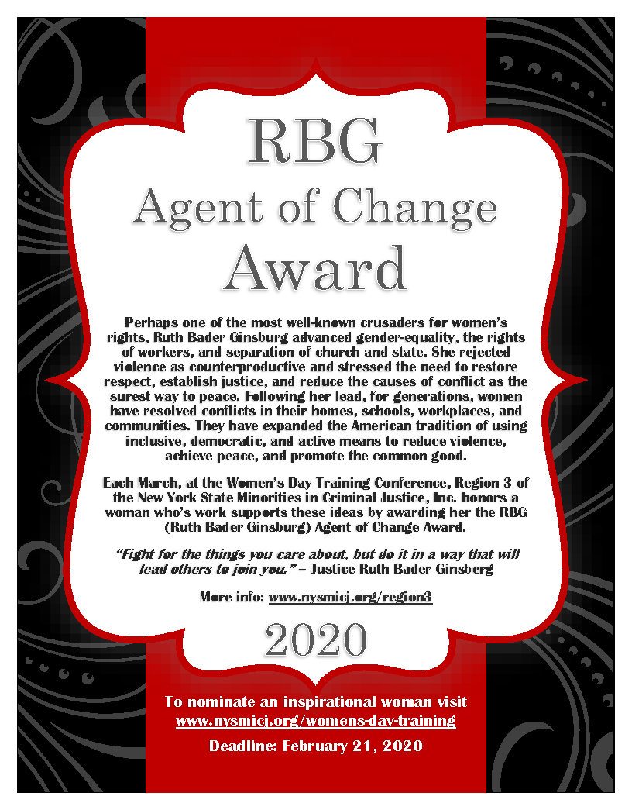
RBG Agent of Change Award
Nominate at www.nysmicj.org/womens-day-training
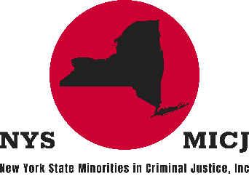
MEMBERSHIP APPLICATION
Please complete application in full
Name: _____________________________
Title: _______________________________
Home Address: ___________________________________________________________
Street City State Zip Code
County: ___________________ Phone (H): ________________ (C): _________________
Personal Email: ___________________________________________________________
Agency | Organization: ______________________________________________________
Work Email: ______________________________________________________________
Address: _________________________________________________________________
Street City State Zip Code
Special Organizational Skills | Interests: ________________________________________
________________________________________________________________________
Membership Pledge: by signing this application of membership, I agree to the following conditions:
- To support and promote the general welfare and goals of the organization and;
- To attend or help organize scheduled regional activities and;
- To participate in one or more annual event or community service project
Membership Category: Regular Associate
Status: New Renewal
Annual Dues Paid: Regular Membership - $35.00 – includes NYSMICJ Pin
Associate Membership - $15.00
Signature: __________________________________________ Date: ________________
Mail money order payable to: NYSMICJ, Inc., P.O. Box 5062, Albany, NY 12205
OFFICIAL USE ONLY
Date received: _________ Check #: __________ Amount: _________
Membership ID: ______________ Region #: ________

