Partnership Structure
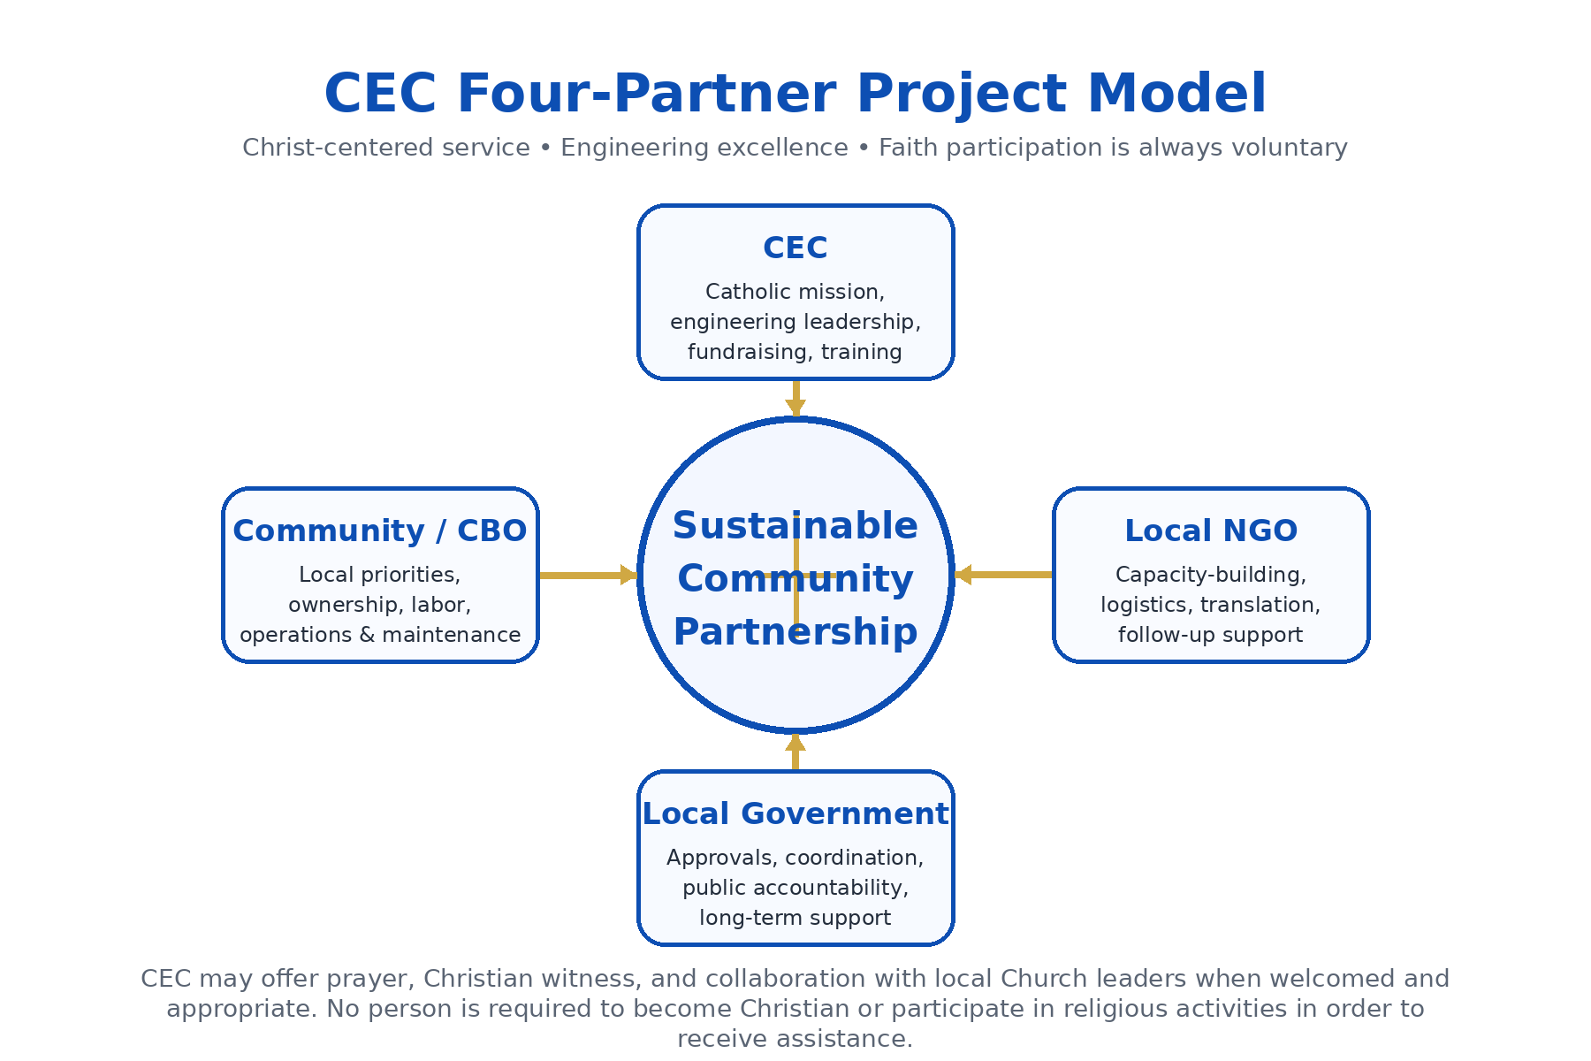

- Community - Community-Based Organization (CBO) and Community Members (Examples include water board, community development committee, women’s committee, village council, etc.)
- Local Partner Organization(s) - Local NGO
- Local municipal/city / government
- Catholic Engineering Corps (CEC)

From years of experience, we have found that CEC projects are most successful when there is a four-way partnership between each of the entities listed above. Each partner has specific skills and expertise, which together, contribute to a more sustainable project over the long-term.

Typical Roles and Responsibilities
The following roles and responsibilities are typical for CEC community development projects and are intended to be a guideline and framework as each partner considers its unique contributions and roles from the initial phase of the project. It is important to note that each project, community, and partnering organization is unique and distinct. Therefore, roles and responsibilities may overlap between partners and/or may be different than what is listed below. Ultimately, the roles and responsibilities of each partner should be detailed in the agreements established between each partner. As a Catholic organization, CEC seeks to witness the love of Jesus Christ through professional service, accompaniment, and prayer when welcomed. Participation in any religious activity is always voluntary, and project assistance is never conditioned on religion.
Community (Community-Based Organization (CBO) and Community Members)
- Contribute to project design (handle permissions/permits/property rights, provide feedback, help select preferred design)
- Provide in-kind contributions (skilled and unskilled labor, borrowed equipment, transportation, translation, lodging and food, local materials, etc.)
- Contribute financially towards capital costs (at least 15% of capital construction project cost in cash is required)
- Responsible for 100% of the financial and logistical aspects of the operation and maintenance component of the project (NOTE: This may be fulfilled by the local government, depending on the project type).
- Organize and involve community members in all aspects of project
- Support site preparations
- Identify community contact(s) to accompany team during visits
- Provide logistical support within community
- Communicate directly with club on a regular basis
- Data collection

Local Partner Organization (Local NGO)
- Provide capacity-building for community members/CBO
- Provide project-specific training for community members/CBO
- Monitor project progress
- Arrange translation services
- Inform club about changes to security/safety situation
- Visit community regularly
- Support site preparations
- Accompany travel team in community during visits
- Provide logistical support to/from community
- Serve as a liaison between club and community
- Technical data collection
- Respect CEC’s Catholic identity and support the principle that project assistance is never conditioned on religion.

Local Partner Municipality/City Government
- Provide capacity-building for community members/CBO
- Provide project-specific training for community members/CBO
- Monitor project progress
- Arrange translation services
- Inform club about changes to security/safety situation
- Visit community regularly
- Support site preparations
- Accompany travel team in community during visits
- Provide logistical support to/from community
- Serve as a liaison between club and community
- Technical data collection
- Respect CEC’s Catholic identity and support the principle that project assistance is never conditioned on religion.

CEC
- Design and construction management
- Involve and seek input from all partners during each phase of the design
- Provide education and training, including O&M training and manual
- Witness the love of Jesus Christ through professional excellence, accompaniment, and prayer when welcomed, while respecting every person’s freedom of conscience.
- Communicate with project partners, including local NGO, local government, and community contacts
- Technical data collection

