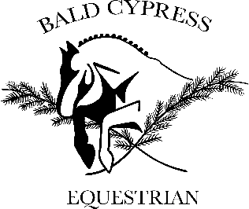Bald Cypress Equestrian Release of Liability

Please carefully read and initial each paragraph as you approve it.

I ________________________________ , am fully aware and fully understand that all horses are

unpredictable and dangerous. I realize that placing my children, or myself in a stable environment is creating a hazardous situation.

Initial____

I understand that riding horses or ponies is a dangerous sport. I am aware that riders must expect to be injured from time to time. I understand that death of people from equestrian accidents is possible.

Initial_____

I realize that professional instruction cannot prevent serious injury or death from working around, handling, or riding horses and ponies.

Initial_____

I understand that jumping horses or ponies is a particularly dangerous activity and that serious injury or death of riders or horses is possible.

Initial_____

I am aware that serious injury or death of my mount is possible when it is handled, trained, or in a lesson.

Initial_____

I release Hannah Neall with Bald Cypress Equestrian and CM Stables , its owners, trainers, and employees from all liability for damage to my property, injuries or death of my children, my animals, or myself.

Initial_____

Hannah Neall with Bald Cypress Equestrian and CM Stables, its owners, employees, and associates, have my permission to initiate emergency first aid treatment for my children, my animals, and myself in case of an accident. They also have my permission to authorize emergency medical treatment by qualified medical personnel for my children or myself, and veterinary treatment by qualified veterinary personnel for my animals.

Initial_____

I understand that I am fully responsible for any guests that I may have on the property. I understand that I am fully responsible for fully informing the guest of all risks related to the handling or riding of horses. I understand that I am fully responsible for informing guests about horse's temperament, training, habits, and for determining that the guest is sufficiently experienced to ride the horse.

Initial_____

WARNING

Under Delaware law, an equine professional is not liable for any injury to or the death of a participant in equine activities resulting from the inherent risks of equine activities, pursuant to 10 Delaware Code Section 8140

I have carefully read each paragraph listed above and understand its contents.

Name (print)____________________________ Children's names_________________________

Signature______________________________ Dated ________________

Street Address__________________________________ City______________

Phones (H)___________________(W)____________________ Emergency___________________

Witness____________________________ Dated___________

Name (print)________________________