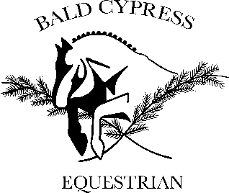
October Clinic Registration

Rider Information
Name: Enter First and Last Name
Address: Street, City, State Zip Code
Age:Click or tap here to enter text.
Email:Click or tap here to enter text.
Phone Number: Click or tap here to enter text.

Groups (Please select one)
☐ Cross rails
☐ 2’
☐ 2’6”
☐ 3’

Payment
☐ One Day Early Registration - $75
☐ Two Day Early Registration - $125
☐ One Day - $100
☐ Two Day - $150
Horse Information

Name:Click or tap here to enter text.
Age:Click or tap here to enter text.
Height:Click or tap here to enter text.
Breed:Click or tap here to enter text.
Experience:Horse’s Current Show Level

Stalls $20/day
☐ Friday
☐ Saturday
☐ Sunday

Number of Auditors
Choose an item.

Brief Description of Horse and Rider Current Level and Goals
Click or tap here to enter text.

*Current negative coggins and proof of shots are required and must be submitted prior to arrival.
*Each rider is allowed one auditor; additional auditors are $15/person.
*All spots and stalls are on a first come, first serve basis. Spots will not be reserved without payment. To qualify for early registration, registration must be completed and submitted prior to 10/1/2020 and payment must be received prior to 10/7/2020. All other registrations and payments must be submitted prior to or upon arrival. Checks can be made to Bald Cypress Equestrian and mailed to 34477 Virginia Dr, Frankford, DE 19945. Health records and registration may be emailed to hannahneallequestrian@gmail.com.

