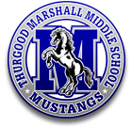
2018 - 2019 PLEDGE DRIVE
Marshall Middle School

Thurgood Marshall Middle School is the highest performing middle school in the district thanks to our incredibly dedicated teachers, administrators, parents and students. The goal of the Marshall Mustang Organization (MMO), is to offset the many budget cut constraints by the district, and provide the teachers with everything they need in the classroom to ensure the best education for our students. Last year, we were able to support EVERY department at Marshall with extra funding that directly impacted EVERY student, including:

- English: Writing Kits & Online Vocabulary programs
- Math Manipulatives: Geoboards, Dice and Cubes
- Social Studies: Maps, Books and DVD’s
- Science Lab Supplies: Tongs, Cylinders, Burners
- Spanish: Verb Charts, Visual Aids & Books
THE MONEY YOU DONATE WILL BE SPENT THIS YEAR AND GIVEN DIRECTLY TO THE ADMINISTRATION AND TEACHERS IN ORDER TO IMPACT EVERY STUDENT.
REMEMBER, 100% OF YOUR DONATION COMES BACK TO OUR SUDENTS!
- GATE Libraries, DVD’s and Supplies
- Common Core Books & Materials
- Robotic & Computer Supplies
- PE Mats, Nets and Balls

Please support the work of the MMO, and consider a one-time suggested donation of $180, which equals just $1 a day. This truly is a very small price to pay for an entire year of education for your child at the best middle school in the district.

Please complete neatly and return the bottom portion of this form with your donation.
*In order to receive a receipt or magnet, this form must be completed and turned in regardless if you pay on line or by check.
============================================================================================================

Donor Name: Student Name: _____________

Email Address: ______ ___________ Phone #: _________________________________

Tax Deductible* Donation Amount (check below):

- $200 Supporter (receive a Marshall Middle School magnet*)
- $180 Supporter (just $1 a day)
- $100 Supporter

Payment Options:
- Cash or Check: Please make your check payable to Marshall Middle School MMO. You can turn your payment into the school office or mail to the Marshall MMO, Attn: Pledge Drive, 9700 Avenue of Nations, San Diego, CA 92131.
- Credit Card or PayPal Installments: Click the Donate button at the bottom of Marshall’s home page to complete your online payment on the school website.
- I completed my payment online at www.marshallmiddle.org.

Have your own business? Make a $500 Sponsor Donation? To say thank you, the MMO will make a banner advertising your business to hang on the fence around the school.

Please email any membership questions to Mary Ringenbach at marshalldonation@gmail.com

Double Your Membership Donation for FREE with Employer Matching!

Marshall’s MMO raised more than $3,000 last year through matching corporate donations. Please check the list below for those companies that have matched employee’s charitable donations in the past and ask your employer or HR department if it has a charitable donation matching program (i.e. Easy Match or Invest in Others). If your employer has a donation matching program, they will have you fill out a simple form to begin the process.

ACCENTURE
AETNA
AIG
ALBERTSONS
ALLOSOURCE
ALLSTATE
AMERICAN AIRLINES
AMERICAN EXPRESS
AMERICAN MUTUAL
APPLE
AT&T
ASP
BANK OF AMERICA
CALLOWAY GOLF
CAPITAL GROUP
CHASE
CIGNA
CITIGROUP
COUNTRYWIDE
COSTCO
DELTA
EDISON
ELSEVIER
ERICSSON
FIDELITY
GEICO
GOOGLE
HEWLETT PACKARD
HILTON
HOME DEPT
HONEYWELL
IBM
INTUIT
KEMPER
LEXMARK
LPL FINANCIAL
MACY’S
MCDONNELL DOUGLAS
MERRILL LYNCH
MICROSOFT
MITSUBISHI
MOTOROLA
NOKIA
NORTHROP GRUMMAN
ORACLE
PFIZER
PITNEY BOWES
PRUDENTIAL
QUALCOMM
QUEST DIAGNOSITCS
SCRIPPS GREEN HOSPITAL
SIEMENS
SONY
SOUTHERN CALIFORNIA GAS
SPRINT
STATE FARM
SUN MICROSYSTEMS
3M
TERADATA
TEXAS INSTRUMENTS
TIME WARNER
TORREY PINES BANK
TOYOTA
UNION BANK
UNITED DEFENSE
UNITED TECHNOLOGIES
US BANCORP
UTC AEROSPACE
VERIZON
WACHOVIA
WELLS FARGO
XEROX

If you have any questions about the Employer Matching program, or need any assistance with the process once you contact your employer, please contact Mary Ringenbach at marshalldonation@gmail.com. Thank you for supporting Marshall Middle School!

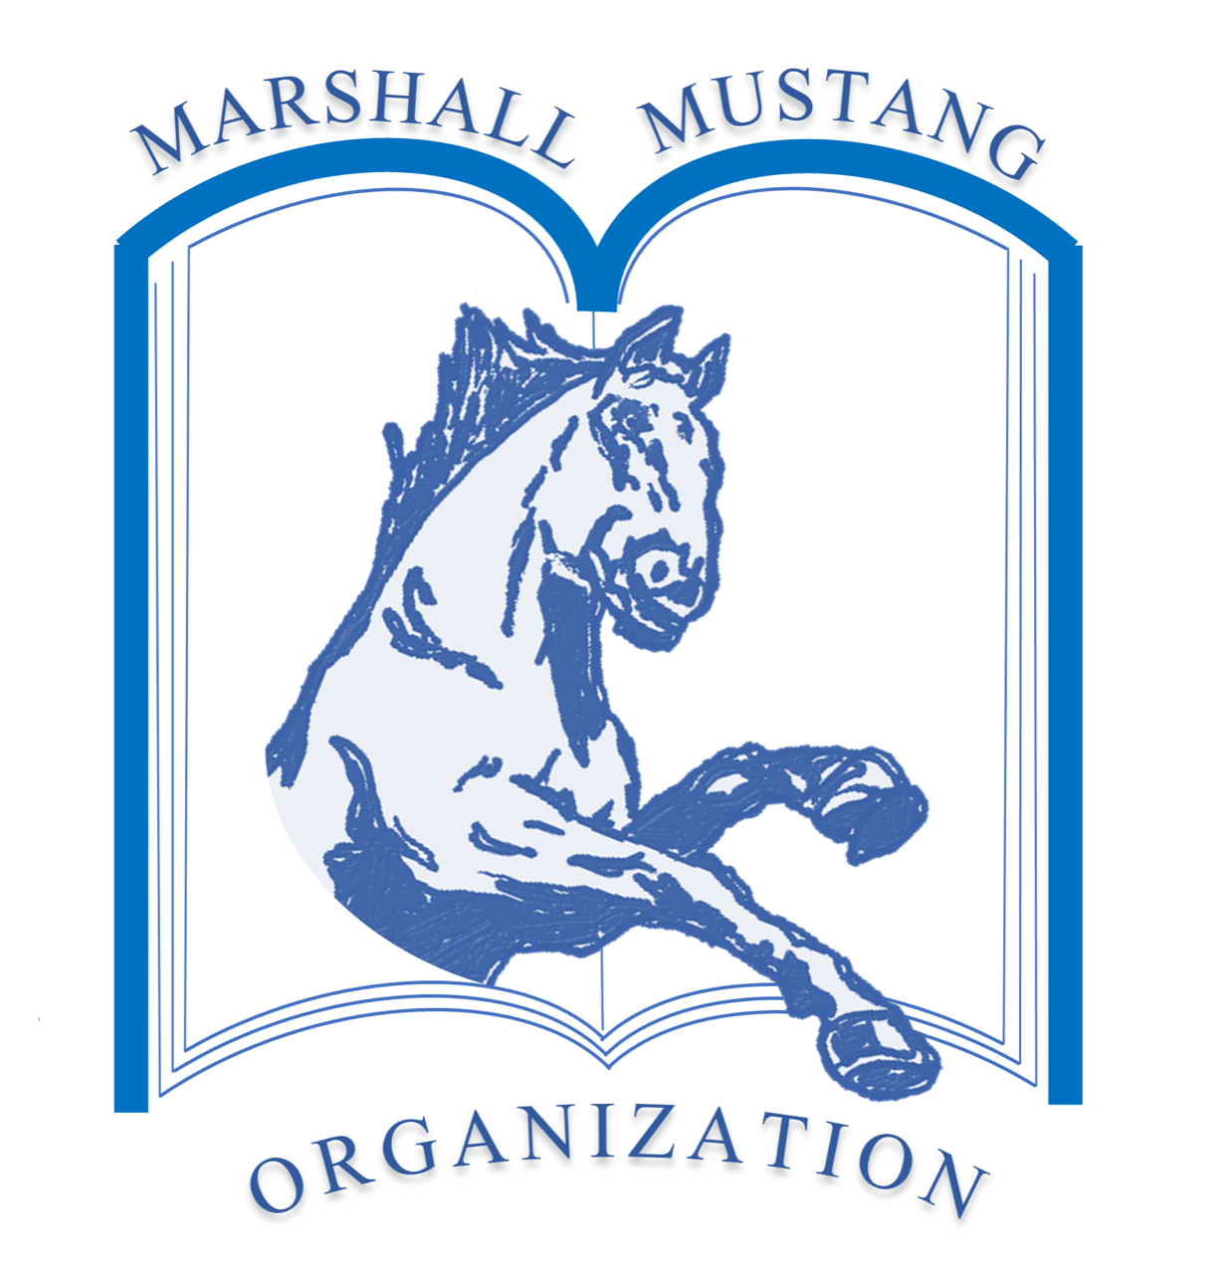

MMO Mission: To promote and enhance education in academics and citizenship through enrichment programs, financial contributions and charitable events.

