Progression of written methods for
addition of whole numbers
The aim is that children use mental methods when appropriate, but for calculations that they cannot do in their heads they use an efficient written method accurately and with confidence.

Note: It is important that children’s mental methods of calculation are practised and secured alongside their learning and use of an efficient written method for addition.

Partitioning
- Partitioning will be used throughout the school and will be represented in different ways.  - Partitioning will also be used for the other three operations (subtraction, multiplication and division).  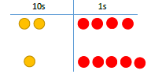  For example:  using place value counters  and base ten  - Children need to understand the value of the digits within numbers, recognising that 13 is not a 1 and a 3 but a 10 and a 3 (13 = 10 + 3).  - Children will be encouraged to both draw and answer questions using different representations. | 2 4  1 5 +  _____
Key Stage 1 (Years One and Two):
Children need to:  - Add one-digit and two-digit numbers to 20, including zero  - Recall and use addition and subtraction facts to 20 fluently, and derive and use related facts up to 100  - Understand that numbers can be added in any order  - Solve problems that involve addition (and subtraction)  The children will be using concrete objects to make different numbers. They will then use pictorial representations to record their numbers. | Numbers are represented in different forms  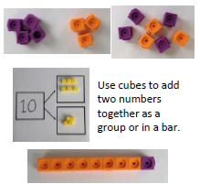  Using concrete objects:  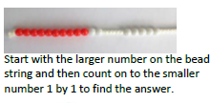  In pictorial representation:  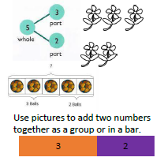

Years 3 – 6: Column Addition
Year 3 need to:  - Add 3-digit numbers with 1’s, (123+4), 10’s (123+20), and 100’s (123+300) mentally.  - Add up to 3-digit numbers using column addition.  - Solve missing number problems.  - Estimate the answer before answering the question and use the inverse to check.  Year 4 need to:  - Add 4-digit numbers with 1’s, (1234+4), 10’s (1234+20) and 100’s (1234+300) mentally.  - Add up to 4-digit numbers using column addition.  - Solve missing number problems.  - Estimate the answer before answering the question and use the inverse to check.  Year 5 need to:  - Add whole numbers with more than 4-digits.  - Add numbers mentally with increasingly large numbers.  - Use rounding to check answers.  - Solve addition multi-step problems.  Year 6 need to:  - Add whole numbers with more than 4-digits.  - Add numbers mentally with increasingly large numbers.  - Use rounding to check answers.  - Solve addition multi-step problems.  - Use simple formulae, including algebra. | Children will use place value counters to support their understanding of addition using columnar written methods.  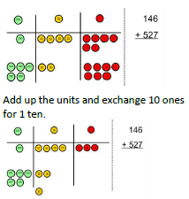  As the children progress, they will then use a formal written method.  Column addition requires children to add together the ones column first, the tens column second, and then the hundreds column. If there are four digits, the thousands will then be added together.  47 258 366  + 76 + 87 +458  123 345 824  1 1 1 1 1 1

