Progression of written methods for
subtraction of whole numbers
The aim is that children use mental methods when appropriate, but for calculations that they cannot do in their heads they use an efficient written method accurately and with confidence.

Note: It is important that children’s mental methods of calculation are practised and secured alongside their learning and use of an efficient written method for subtraction.
Key Stage 1 (Years One & Two):
Children need to:  - Know what the subtraction and equals sign look like and what they mean.  - Have instant recall of number bonds within 20 and use related facts to 100.  - Be able to subtract one-digit and two-digit numbers (Year One) and two-digit by two-digit numbers.  - Be able to answer subtraction problems, using concrete objects and pictorial representations. | 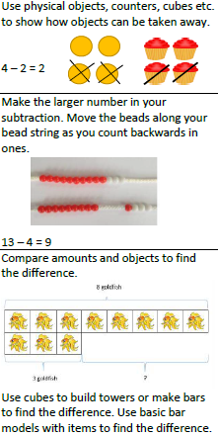  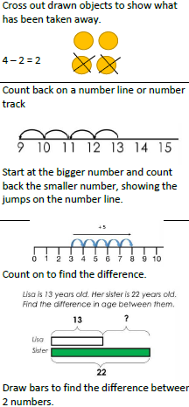  Examples of concrete objects: Pictorial representations:

Years 3 – 6 : Column Subtraction
Year 3 need to:  - Subtract 3-digit numbers with ones, (123-4), 10’s (123-20), and 100’s (123-100) mentally.  - Subtract up to 3-digit numbers using column subtraction.  - Solve missing number problems.  - Estimate the answer before answering the question and use the inverse to check.  Year 4 need to:  - Subtract 4-digit numbers with ones, (1234-4), 10’s (1234-20) and 100’s (1234-200) mentally.  - Subtract up to 4-digit numbers using column subtraction.  - Solve missing number problems.  - Estimate the answer before answering the question and use the inverse to check.  Year 5 need to:  - Subtract whole numbers with more than 4- digits.  - Subtract numbers mentally with increasingly large numbers.  - Use rounding to check answers.  - Solve subtraction multi-step problems.  Year 6 need to:  - Subtract whole numbers with more than 4- digits.  - Subtract numbers mentally with increasingly large numbers.  - Use rounding to check answers.  - Solve subtraction multi-step problems.  - Use simple formulae, including algebra. | Column subtraction requires children to subtract the ones column first, the tens column second, and then the hundreds column. If there are four digits, the thousands will be subtracted last.  To support their understanding, children will make these calculations using place value counters and then should be encouraged to draw a pictorial representation.  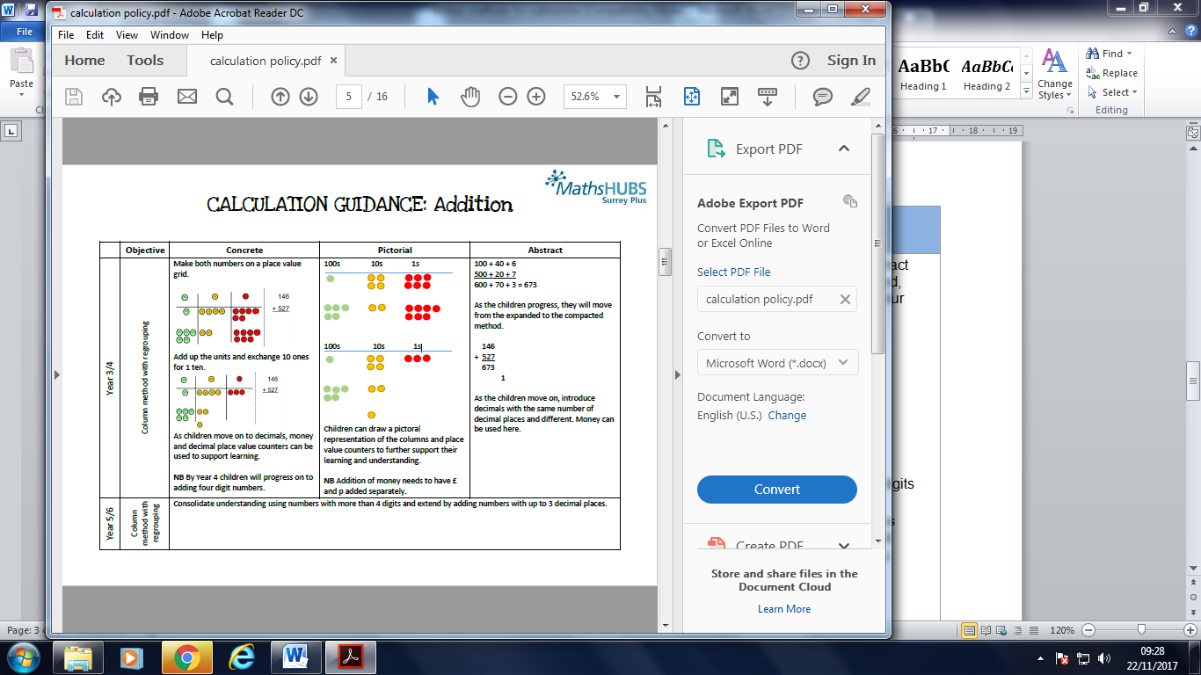  The children will then move onto using a written method.  It is important for children to recognise the value of the digits (e.g. 64-32 is 60-30, rather than 6-3).  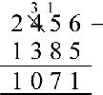  In this example you cannot answer 50–80 unless you exchange it for a hundred to change the 50 into 150 (150-80=70).

