Written methods for
multiplication of whole numbers

The aim is that children use mental methods when appropriate, but for calculations that they cannot do in their heads they use an efficient written method accurately and with confidence.

Note: It is important that children’s mental methods of calculation are practised and secured alongside their learning and use of an efficient written method for multiplication.

Key Stage 1 (Years One and Two):
Children need to:  - Answer one-step problems using objects, pictures or arrays.  - Know their 2, 5 and 10 times tables by the end of Year 2.  - Solve number sentences using the multiplication and equals sign (Year 2)  - Know that multiplication questions can be done in any order (commutative) (Year 2). | - The understanding of multiplication is introduced looking at ‘groups of’ or ‘lots of’. 7x2, is 7 groups of 2, or 7 lots of 2. Children can use counters or cubes to support this.  - This can then be supported by arrays. To show the links between multiplication.  7x2=14  2 x 7 = 14  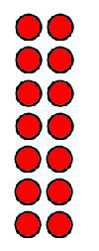  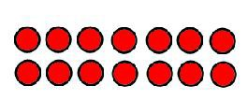  7 x 2 = 14  The children will write addition sentences. This is to understand that multiplication is the same as repeated addition. They will also write multiplication statements linked to pictures.  An example taken from Year 2:  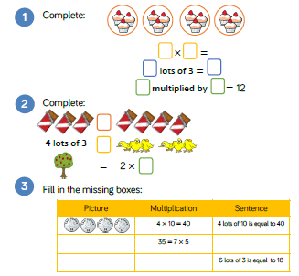

Key Stage 2 (Years 3 – 6):
In Year 3, children need to know:  - Multiplication facts for the 3, 4 and 8 times tables.  - How to write and calculate number sentences for multiplication.  - How to solve problems involving multiplication.  In Year 4, children need to know:  - Multiplication facts up to 12x12.  - How to multiply up to 3 digits by 1 digit using short multiplication.  - How to multiply three digits mentally.  - Factor pairs  In Year 5, children need to know:  - How to multiply numbers up to 4 digits by a one or two digit number.  - Multiplication facts up to 12x12.  - Factors - finding all factor pairs of a number and common factors.  - How to multiply whole and decimal numbers by 10, 100 and 1000.  - Square and cube numbers.  - How to solve problems involving multiplication.  In Year 6, children need to know:  - How to multiply numbers up to 4 digits by a two digit number.  - Common factors, common multiples and prime numbers.  - How to solve problems using multiplication.  - Estimation to check results. | Children will continue to use repeated addition to develop their understanding of multiplication  e.g.  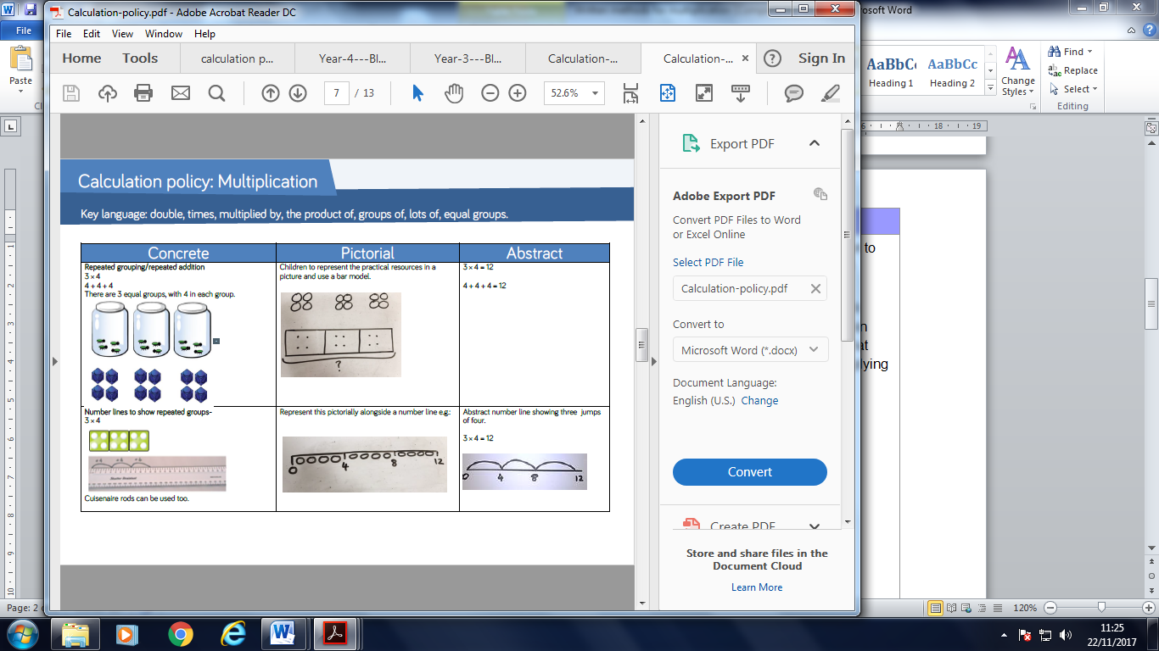  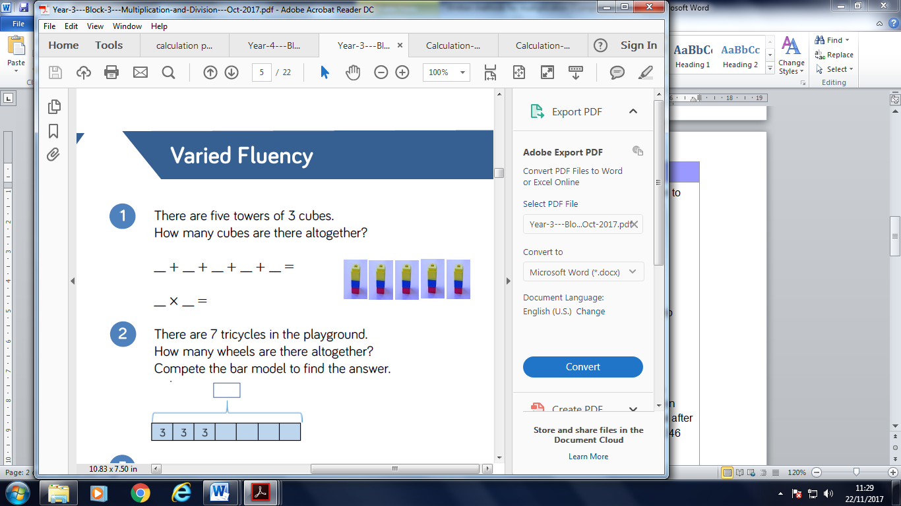  They will also use bar models and arrays (as in Key Stage 1) to help picture multiplication.  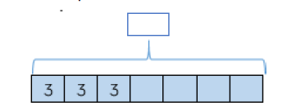  Bar Model  The next step will be to multiply using written methods. When multiplying, the children will be taught to multiply by the ones first. Looking at the question below, it is important that the children know that after multiplying 346 by 4, they are then multiplying 346 by 20 rather than 2.  346  X 24  1384  6920  8304  11

