Written methods for
division of whole numbers
The aim is that children use mental methods when appropriate, but for calculations that they cannot do in their heads they use an efficient written method accurately and with confidence.

Note: It is important that children’s mental methods of calculation are practised and secured alongside their learning and use of an efficient written method for division.
Key Stage One (Years 1 & 2):
Children need to:  - How to answer one-step problems using objects, pictures or arrays (Year 1).  - How to recall and use division facts for the  2, 5 and 10x table, including identifying odd and even numbers.  - Solve number sentences using the division and equals sign.  - Solve division problems using materials, arrays, repeated addition and mental methods.  - Solve division problems in different contexts. | 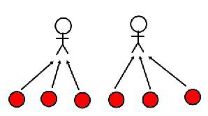  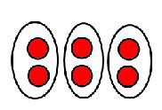  Children start learning about division by ‘sharing equally’. They will use objects (e.g. cubes) to support the understanding of sharing equally.  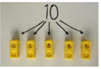
Key Stage Two (Years 3-6):
In Year 3, children need to know:  - Division facts for the 3, 4 and 8 times tables.  - How to write and calculate number sentences for division.  - How to solve problems involving division.  In Year 4, children need to know:  - Division facts for times tables up to 12x12.  - How to use place value, known and derived facts to divide mentally.  - How to solve problems involving division.  In Year 5, children need to know:  - How to divide numbers up to 4 digits by a one or two digit number.  - Division facts up to 12x12.  - How to divide whole and decimal numbers by 10, 100 and 1000.  - How to solve problems involving division.  In Year 6, children need to know:  The final method is to divide using long division with remainders.  - How to divide up to 4 digits by a two digit number using both long and short division.  - How to interpret remainders as whole numbers, fractions or by rounding.  - How to solve problems using division.  - Estimation to check results. | 