ROBERTSWOOD SCHOOL

WEEK COMMENCING MONDAY 10TH DECEMBER

|  |  |
| --- | --- |
| **WEEK AT A GLANCE**  **RM Maths – LAST WEEK**  **Some Outside Run Clubs are still on – see below** | |
| **Monday**  **10th Dec**  **Tuesday**  **11th Dec**  **Wednesday**  **12th Dec**  **Thursday**  **13th Dec**  **Friday**  **14th Dec** | ► Cheerleading (Y1-3) - Lunchtime Club – LAST ONE  ► Drum Lessons  ► Mini Tennis - After School Club – LAST ONE    ► 10.45am Prospective Parent Tour  ► Guitar Lessons  ► Dolce Christmas Lunch and Wear a Christmas Jumper Day  ► Year 6 to the Epilepsy Centre  ► Guitar Lessons  ► PFO - After School Club – LAST ONE    ► 2.00pm Years 1 and 2 Production to Parents  ► Smart Raspberry - After School Club – LAST ONE  ► 9.30am Years 1 and 2 Production to Parents  ► Cheerleading - Lunchtime Club – LAST ONE  ► Rugby Tots - After School Club – LAST ONE |

**Forthcoming Dates**

Tuesday 18th December – Star of the Term Tea Parties

Wednesday 19th December - Class Parties

**LAST DAY OF TERM – WEDNESDAY 19TH DECEMBER – FINISH AT NORMAL TIME**

R

**LETTERS, SCHOOLCOMMS AND FLYERS SENT HOME THIS WEEK**

**LETTERS**

Year 5 - Bread Making and Film Version of “Holes”

**SCHOOLCOMMS**

Years 1-6 - Cheerleading Club

Rec – Y6 - Parent Factsheet on Fortnite

Y6 - Various

**FLYERS**

Rec – Y6 - Goldhill Church

**PLE PLEASE NOTE THERE WILL BE NO CREATIVE ARTS OR READING EGGS**

**S ON MONDAY 22ND MAY.**

**RSPCA CHRISTMAS COLLECTION BOX IN SCHOOL FOYER. PLEASE DONATE ANY** **TOYS/FOOD/SNACKS.**

**We are currently looking for a relief school crossing patroller. If you are interested, please contact Georgina at** [**glongley@buckscc.gov.uk**](mailto:glongley@buckscc.gov.uk)**.**

**Dolce Christmas Lunch**

**Wednesday 12th December**

***If you have not ordered your child a Christmas Lunch, please send them into school with a festive lunch box.***

**WEAR A CHRISTMAS 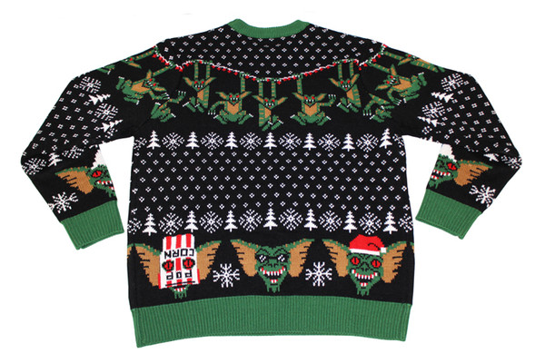 JUMPER DAY**

**WEDNESDAY 12TH DECEMBER**

**To coincide with our Dolce Christmas Lunch Day, children can wear a Christmas Jumper and bring in £1 for the NSPCC.**

**Normal school uniform is to be worn, just exchange your school jumper with a Christmas jumper.**

**NOTE THERE 2D**

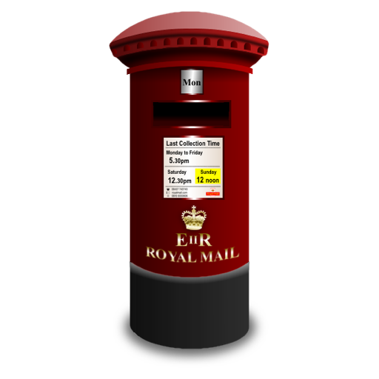**CHRISTMAS POST BOX**

**The school post box will be outside the main hall next to the Walk to School tables again next week. Your children can put their Christmas cards in the box and they will be sorted out at lunchtime every day and distributed to the children. Please make sure the recipients’ name and class are clearly written on the envelope. We ask that you make a contribution of 2p per card. There will be a basket on top of the post box for you to put the money in. 50% of your donations will be given to the NSPCC and 50% to the school fund.**

**Please go to**[**Parent Survey 2018**](https://robertswoodschool.co.uk/parent-survey)**for the results of the parent survey.**

Thank you so much for the 132 responses.

We were overwhelmed by the number that completed the survey.

The responses and comments were really positive.

6 areas scored over 95% for a combination of parents 'agreeing' or 'strongly agreeing' with statements relating to 'happiness', 'safety', being 'well looked after', being 'well taught', with 'the school being well led and managed' and families feeling that they would 'recommend Robertswood'.

The individual comments relating to the 'aspiration your child' and 'school' were also very helpful to help celebrate what we do as a school currently and will also ensure that this is carried on into the future for the benefit of children and families of Robertswood School. 