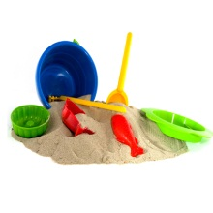

**Robertswood Nursery News 07.12.18**

Dear Parents and Carers



This week the children have been really busy finishing off their Christmas cards. They have had lots of fun printing their stars and using lots of glitter. The children have also been practising writing their name for the inside of their card. We have been really pleased to see how many children are beginning to hold their pencil with the correct grip and are starting to form some of the letters of their name correctly.

[](http://www.bing.com/images/search?view=detailV2&ccid=O6UKL4yJ&id=B1381D6C5A374EE693AB4B5AE1FF12B1CD9F37A0&thid=OIP.O6UKL4yJnO_5Rg_ZQvGkbwEsC1&q=singing+symbol&simid=608043315200263539&selectedIndex=17&adlt=strict)We are all so very proud of all the children in Nursery and Reception for their performance in the ‘Whoops-a-Daisy Angel’. The children all looked amazing in their costumes and they all sang so beautifully. We hope that you all enjoyed it too. Well done everyone!

We will continue to look at the ‘Stickman’ story and the children are all looking forward to watching the film on the IWB. They will also be making their very own stickman that the children will be able to bring home. The children will also have the opportunity to engage in lots of different Christmas activities such as making party hats and paper chains, painting snowmen and lots of colouring and cutting.

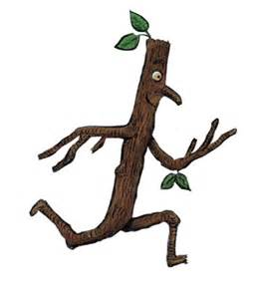The children are all very excited about our Christmas party. Please don’t forget to sign your name on the food list. We will be having the party on Friday the 14th in the afternoon and on Monday 17th in the morning

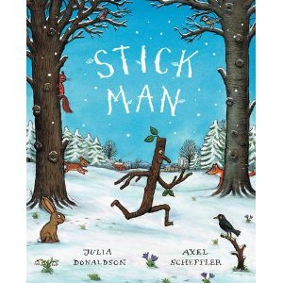

**Next week:**

Our book of the week will continue to be ‘Stickman’

**Please can you remember to bring in your parent post it notes if you haven’t done so already, thank you.**

**Please don’t forget to return any library books that you may still have at home.**

We would like to wish you all a happy weekend.

The Nursery Team.