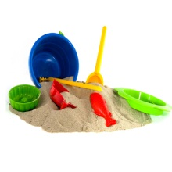

**Robertswood Nursery News 30.11.18**

Dear Parents and Carers

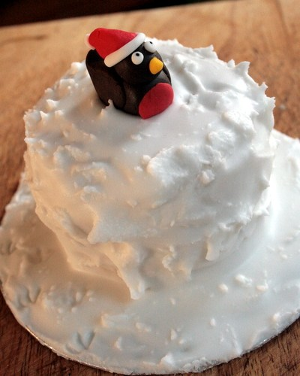This week the children were very excited to make their Christmas cake. They helped to mix all the ingredients together and put their mixture into the small tins. We put them in the oven to cook and the next day they were able to decorate them ready to bring home. At the end of the day the children were looking forward to taking them home to share with their families.

Well done Nursery!

We have been over to the big school hall this week to practise our Christmas Nativity. The children sat nicely and joined in with all the songs. The children are all looking forward to performing their nativity to their families. They are all going to make you very proud.

The children have also been very busy making their star Christmas cards and have had lots of fun using all the different colour glitters and they can’t wait to bring them home.

Please can you make sure that your child does **not** bring any toys into Nursery, this would be really appreciated.

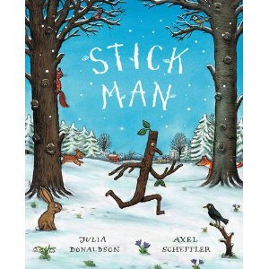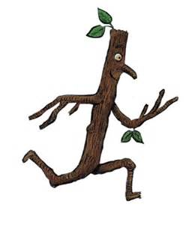

**Next week:**

Our book of the week will be ‘Stickman’

Our number of the week will be ‘10’

We will be performing our Nativity. Thank you all so much for the costumes. They are all going to look beautiful.

**Please can you remember to bring in your parent post it notes if you haven’t done so already, thank you.**

**Don’t forget to come along to the Christmas Fun Night. The children will be able to come and buy their special Christmas decoration they have made. We look forward to seeing you all.**

**Please can you remember to return your child’s library book.**

The Nursery Team.