**APPLICATION PROCESS FOR KOWHAI GRANTS**

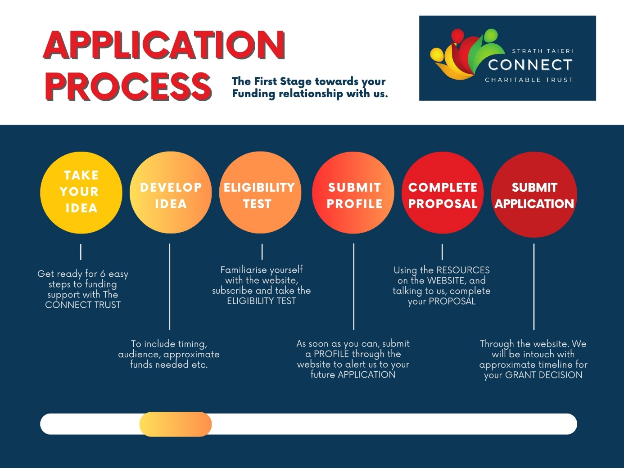

**Useful Links**

ELIGIBILITY TEST <https://strathtaiericonnect.org.nz/funding-eligibility-test>

PROFILE FORM (for Rubra, Schist and Kowhai Grants) <https://strathtaiericonnect.org.nz/resources>

TO SUBMIT PROFILE <https://strathtaiericonnect.org.nz/create-a-profile-1>

KOWHAI APPLICATION FORM <https://strathtaiericonnect.org.nz/resources>

TO SUBMIT APPLICATION FORM <https://strathtaiericonnect.org.nz/submit-an-application>

KOWHAI PROPOSAL TEMPLATE <https://strathtaiericonnect.org.nz/resources>

TO SUBMIT PROPOSAL <https://strathtaiericonnect.org.nz/submit-an-application>