**APPLICATION PROCESS FOR RUBRA GRANTS**

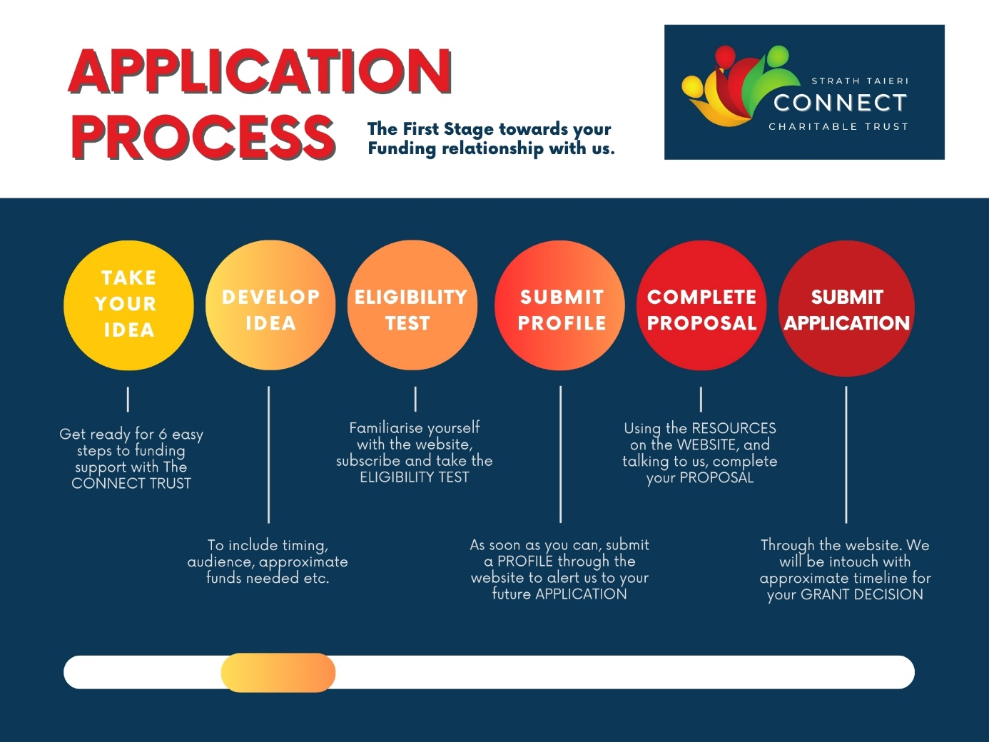

**Useful Links**

ELIGIBILITY TEST <https://strathtaiericonnect.org.nz/funding-eligibility-test>

PROFILE FORM (for Rubra, Schist and Kowhai Grants) <https://strathtaiericonnect.org.nz/resources>

TO SUBMIT PROFILE <https://strathtaiericonnect.org.nz/create-a-profile-1>

RUBRA APPLICATION FORM <https://strathtaiericonnect.org.nz/resources>

TO SUBMIT APPLICATION FORM <https://strathtaiericonnect.org.nz/submit-an-application>

PLEASE NOTE: There is no separate Proposal required for Rubra Grants, just include as much information as possible on your APPLICATION FORM.