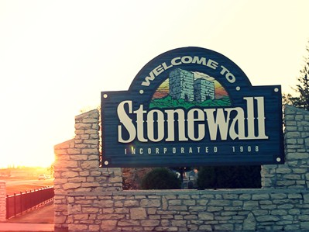
2026 Stonewall Men’s Bonspiel
March 12-15
Event contact: Email: mdunlop1455@gmail.com Phone: 204-513-1044
Online registration through the Stonewall Curling Club website is also available
Entry fee is $200 per team
Guaranteed 3 games
500 Main Street, Stonewall, MB.
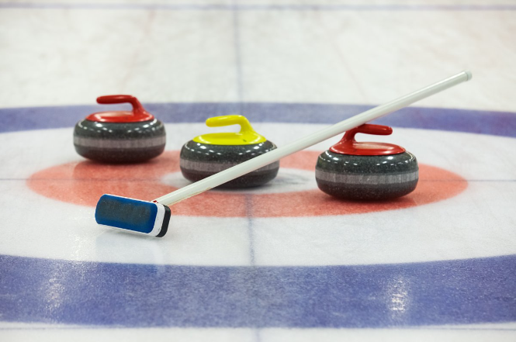
Live Music Friday Night by Neil Kitching
Late night Karaoke after the last draw Saturday night
All entries qualify for draw of a weekend golf getaway to Hecla

