Southern Hospitality Technique & Competition Camp
June 10th-14th, 2018

In Partnership with
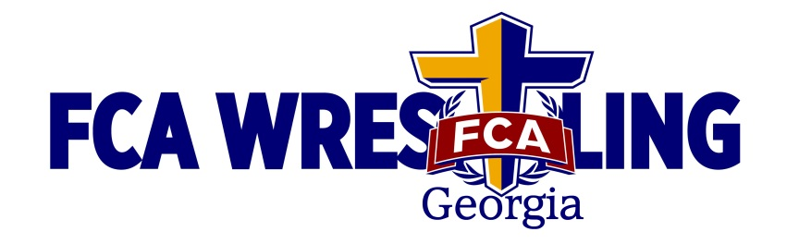

Camp Location:
Camden County High School 6300 Laurel Island Parkway, Kingsland, Georgia 31548
(located 2 miles off of Interstate 95 - 35 miles north of Jacksonville, FL or 25 miles south of Brunswick, Ga.)

Teaching Groups:
Youth/Intermediate, Advanced, and Big Man
This camp will provide wrestlers of all ages (5-18) and levels an opportunity to learn high level techniques while reinforcing basics. There will also be options for Dual Meets daily as well as individual matches in the evening.

Cost:
$260 Resident Rate: Includes 4 Nights in Hotel (4 campers per room) with all the amenities (on-site supervision), on-site meals, camp instruction, camp T-shirt, transportation to practices.

$140 Commuter Rate: Includes camp instruction, camp T-shirt, and lunch.

Final registration:

Resident Campers need to arrive at Hotel from 12:30pm-3:30pm on June 10th for check in. A Camp itinerary will be given at this time as well. First session is at 4:30pm.
Host Hotel: http://www.stayspringfield.com/
Springfield Hotel and Suites (Camden Convention Center) 1215 East King Avenue, Kingsland GA 31548

Commuters need to check in at High School Gym by 4:00pm. Commuters should check in at the High School with Coach Fegel. You will receive band or stamp upon completion.

Please make checks payable to “Camden Wrestling” and send to
113 Fiddlers Cove Drive Kingsland, Ga. 31548 before June 1st
(If you are attending with a large group please ask your Coach how he wants to handle applications/payment)

Contact information…Email Jess Wilder at jwilder@camden.k12.ga.us
or call/text cell(912) 674-9373

Camp Itinerary

Sunday June 10th

Check in 12:30pm-3:30pm Hotel
Session 1 4:30pm-6:00pm Technique
Session 2 6:00pm-8:00pm Live Wrestling
Dinner 8:00pm (Pasta Buffet)

Monday June 11th
Breakfast 7:30am- 8:30am
Session 3 9:30am-11:30am Technique
Lunch 11:30am-12:30pm Lunch
Session 4 4:00pm-5:45pm Technique
Session 5 6:00pm -7:30pm Live Wrestling
Dinner 7:30pm (Pizza)

Tuesday June 12th
Breakfast 7:30am- 8:30am
Session 6 9:30am-11:30am Technique
Lunch 11:30am-12:30pm Lunch
Session 7 4:00pm-5:45pm Technique
Session 8 6:00pm -7:30pm Live Wrestling
Dinner 7:30pm (BBQ)

Wednesday June 13th
Breakfast 7:30am- 8:30am
Session 9 9:30am-11:30am Technique
Lunch 11:30am-12:30pm Lunch
Sessions
10,11 1:00pm Individual Tournament
Bracketed Tournament to a Champion but once you lose you will continue to get matches every round in a ‘call-out” format.
High School Champions receive Gold Camp T-Shirt
Youth and Middle receive medals for Top 3
Dinner 7:30pm (McD, BK or Coach Choice)

Thursday June 14th
Breakfast 7:30am- 8:30am
Session 12 9:30am-11:00am Technique review & “wrestling things I wish I knew”
Depart 11:00am-Noon Hotel (Shower, Pack, and Depart)

Wrestlers can be picked up from CCHS at 11:00am or the hotel from 11:00am-Noon.
Camp Technicians
Scott Reyna
3X NCAA Division 1 All-American (Oklahoma State)
2X Oklahoma State Champion (Midwest City)

Andy Medders
NAIA National Champion
4x All-American
Florida State Champion

Josh Henson
Head Coach Shorter University
NCAA Division 1 All-American

Dorian Henderson
4X NCAA National Qualifier
3X State Champion
Fargo and Senior National All American

Michael Irving
NAIA National Champion
4x Collegiate All-American
5th on United States Olympic Ladder
Olympic Trials Competitor

Jess Wilder
Georgia High School Coach of the Year
2012, 2105, 2016, 2017, 2018 State Champs
Former Head Coach of Cumberland College for 9 years
7 Consecutive top ten National finishes

There will be several other technicians as well…

Southern Hospitality Camp Application

Student Name:___________________________________________

School __________________ DOB__________Age _____ T shirt size__________

Medical Insurance Company____________________________________________

Company Address____________________________________________________

Policy # :________________________ Policy Owner________________________

Allergies________________________ Medications__________________________

Parent or Guardian will be contacted in case of emergency.

Waiver and Release: I, the undersigned, hereby certify that I am the parent or legal guardian of the camper. In consideration of my application being accepted, I, intending to be legally bound, do hereby, for myself, my heirs, executors and administrator, waive, release, and forever discharge any and all rights and claims for damages, which I may have or assign which may hereafter accrue to me against Camden County School System and instructors for any and all damages which may be sustained or suffered by me in connection with my association with, or participation in, and for arising out of my traveling to or returning from Southern Hospitality Wrestling Camp to be participated on the grounds of Camden County High School and the Springfield Suites. The camp directors have permission to seek medical attention for my child, and I grant permission for the implementation of appropriate medical treatment in event of injury or sickness. I hereby certify that my child is physically fit to participate in an active wrestling camp and that I know of no physical impairments which would limit participation.

I hereby certify that I have read and fully understand this waiver of liability

I understand that any camper disregarding camp rules will be sent home with no refund of their camp.

Signed (parent or Guardian) ______________________

Home (______)________________________________

Cell (______)_________________________________

Work (______)_________________________________

Additional Contact in Case of Emergency ______________________________________

