# WORLD FEDERATION OF INTEGRATIVE HEALTH

Address: University of East-West Medicine  
595 Lawrence Expressway, Sunnyvale, CA. 94085, USA  
Tel: +1-408-733-1878 Email: wimcongress@gmail.com

## Visa Invitation Letter

To Whom It May Concern,

This letter serves as an official invitation to:

• Full Name: __________

• Passport Number: ______________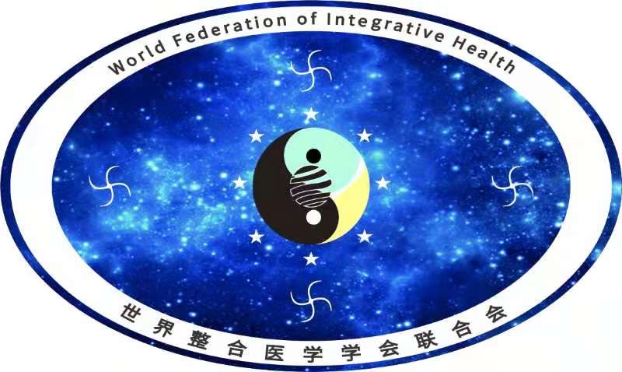

• Date of Birth: ______________

On behalf of the Organizing Committee of the 9th World Congress of Integrated Medicine， hosted by the World Federation of Integrative Health and organized by the University of East-West Medicine, we are pleased to invite the above-named individual to attend the Congress, which will be held from December 5–7, 2025 at the University of East-West Medicine in Silicon Valley, California, USA.

The theme of this year’s Congress is:  
“Great Medicine · Great Health · Great Industry.”

The event will feature multiple specialized forums, including but not limited to:  
- AI and Traditional Chinese Medicine  
- Women’s Health  
- Cancer Rehabilitation

More than 300 participants are expected, including experts, scholars, medical academicians, distinguished TCM masters, university leaders, and representatives from healthcare enterprises across over 60 countries.

[Invitee’s Name] is invited in the capacity of expert and will participate in academic exchange and related activities during the Congress. This invitation letter is issued as an official supporting document for the purpose of applying for a U.S. visa.

### Important Notes:

1. The Congress does not cover visa application fees, international airfare, accommodation, or personal expenses. All related costs shall be borne by the participant.

2. The Organizing Committee will provide an official certificate of participation and on-site registration proof upon attendance.

3. The invitee is required to comply with all applicable laws and regulations during their stay in the United States.

We sincerely look forward to your participation in the 9th World Congress of Integrated Medicine and greatly appreciate your support for the global advancement of Integrated Medicine.  


Respectfully,

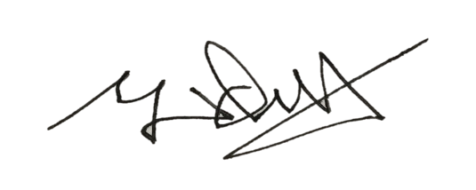  
Dr. Yingqiu Wang  
President, University of East-West Medicine  
Chair, 9th World Congress of Integrated Medicine

Date: 9/30/2025

Contact Information:  
- University of East-West Medicine (uewm.edu) | Tel: +1-408-808-9168  
- Secretariat, World Federation of Integrated Medicine Societies (wfih.org) | Tel: +1-626-215-3353