The 8th World Integrative Medicine Congress
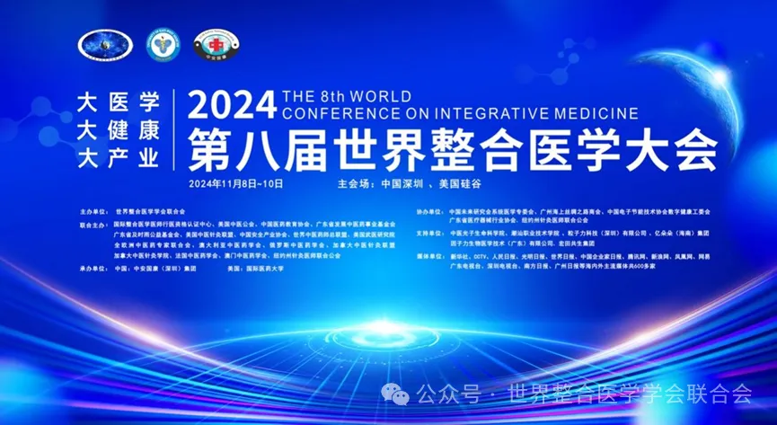
In this golden autumn season, with high skies and fragrant osmanthus, we gathered in this city of innovation and dreams to witness the grand in-person event of the Eighth World Integrative Medicine Congress, held from November 8-9, 2024, at the Shenzhen OCT InterContinental Hotel and the main campus of the Silicon Valley International University of Medicine. The online conference is simultaneously broadcast globally from November 8 to 12, continuously from 9 AM to midnight daily, with themed forums held online throughout the event.
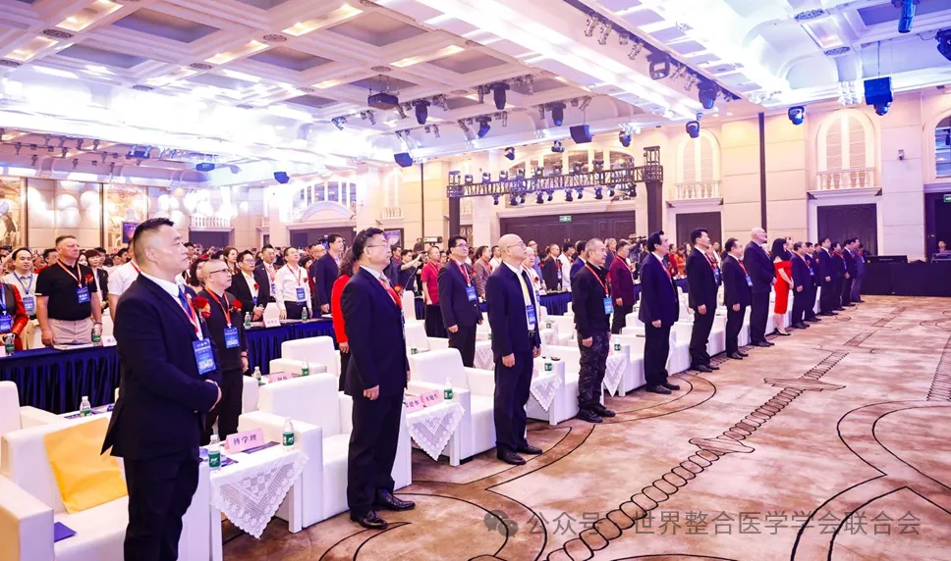
The Silicon Valley International University of Medicine and Qihuang Online streamed the event simultaneously, with the congress hosted by the World Federation of Integrative Medicine Societies and co-hosted by various institutions, including the American Association of Traditional Chinese Medicine, China Medical Education Association, China Safety Industry Association, Chaoshan Vocational and Technical College, the European Federation of Chinese Medicine Experts, the Australian Chinese Medicine Association, the Canadian TCM and Acupuncture Alliance, and the American Wu Yi Research Institute. Organized by Zhong’an Guokang Group and the International University of Medicine, the event brought together thousands of medical experts and scholars from the Americas, Asia, Europe, Australia, and Africa, marking a significant event in global medical history. To encourage learning in integrative medicine, six free credits were offered to medical students and professionals in China, along with 24 free credits for licensed acupuncturists in California and across the United States (details available at https://wfih.org (https://wfih.org/)).
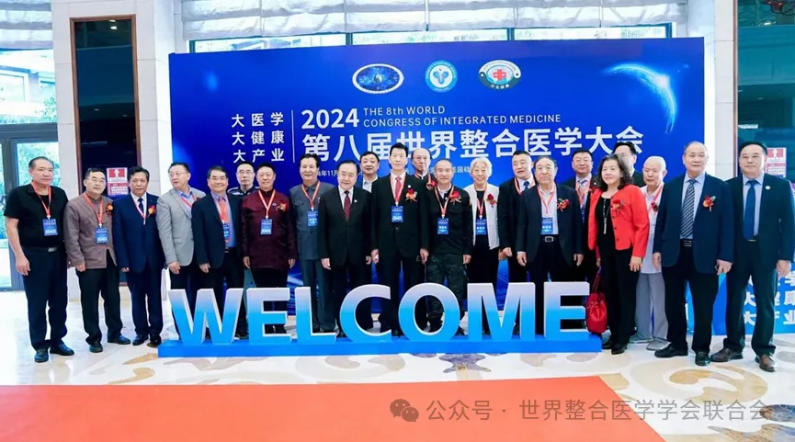
The Eighth World Integrative Medicine Congress was led by Honorary Chairman Academician Fan Daiming and Chair Dr. Wang Yingqiu, with Executive Chairs Dr. Xueli Fu (USA) and Dr. Gao Jinglian (China). The congress presidium included Chairman Academician Huang Zhengming, co-chairs Professor Zhu Zhenggao and Academician Ruan Shaoping, and over 20 Chinese academicians and TCM masters, including Li Diangui, Huang Chuanguo, Zhang Boli, Yu Mengsun, Shi Xuemin, and Wei Guikang. More than 50 university presidents, over 200 hospital presidents, representatives from 500 health and medical enterprises, and over 60 domestic and international venture capital firms gathered in Shenzhen. Co-hosts included the Australian Chinese Medicine Association, the American Association of Traditional Chinese Medicine, the American Acupuncture Alliance, the Canadian TCM and Acupuncture Alliance, and the European Federation of Chinese Medicine Experts, with support from 30 additional organizations, such as the World Federation of Acupuncture-Moxibustion Societies' Critical Care Specialty Committee, Needle Knife Specialty Committee, the French Pharmacological Society, and the Guangdong Provincial Foundation for Traditional Chinese Medicine Development. Attending medical experts shared the latest research and innovative clinical experiences in integrative medicine, ushering the world into an era of “Preventive Care as a Priority, Universal Health for All.”

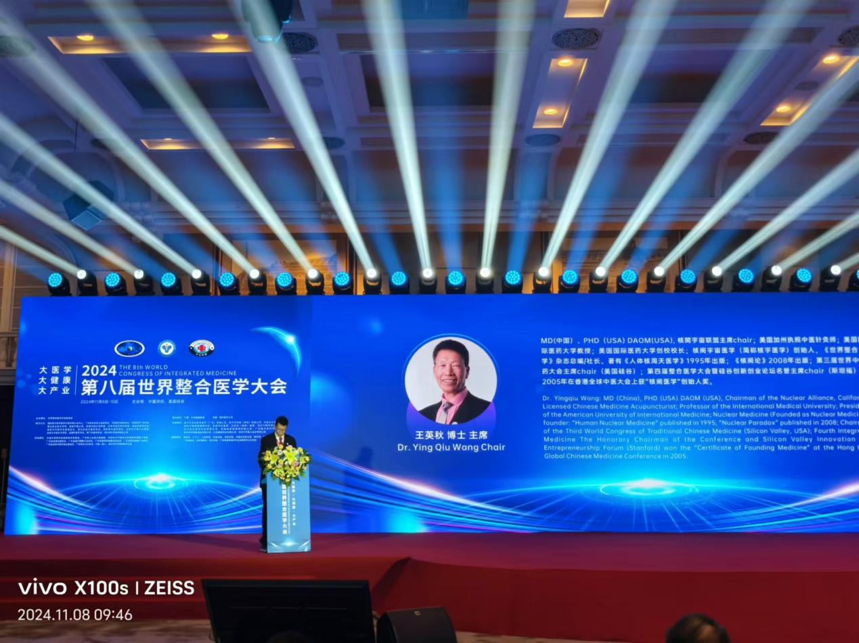

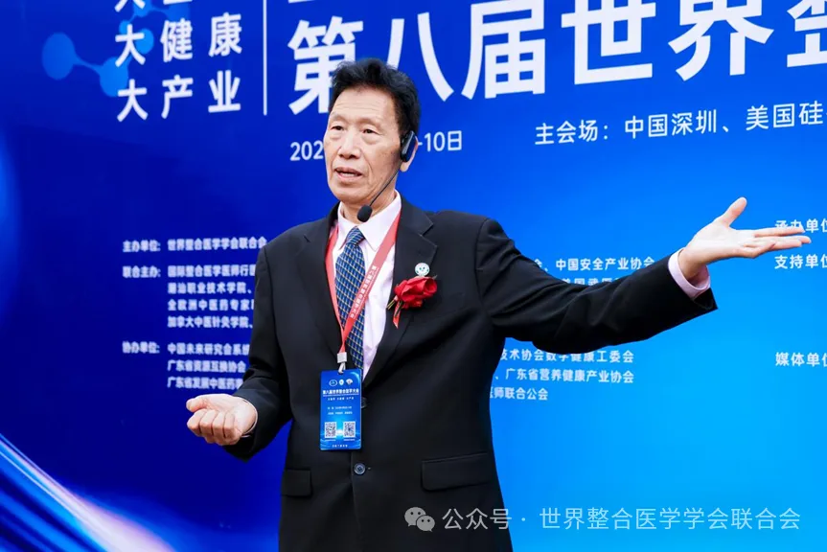
In his speech, Dr. Wang Yingqiu, President of the World Federation of Integrative Medicine Societies and the International University of Medicine, stated that a comprehensive implementation of integrative medicine in China could potentially save billions of yuan in healthcare costs each year. The core theme, Nuclear Universe Medicine, emphasizes a TCM-centered medical system where the essence of life lies in quality, quality lies in dimensions, and dimensions in the "Three Connections" — spirit, energy, and pulse. TCM, with its locally sourced, locally applied, and locally integrated practices, is simple and effective, enhancing the body’s balance and immunity through yin-yang harmony. This balance is achieved by improving one's energy and spirit, with earthly qi representing yin and heavenly qi representing yang.
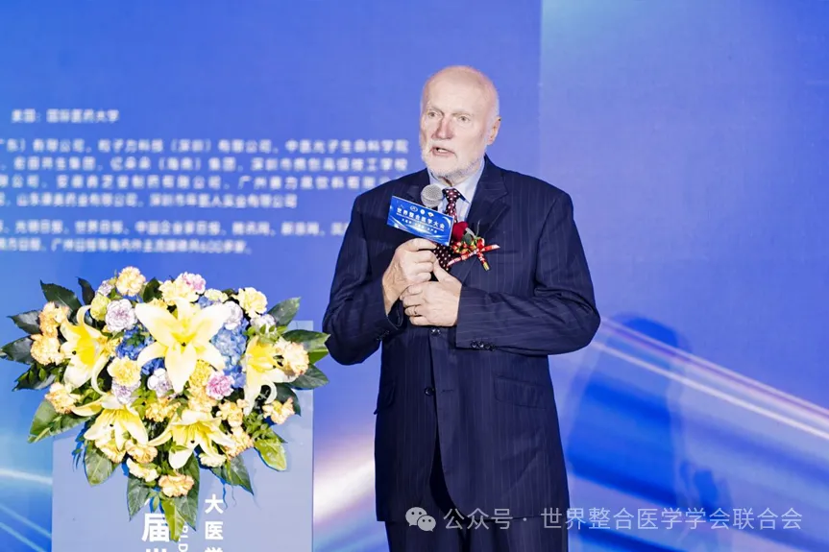
Professor Ante Simonic, MD, Ph.D., co-chair of the Eighth World Integrative Medicine Congress, is an expert in neuropharmacology, former Deputy Prime Minister of Croatia, and former member of the Croatian Parliament, where he served as Vice President of the Farmers' Party. He has also held the role of Croatian Ambassador to China, Mongolia, and North Korea. Professor Simonic has served as a professor and dean at the University of Rijeka Medical School for over 30 years and was elected three times as President of the Croatian National Pharmacology Society. Additionally, he founded and chaired the Croatia-China Friendship Association and is a senior advisor, committee chair, and lifetime professor at Rijeka Medical School. He received the Chinese Government Friendship Award in 2017 and the Chinese People’s Friendship Ambassador Award in 2024.
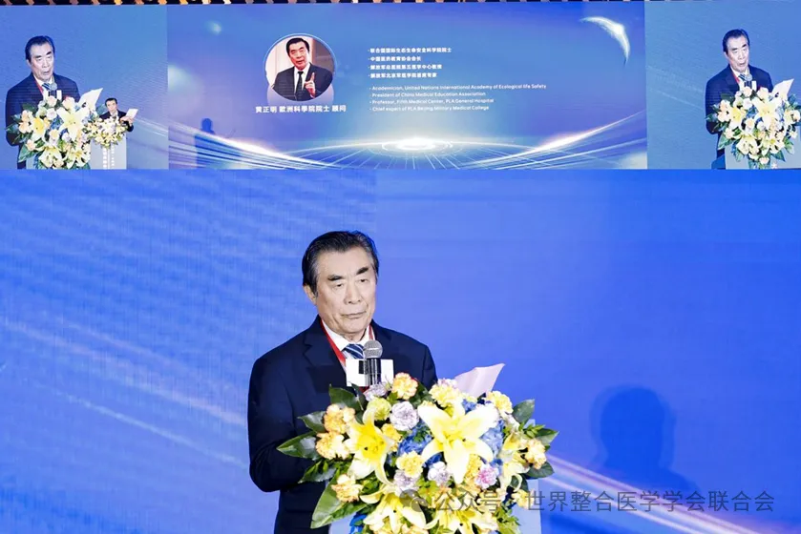
Professor Huang Zhengming, chair of the presidium of the Eighth World Integrative Medicine Congress, emphasized in his speech that the development of integrative medicine represents not only an innovative trend but also a profound reflection and active exploration of global health. By organically integrating basic, clinical, preventive, traditional, and rehabilitation medicine, this approach provides patients with more comprehensive, systematic, and personalized medical services.
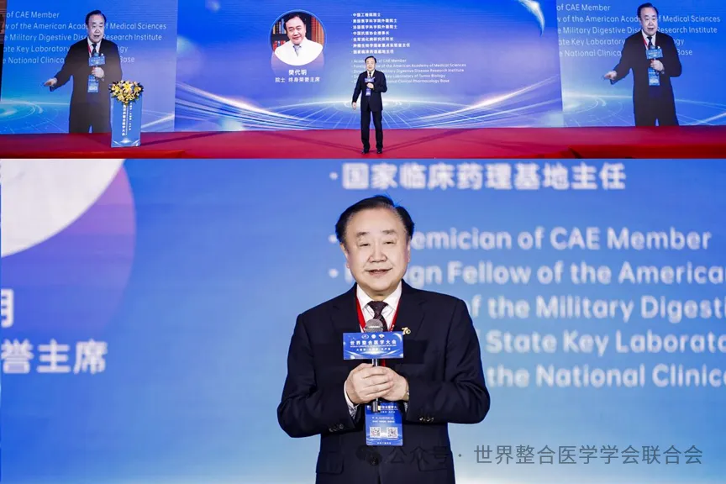
Academician Fan Daiming, honorary chair of the Eighth World Integrative Medicine Congress, former Vice President of the Chinese Academy of Engineering, a foreign academician of the National Academy of Medicine (USA), and the French Academy of Medicine, Chairman of the China Anti-Cancer Association, and director of several major medical institutions in China, delivered a keynote address on the core theories of integrative medicine. He emphasized that integration is a characteristic of this era and a key to solving major challenges. Medicine, he stated, originates from the initial expression of human suffering and the desire to alleviate it. Researching the essence and development of medical knowledge aims to guide medical personnel in disease prevention and treatment, building a higher level of medical knowledge systems.
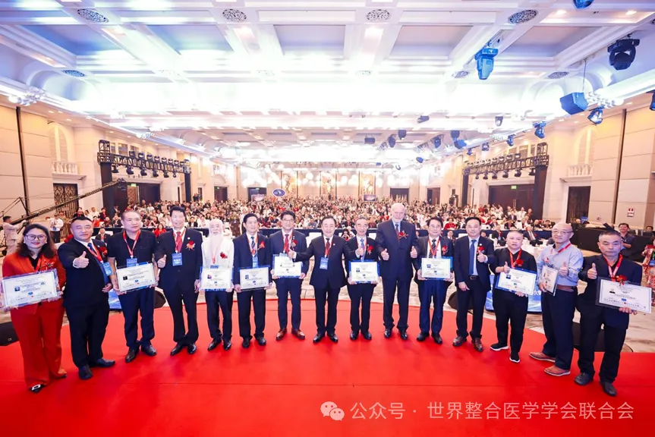
The congress also awarded 11 Outstanding Technology Innovation Awards, recognizing significant academic achievements and supporting advancements in the field of integrative medicine.
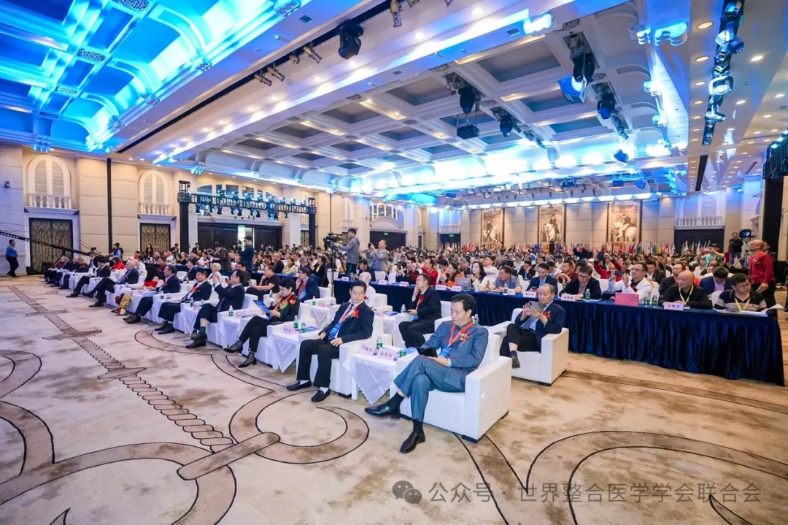
In conjunction with the publication of Integrative Medicinemagazine, the forum invited prominent domestic and international academicians and TCM masters to discuss the challenges and opportunities in current medical development. Dr. Gao Jinglian moderated the high-level roundtable discussion, which included guests like Dr. Wang Yingqiu (USA), Academician Fan Daiming, Master TCM Practitioner Li Diangui, Professor Ante Simonic (Croatia), Professor Zhu Miansheng (France), Dr. Cheng Jianhua (Australia), Dr. Zhang Chunxiang (President of Southwest Medical University), and Dr. He Yuanyong (Fellow of the Royal College of Physicians, UK).
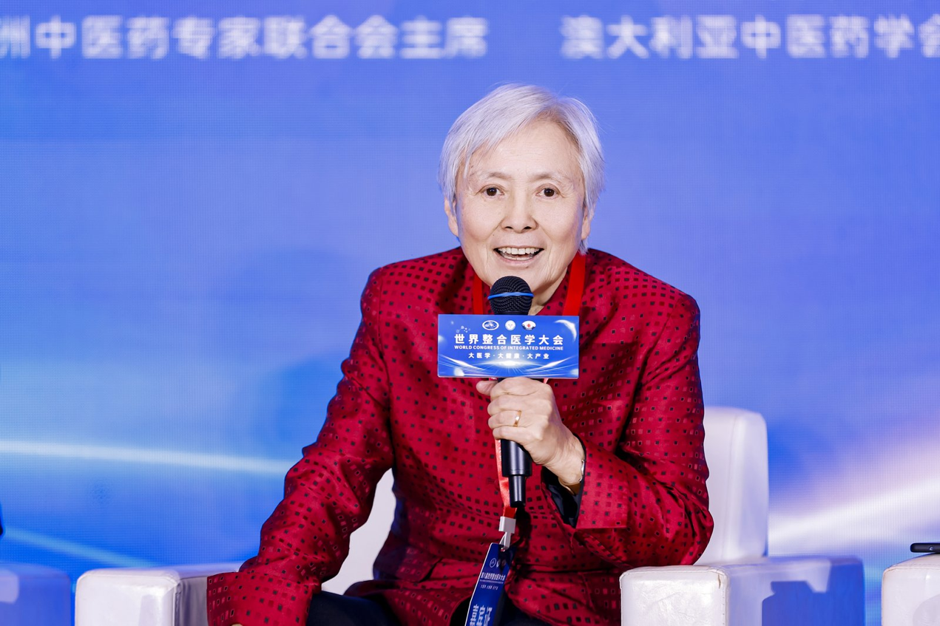
The congress highlighted three main themes under the overarching topic of "Grand Medicine, Grand Health, and Grand Industry":
1. High Dimensionality: Promoting the integration of physical, mental, and spiritual health, eliminating diseases at the earliest stages.
2. Global Vision: Embracing TCM’s principles of "Harmony of Man and Nature, Natural Law, Unity of Universe and Humanity," incorporating various global medical theories and techniques.
3. Public Benefit: Promoting practices like Taiji and Qigong, which are cost-effective, time-saving, and highly effective, with morning exercise sessions streamed worldwide to guide people toward a healthier, more successful, harmonious world.
Professor Jiang Dan, Chair of the Academic Committee, encouraged experts, medical institutions, and investors to pursue integration and innovation, strengthening global medical collaboration. Specialized forums covered topics such as women’s health, men’s health, anti-aging, depression and cancer recovery, sleep health, syndrome management, cardiovascular health, hypnosis, quantum medicine, micro-blade acupuncture, periosteal activation, needle knife therapy, structural and minimally invasive medicine, TCM infertility treatment, Taiji prescription standards, and international TCM culture. The congress provided a broad and accessible platform for academic exchange for the global medical community and public health.
Professor Lu Biao, Director of the Expert Committee, mentioned that during the congress, 100 experienced TCM doctors offered free consultations to attendees, with an estimated 6,000 patients over two days. This effort addressed chronic, unresolved health issues, showcasing TCM’s unique appeal. Representatives like Lu Shengchun, Liu Zhenhuan, Bo Zhiyun, and others were awarded the Outstanding Technology Innovation Award for individual and organizational contributions.
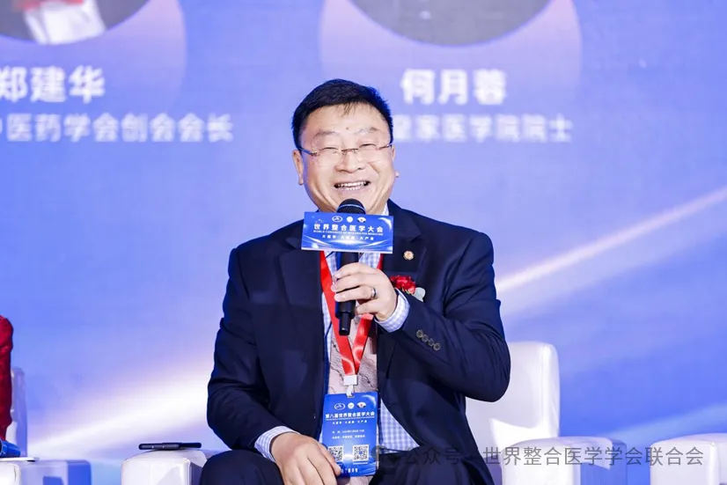
Professor Cheng Jianhua, current Vice President of the World Federation of Chinese Medicine Societies and co-chair of the congress, noted that the event supports global TCM promotion and has gained enthusiastic participation from experts, scholars, and medical seekers from over 60 countries.
The congress also announced three major projects: the establishment of the Guangzhou Teaching Division (Preparatory Department) at the International University of Medicine, the International Certification Center for Integrative Medicine Practitioners, and the Youth Depression Recovery Center at the International University of Medicine. Zhong’an GuokangGroup, along with Factor Life Biomedical Technology (Guangdong) and Particle Force Technology (Shenzhen), and the Guangdong Provincial Timely Rain Charity Foundation will support the recovery of 1,000 youth depression patients.
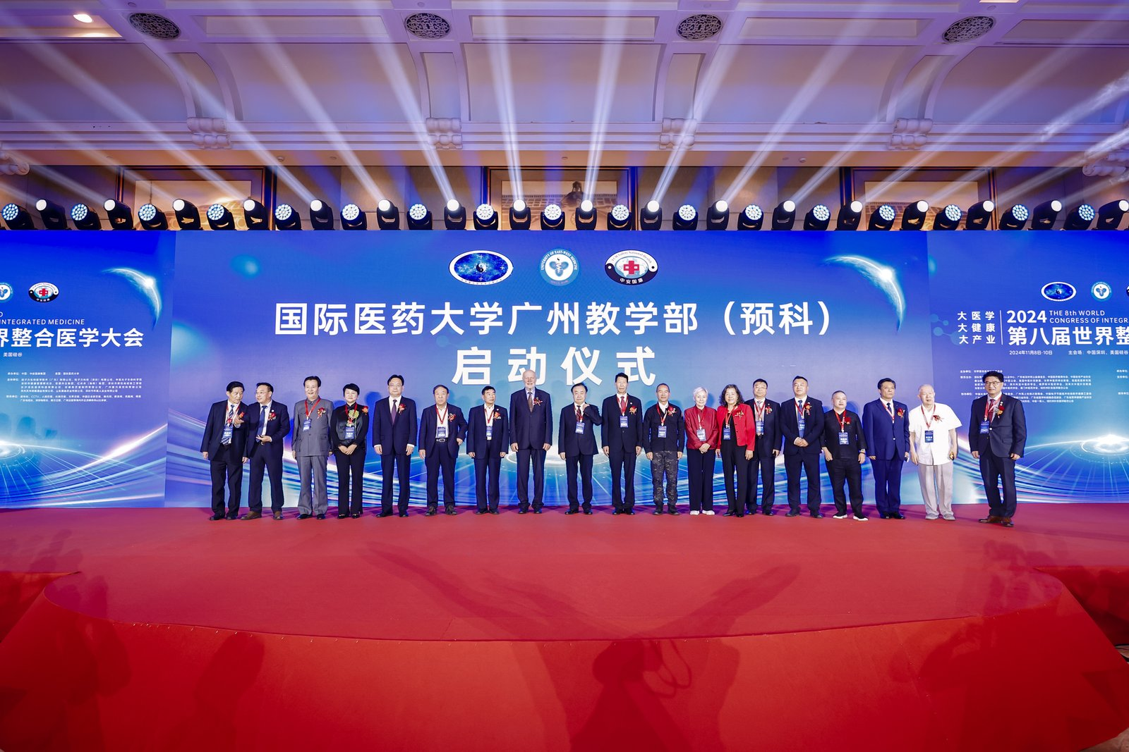
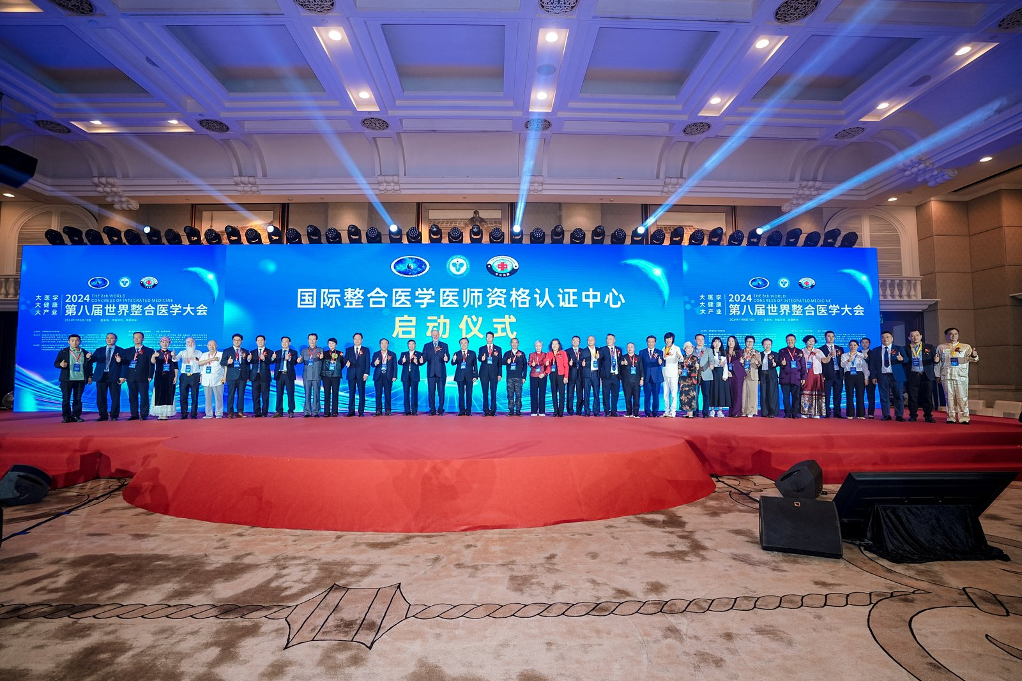
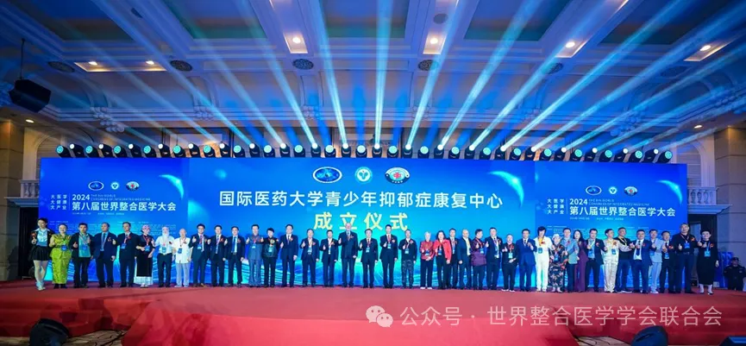
Participants included prominent medical professionals such as Zhu Miansheng (France), Zhang Chunxiang, Yu Shuguang, Fang Bangjiang, Mary Jo (USA), Huang Guojian (Canada), Zhu Zhenggao, Wu Jihua (Russia), Jiang Dan (UK), Lu Shengchun, Liu Meichang (USA), and others from multiple countries and regions. The World Federation of Integrative Medicine Societies, headquartered in Silicon Valley, is a global organization led by the International University of Medicine, and this congress has attracted experts, scholars, TCM masters, and academicians from around the world, making it one of the most active academic organizations globally.
The congress covers fields such as Western medicine, TCM, spinal neurology, and physical therapy, and includes Western natural therapies like crystal and hypnotherapy, herbal medicine, and health-promoting exercises such as yoga, Qigong, and Taiji. It also showcases cutting-edge technologies like cytokines, stem cell therapy, targeted therapy, robotic-assisted therapy, laser treatment, traditional Chinese herbal medicines, and vitamin supplements.
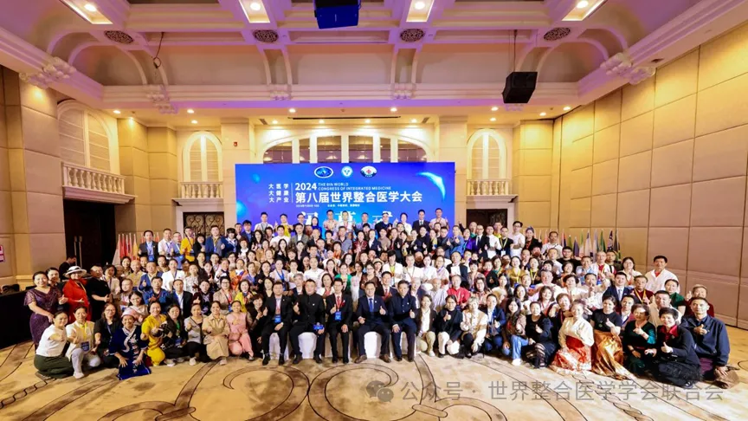
The mission of the World Federation of Integrative Medicine Societies is to be people-centered, aligning with Academician Fan Daiming’s holistic integrative medicine perspective. With active participation from over 60 countries and regions, key members include Australia’s largest Chinese Medicine Association, the European Federation of Chinese Medicine Experts, and the Canadian TCM and Acupuncture Alliance, making it a TCM-led academic organization with national chapters and specialized academic committees holding annual congresses.
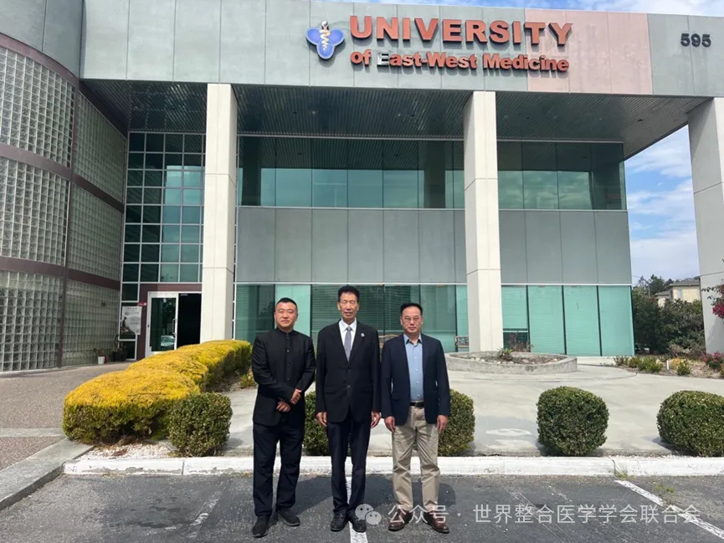
(Left) Dr. Fu Xueli, the lifelong Executive Chair of the Congress, serves as Vice President of the university, Dean of the College of Continuing Education, and President of the American Martial Arts Medicine Research Institute. (Center) Dr. Wang Yingqiu, President of the World Federation of Integrative Medicine Societies and President of the International Medical University. (Right) Dr. Gao Jinglian, Secretary General of the World Federation of Integrative Medicine Societies, is also Vice President of the American International Medical University.
The 8th World Integrative Medicine Congress has become a historic milestone in global medical history. With nearly a thousand media outlets covering the event in Chinese and 600 major English-language overseas Chinese media sources reporting on it, the Congress has reached the entire global Chinese-speaking community. The Congress proceedings are published in a 350-page compendium, and the 80-page World Integrative Medicine journal. Under the leadership of Dr. Fu Xueli and a team of 20 volunteers who worked tirelessly for half a month, and with sponsorship from Tongqi Pharmaceuticals, 3,000 copies of the print version were produced, while the digital version was released globally to widespread acclaim.
Particularly noteworthy is the "Integrative Medicine Declaration," signed by 100 academicians and 100 university presidents under the leadership of Academician Fan Daiming. This declaration appears prominently in both publications and has also been published on the official website of the World Federation of Integrative Medicine Societies. Academician Fan Daiming serves as Chief Advisor for the World Integrative Medicine journal, with Dr. Wang Yingqiu as Editor-in-Chief and Publisher, and Dr. Fu Xueli as Managing Editor. The journal's academic caliber has been highly praised.
As Honorary Chair of the Congress, Academician Fan Daiming will deliver a keynote address in Xi'an at a massive Integrative Oncology Congress with 50,000 attendees from November 14-17. Despite the tight schedule, Academician Fan will appear in person, supporting the development of integrative medicine worldwide. His efforts also help promote the 6th World Traditional Chinese Medicine Forum, which will be held in Kuala Lumpur from November 15-17, bolstering the global exchange and advancement of integrative medicine.
