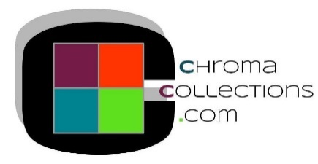

PRODUCT SPECIFICATION – SECTION 09 54 00 – ACOUSTICAL CEILING PANELS
Flats^{tm} Canopies: Scrim Surfaced Series

2.1 MANUFACTURER

A. Chroma Collections
    - Address: 415 Nelson Pl., La Crosse, WI 54601
    - Phone Number: 608-785-1232
    - Fax: 608-785-1233
    - Website: www.chromacollections.com
    - Email: customerservice@chromacollections.com

  - ACOUSTIC CEILING UNITS

A. Acoustical Ceiling Panel (ACP) - [Type ACP-1]
- Name: Flats^{tm} Canopy
- Physical Characteristics
      - Pattern: [Rectangle, Square, Oval, Circle, Triangle, Trapezoid, Octagon, Hexagon, Concave, Convex, Chevron] (See PDF attachment)
      - Size:
1. Rectangle
W/L: [23”x 94”, 36”x 94”, 46’’x94”, 23”x 70”, 36”x 70”, 46”x 70”]
2. Square
W/L: 46”x 46” [w/standard 90-degree corners, w/rounded corners 4’’Radius,
w/square 4’’Radius cut outs]
3. Oval
W/L: [46”x 94”, 46’’x 70’’]
4. Circle
DIA 46” [standard circle-no opening,
w/cut out DIA 12” center]
5. Triangle
W/L: [Equilateral 46”x 39.84”, Right 46”x 46”, Half Right 32.52”x 32.52”]
6. Trapezoid
W/L: 46”x 46”
7. Octagon
W/L: 46”x 46”
8. Hexagon
W/L: 39.84”x 46”
9. Concave
W/L: 46”x 46”
10. Convex
W/L: 46”x 46”

11. Chevron
W/L: 46”x 46”
      - Thickness: [1”, 2’’]
      - Edge: [Square]
      - Finished Surface: Painted Scrim
      - Finished Surface Color: [White, Black, Custom Flat Latex Color #]
      - Core Composition: Fiberglass
      - Recycled Content: 34%
      - Mounting: [Impaling clips and adhesive (adhesive supplied by others), Rotofast RCA2P Cloud Anchor ]

    - Performance Criteria

- Noise Reduction Coefficient (NRC) @ 1’’ thickness: 0.90 (1.20 Sabins per SF)
- Noise Reduction Coefficient (NRC) @ 2’’ thickness: 1.00 (1.38 Sabins per SF)
- Flame Spread Classification per ASTM E84: Class A

Chroma Collections shall be held harmless for any damages resulting from the use of this specification guide

