Week 4 Dag 1

Skryf oor die ervaring van jou reis tydens die pandemie. Wat was en is jou bronne wat lewensenergie gegee het? Wat het lewe uit jou gedreineer? Watse verlies het jy beleef? Was daar wins op enige vlak van jou mensewees? Wat was jou verhoudig met sg "negatiewe" emosies in hierdie tyd? * Wees bedag op emosionele reaksies en fisiese densasies terwyl jy skryf of nadink. Luister liefdeVOLbewus daarna.

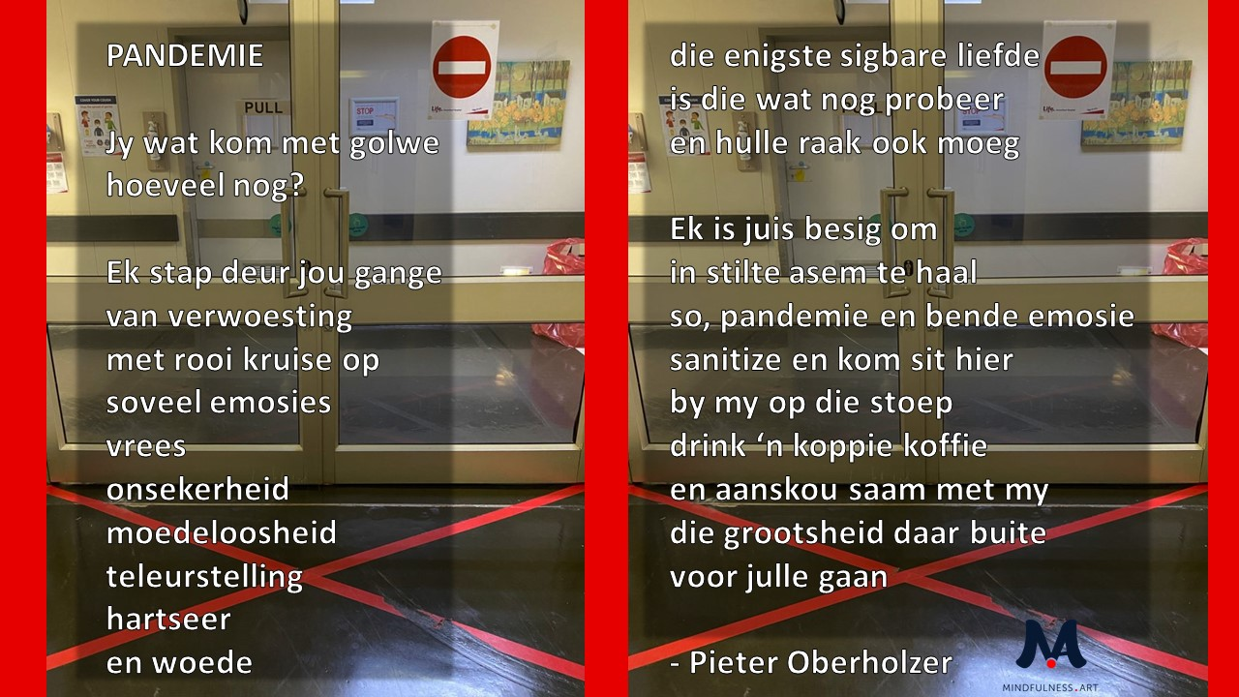
Lees Dr Pieter Oberholzer se Mindfulness geinspireerde gedig oor die Pandemie:

Lees en oordink die reaksie op Rumi se bekende "Guest House" gedig:

On Hospitality: A Reply to Rumi – Amy Newell

Welcome all the visitors you say.
Do not put bars on the windows
Or locks on the doors. Do not close up the
Chimney flue. Duct tape and plastic
sheeting will not keep the visitors at bay.
They’ll pound on the doors, they’ll break
your windows, they’ll create the barricades
they’ll storm the beach, swarm in like ants
through cracks. They’ll lead like water through
the walls, and creep like mice, and curl like smoke
and crack like ice against the window glass.
Keep them out? It can’t be done, don’t try.

Welcome all the visitors.
Fine. There’s all kinds
Of welcoming, however.
I do not have to throw a house party.
I will not post flyers.
There will be no open bar.
No one will get drunk
and lock themselves in the bathroom.
No one will break the furniture, grind chips
into the rug, throw anyone else in the pool,
or lose an earring in the couch.
I do not have to run a guest house, either
There will be no crackling fire
And no easy chairs. I will not serve
tea to the visitors. I will not dispense
ginger snaps and ask my guests
about themselves:
“Did my mother send you?”
“Why must you plague me?”
“Why not stay a while longer?”
“Who are you really?”
If I must welcome-and I am convinced I must-
Let me build a great hall to receive my guests.
Like a Greek temple, let it be open on all sides.
Let it be wide, and bright, and empty.
Let it have a marble floor.
Beautiful and cold and hard.
Let there be no sofas, no benches, no dark corners
no ante-rooms and no coat closets
No walls and not even a ledge to lean against.
I’ll welcome anyone who comes
I’ll show them my enormous empty hall.
Come in, come in, I’ll say. I’ll even smile
perhaps make conversation for a while.
And if someone settles on the floor, as if to stay,
or circles round and round, as if they have lost their way,
I’ll be kind, extend my hand,
and gently show them out again.

