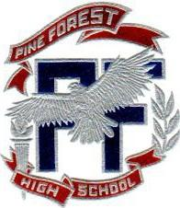

Pine Forest High School

Ronald B Gray Jr.
Director Of Bands

2500 Longleaf Drive, Pensacola, FL 32526
Phone (850) 941-6150 Ext (249) FAX (850) 941-6163

Date

Contact
Company
Address
City, State Zip

Dear Contact:

Do you realize the importance of a music education?

Engaging students in music is a critical factor in creating tomorrow’s workforce. Skills learned through the discipline of music transfer to study skills, communication skills, and cognitive skills. It has been proven that the discipline of music study (particularly through participation in ensembles) helps students learn to work effectively in school, social and work environments.

Since your company is known as a “good neighbor” that supports our community, we are requesting your assistance in providing a quality musical experience to the students of Pine Forest High School. This assistance can be by direct donation, sponsorship, or by donating in-kind goods or services.

Please keep in mind, your donation, no matter how big or small, will help us a great deal and you can rest assured that it will be used for the sole purpose and benefit of the students enrolled in the band program at Pine Forest High School.

Thank you in advance for your consideration and support of our local youth. If you have any questions or would like additional information, please contact Ronald Gay at 954-649-9760

Best wishes,

Name
Title
Pine Forest High School Band Boosters

P.S. This letter, along with our Thank You Receipt (indicating your exact donation), are sufficient documentation of your donation for tax purposes. Please Make all Donations Payable to Pine Forest High School (Band in Memo section)

