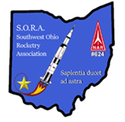

**SOUTHWEST OHIO ROCKETRY ASSOCIATION (SORA)**

**ANNUAL LAUNCH REPORT YEAR 2021**

**NAR SECTION #624**

Year 2021 was an exciting and challenging year for the club with a large number of launches even with a year of Covid restrictions. When allowed, launches occurred with social distancing and mask usage as appropriate for outdoor events. Here are the stats for the year:

The Club conducted 10 launch days. Three launches were cancelled due to weather and one cancelled as it was too close to Christmas.

There was a total of 199 rockets launched, which is up from 2020 in total by 6 rockets. 149 of the flights were 100% fully successful from launch to touchdown. This corresponds to an overall 75% success rate which is slightly less than 2020’s percentage of 79%. The majority of unsuccessful flights involved parachute problems.

Of all the launch events, there were no ground fires, no medical injuries, and no damage to nearby vehicles or buildings out of 199 rocket launches. A perfect safety record (again)!

194 of 199 rockets were recovered accounting for a recovery ratio of 97% which is the same as 2020.

The Total Impulse of motors used in 2021 increased from 2020 as rocketeers gained more experience. Refer to the Table at the end of the report. We went from a Total Impulse of 3562.5 Newton-Seconds to 3740.0 N-S. This is a five percent increase.

There were 66 participating rocketeers, which is up from 63 in 2020. A rocketeer is counted only once per launch date. There was also an increase in attendance from visitors and family members from 63 in 2020 to 66 in 2021.

One launch date (October 2) was specifically set up for the Boy Scouts who were learning model rocketry. 27 rockets were launched by 19 boy scouts.

After the Covid delay of the Team America Rocketry Challenge in 2020, the final judging occurred in 2021. TARC Team 20-6871, sponsored by SORA, placed third at the Ohio Cup championship. Although not quite good enough to go on to Regionals, it was a great experience for the high school students.

$316 was donated to the club or from proceeds from sales of mugs, t-shirts, food/drinks, and logo stickers at the launches. The Club also received a donation of $1000 for providing cleanup crews at the Lebanon Blues Festival over three days.

This year featured quite a lot of electronic systems employed during launches. Multiple types of altimeters were used which added a more scientific perspective to the launches. Astrocam camera systems made for some exciting videos looking down on the launch sites, and Jolley Logic parachute deployment systems were used to deploy chutes at specific altitudes.

Looking at the less-than-optimal launches, we broke failures down into four main categories: Parachutes, Motors, General Construction, and Other. Parachute failures by far topped the list with 29. Motor issues were 10, Construction 6, and Other was 3. An example of an Other was a rocket landing on a brutally hard surface or lost in tree. The top three sub-categories under Parachute failures were parachutes’ shock cord or chute separation from the rocket, chute not unfurling, and shroud line tangle/ripping off the chute.

CATOs (catastrophe on take-off) due to bad motors (5 events) was closely followed in frequency by too low of an impulse motor being used (4). Construction issues were evenly split between Cp/Cg, body tube separation issues, followed by fin loss and rod/rail sticking issues. Several of the CATOs resulted in URDs as they say in NASA – Unscheduled Rapid Deconstruction of the rocket.

This is the first year we started tracking failure modes. This will give us some impetus to work harder on improving our success rate.

Many thanks for all the help given by the Robb our President! He did an incredible job maintaining our great relationship with the park, working with the Lebanon Library, and helping with launch site prep. Thanks also to all the volunteers who helped with Range Safety, Launch Control, setting up, breaking down, and spreading the wealth of knowledge around to all the new rocketeers (and even some of us old rocketeers still eager to learn)!

Overall, it was a great year amid Covid restrictions and the added difficulty of holding business meeting.

If you have ideas for 2022, let us know. We are always open to suggestions.

We continue to launch on the Sunday after the third Tuesday, weather permitting. Stay posted and look for announcements regarding resumption of in-person meetings at the Lebanon Library. Website: https://rocketryohio.com/

We are looking forward to an even better 2022!

**Our club motto – “Sapientia ducet ad astra” – Wisdom leads to the stars!**

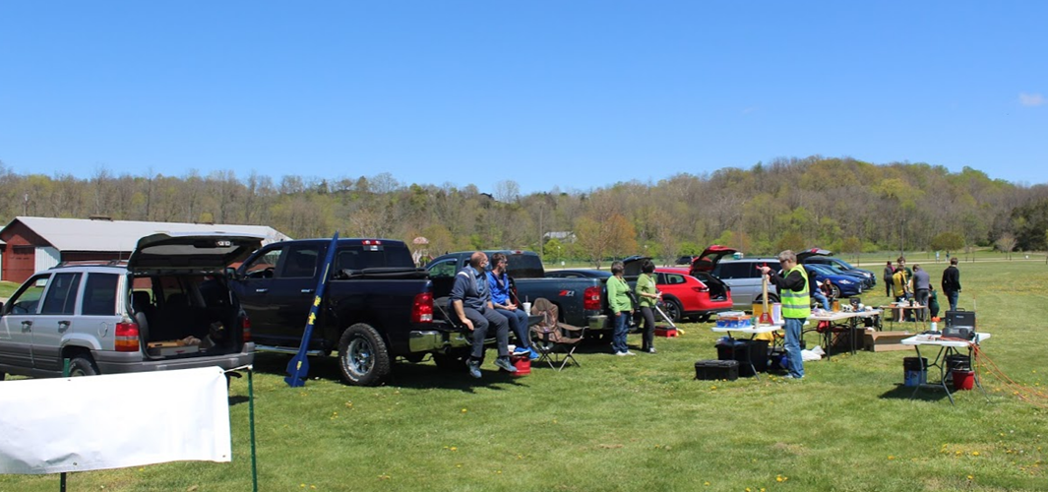

|  |  |  |
| --- | --- | --- |
|  |  |  |
| Up, up , and away on a G79-6 Smokey motor | **Rick attempting to see Astrocam’s camera on/off light** | **Tim’s Pershing 2** |
|  |  |  |
| **TARC team prepping their scratch-built rocket, F27-4R motor** | **Rob’s Cherokee-E ready to go.** | **New coffee mugs!** |
|  |  | |
| **T-Shirts!** | **Dick’s Spider** | |
|  |  |  |
| **Dave-s V-2** | **Dual Phoenix missiles ready to fly** | Tim’s SR-71 Blackbird on a perfect flight |
|  |  |  |
| **Discussing the finer points of model rocketry** | **Ready to fly** | Beautiful ending to a beautiful flight |



