SOUTHWEST OHIO ROCKETRY ASSOCIATION
AUGUST 23, 2020 LAUNCH REPORT 1 PM TO 4 PM
NAR SECTION #624
Launch Conditions: Cloudy with intermittent sun, wind less than 5mph

Total Number of Launches: 37 Rockets Recovered: 37

Total Number of 100% Fully Successful Flights (excluding simple fin breaks on landing): 28

Number of Launch Participants: 5

Number of Family/Friends/Observers/Non-launching rocketeers: 2

Teams and Competitions: 0

Types and Number of Motors:
A: 4 B: 10 C: 12 D: 3 E: 2 F: 5 G: 0 H: 0 I: 0 Higher: 0
Total includes a two-stage rocket using C and B engines
2 Helicopters: pull string powered

Ground Fires: 0 Medical Incidents: 0 Damage to vehicles/facilities: None

Donations: $26

Rocket Items and Issues:
- Two rocket engines failed to ignite (F32-10) after multiple attempts
- One CATO (E12-6) Aerotech Cheetah
- One Bullpup underpowered (A8-3)(Ground impact just as chute deployed). Undamaged. Successfully flown later on B6-2 and on a C6-5
- One rocket Estes Heatseeker stuck on pad due to engine hook snagging stand-off clip
- One Satellite ejected the motor just after take off
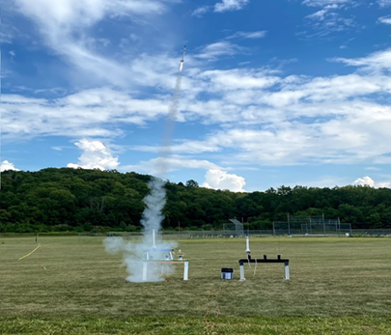
- Two engines failed to eject parachutes
- One shock cord broke but rocket not damaged.

Contest for next launch (September 27):
Parachute Duration using a single “A” engine

Robb White’s Cherokee-E on a thrilling F44-4W.

