

**SOUTHWEST OHIO ROCKETRY ASSOCIATION**

**JULY 26, 2020 LAUNCH REPORT 1 PM TO 4 PM**

**NAR SECTION #624**

**Launch Conditions:** Blue skies with sporadic clouds, wind 5mph

**Total Number of Launches:** 29

**Total Number of 100% Fully Successful Flights** (excluding simple fin breaks on landing): 25

**Rockets Recovered:** 27

**Number of Launch Participants:** 6

**Number of Family/Friends/Observers/Non-launching rocketeers:** 10

**Teams and Competitions:** 0

**Types and Number of Motors:**

A: 7 B: 6 C: 4 D: 8 E: 1 F: 0 G: 0 H: 0 I: 0 Higher: 0

3 MicroRoc Maxx motors (1/8A1-1)

**Ground Fires:** 0

**Medical Incidents:** 0

**Damage to vehicles/facilities:** One rocket gently landed on the hood of Rick’s pickup truck, no damage to either

**Donations:** $12

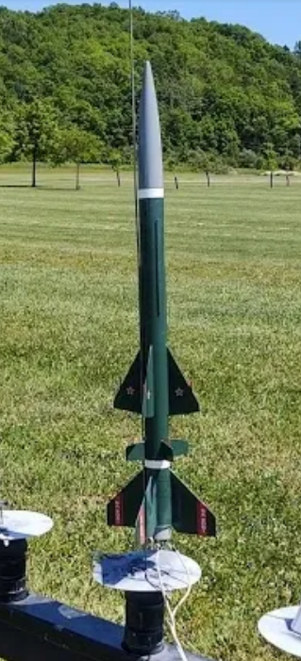

**Rocket Items and Issues:**

1. One rocket lost in high weeds due ejection failure (ballistic re-entry)
2. One rocket lost in forest due to severe drift (too short delay charge and caught a thermal)
3. Three MicroRoc launches. Two were erratic flights. Rod may be too short even though it is the rod that came with the rocket kits.
4. Setting up MicroRoc pad took some time and creativity as hadn’t used MicroRoc before.

**Additional items:**

1. Social distancing and mask wearing went well (Covid restrictions). Did not hamper safe launching.
2. Anemometer didn’t seem to be reading correctly (underestimating)
3. New orientation of the launch pads worked well. (Facing east)

Rick Forrester’s Sasha lost on hillside in the back of the picture. Rest in Peace…