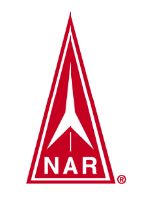
SOUTHWEST OHIO ROCKETRY ASSOCIATION (SORA)
LAUNCH REPORT MAY 23, 2021
1:00PM TO 5:00PM NAR SECTION #624

Launch Conditions: Intermittent clouds, wind 7 MPH.

Total Number of Launches: 26 Rockets Recovered: 26

Total Number of 100% Fully Successful Flights (excluding simple fin breaks on landing): 21

Number of Launch Participants: 7

Number of Family/Friends/Observers/Non-launching rocketeers: 4

Teams and Competitions: 1

Types and Number of Motors:
A: 7 B: 6 C: 3 D: 3 E: 3 F: 4 G: 0 H: 0 I: 0 Higher: 0

Ground Fires: 0 Medical Incidents: 0 Damage to vehicles/facilities: None

Donations: $20

Rocket Topics and Issues:
- Team 20-6871 of the America Rocketry Challenge performed three un-official launches to gather data on their new rocket. Maximum height achieved was 685. Getting closer to the required 800 feet!
- Jon demonstrated an Orbital Transport rocket with beautiful flights of the glider.
- Dani (new SORA member) performed two successful flights of a Generic E2X on A8-3 motors.

Next SORA launch: May 23, 2021

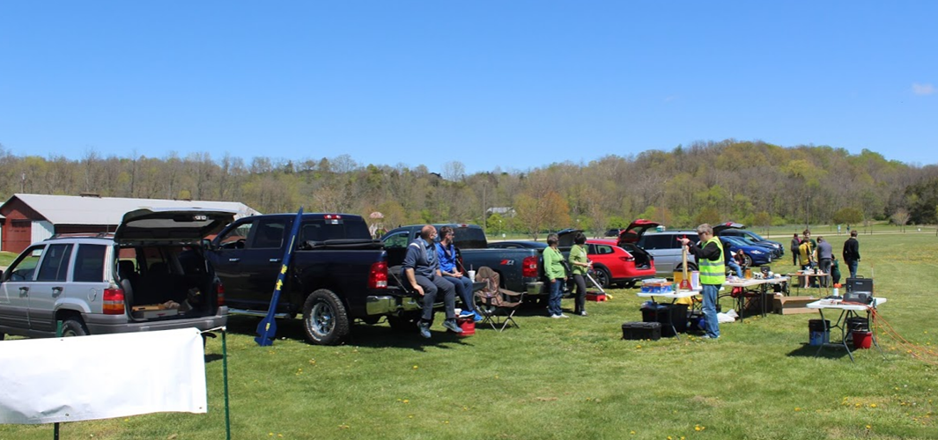
Dave performing Range Safety Officer duties

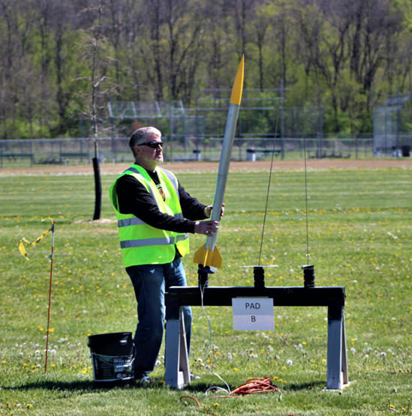 | 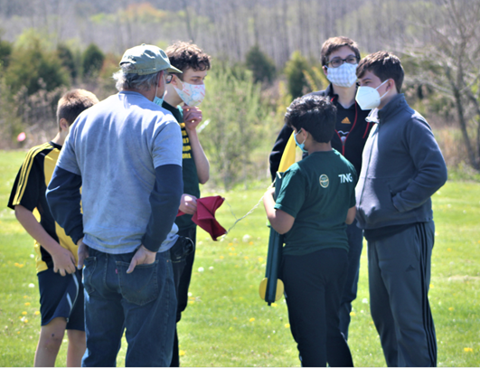
Dave prepping Aerotech HV Arcas | Pre-flight planning TARC competition team
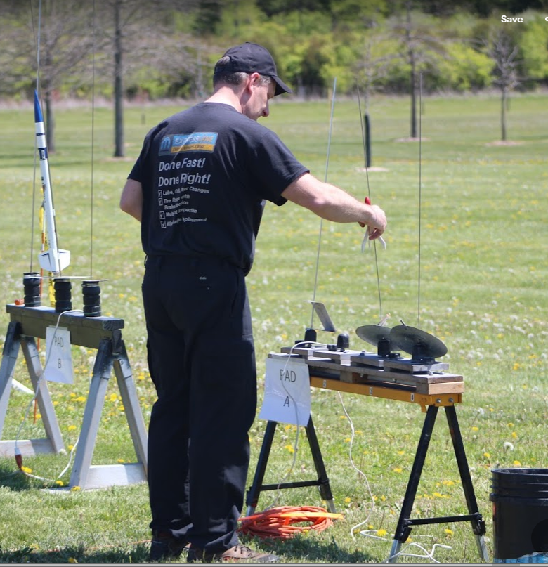 | 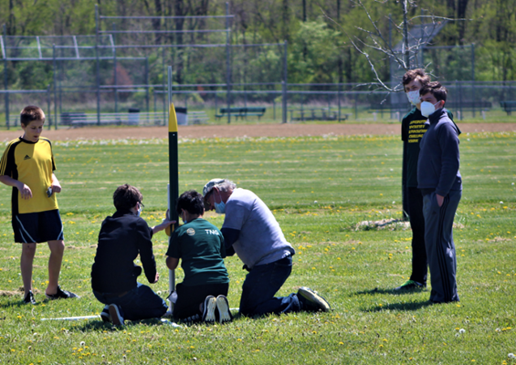
Jon with his Astron Scout | TARC team prepping their scratch-built rocket, F27-4R motor
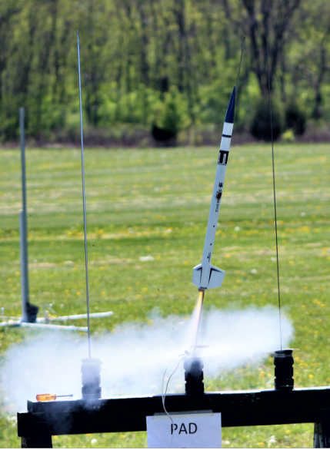 | 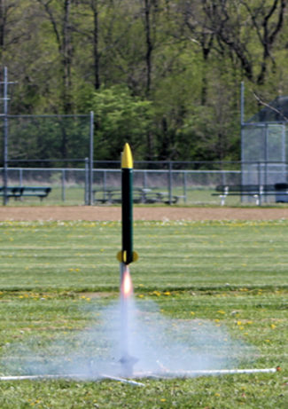
Robb’s Cherokee E | Launch!

